BOOK EXCERPT 1
How to Dress for Your Body Type
The average super model is 5’10”, perfectly proportioned, and impossibly thin. However, if you are like the other 99.99% of the population and not fortunate enough to be blessed with Gisele Bundchen’s physique, you can still look fabulous, stylish and wear the latest trends.
They key is to know your body, and know what looks great on you. With that knowledge you can take almost any style, trend, or silhouette and make it work for you. You don’t need a designer outfit to look great. Even the most expensive outfit in the world won’t look good on you if it doesn’t fit you properly. A simple t-shirt can look great on you if your body fits it right so you have to start understanding what suits your body type as every woman is unique. We all have different curves, flaws and assets. If you learn how to work with yours, the fashion world will become your personal playground and you will never have to dread the dressing room again.
How to Start
To begin your journey to understanding what will flatter you, you must first be brutally honest with yourself. The truth is that most women don’t see what’s really happening with their bodies when they look in the mirror.
Some women see only the negative aspects of themselves in their reflection. Wide hips? Tiny bust? Thick ankles? Perceived flaws such as these are often the only traits women notice when evaluating their bodies.
But there is so much more! For every flaw or imperfection we see, there are always assets we ignore. If you are full figured and curvy you might hate your tummy, but have an incredible bust. Maybe you despise your short legs, and are totally ignoring your long, lean torso.
Don’t focus on the negative! Try writing down your body flaws. For every one you write down, try to find one part of your body you find beautiful. All of those beautiful parts are assets that you will want to remember to play up when it’s time to go shopping.
On the flip side, remember that you are being brutally honest with yourself. Perhaps you have put on some weight in the last couple of years and your tummy isn’t as flat as it once was. Details like this are not something to dwell on, but they also cannot be ignored. Many women refuse to accept parts of their body as they are and try to fit into clothes for the body they want, not the body they have. This will result in ill-fitting outfits that do the opposite of flatter the wearer.
Proportion is the most important element of your body you should be paying attention to when evaluating your shape. In addition to understanding where your problem and asset areas are, look to see the width of your shoulders in comparison to your hips. Are they larger or smaller or around the same size? How much does your waist come in in the middle of the body? Are you long or short waisted? These proportional elements will come into play when you are deciding what body type categorization fits you best.
Whether you can do it by just looking at yourself in the mirror, or you need to get out a tape measure for a reality check, make sure you get a clear picture of your sizes, proportions and shape.
By being honest and observant about your body you are arming yourselves with the power to walk into any shopping environment and feel confident that you will be able to find garments that look and feel great. Knowing your body shape and buying the right clothes that fit you and compliment you will help you look classier, more fashionable and definitely more chic. So if you by the right garment for your body shape, the chances are you will look great, so you don’t need to spend a ton of money buying expensive items of clothing when a $20 tee makes you look just as great as a $80 tee.

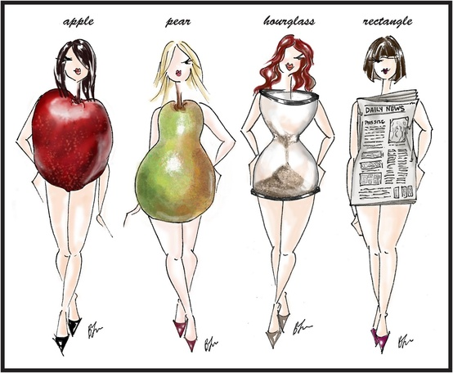

Finding Your Body Type
There are four main body types that most women can identify with. Of course everyone is unique, so you might find yourself falling into more than one category or description. However, the following basic types are a great way to start to learn how to dress for your body.
To decipher which body type category you fit into, simply think back to that honest evaluation of your body back in the last section. With those details, it should be pretty clear what body type you roughly fit into.
Ultimately, the main goal is to dress so you end up with what is called an hourglass shape. Obviously this will mean different things to different women, but the hourglass is the classically feminine curve that starts with a fuller upper body, followed by a slim waist, and finally ending in a full hip and lower body.
While all women have different goals and ideas about what looks great, the hourglass, or some variation of the hourglass, is the most common look that women strive for.

BOOK EXCERPT 2
Shop Sales Vigorously but Cautiously
Whether you are shopping online, at a department store, or in an outlet, there is inevitably always a sale section. While sales are fantastic places to find deals, they can also suck you into making shopping mistakes.
Sale sections often have great deals, but they are riddled with items that were already cast aside by other shoppers. Make sure to TRY ON everything you find in the sale sections. If you try on 15 sale items and none of them look right, don’t feel bad! They probably looked bad on everyone before you as well!
Some people think to themselves that if they only buy the item they want during the end-of-season sale, by that time next year, it would no longer be in fashion. If that is the case, do not and I really mean DO NOT buy that sort of clothing. Do not buy clothing that would be trendy for only a short period of time before the faze and craze dies down. Buy clothing that are trendy forever. Buy the classic, classy and great quality pieces of clothing such as a nicely cut, plain black dress or a pretty yet simple blazer.
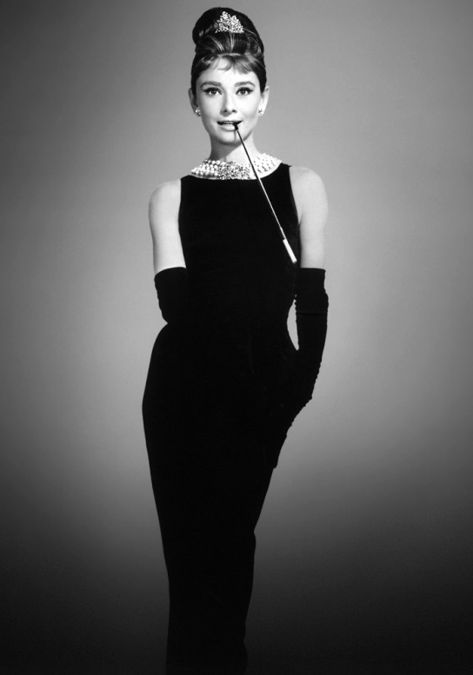
Timeless- The Little Black Dress was made famous by the beautiful Audrey Hepburn during the 1960’s and is still one of the most popular outfits today.
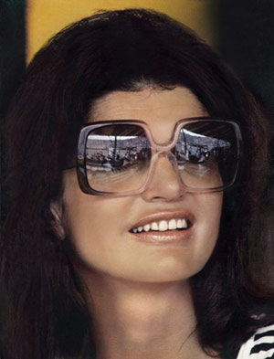
Classic- Oversized Sunglasses were made famous by the amazing Jackie Kennedy during the 1960’s and it is still trending with celebrities such as Kim Kardashian, Cameron Diaz and Rihanna sporting them regularly.
Shop the sale section like an anthropologist looking for treasure. Know in advance that the chances are high you might come up with nothing but sand. But once in a while you might just find that one treasure that makes it all worthwhile!
Even if it is the beginning of spring and you find a winter coat that is on sale, if you find that the winter coat looks great on you, do not hesitate to buy it. This is because you can always just stock up on your winter clothes first, so that when winter comes, you don’t have to go mad, rushing around trying to buy items that are full-priced because you don’t have a winter coat. End of season sales are great, just buy the items that are on sale that you love and have tried on then just fold them neatly in your wardrobe until that season comes around again. That way you don’t have to pay for full-priced items when that season comes around again because you discovered you have nothing to wear!
Another piece of advice is: DO NOT SETTLE FOR ANYTHING BELOW 40% OFF! This is because even with 30% off, those items are still expensive and there is no doubt that the shop will have another sale and the next sale will be bigger than the current one. Shops do this because they want to suck people in to buy clothing with a lower percentage cut off the original price before trying to get rid of their garments by having a bigger sale. All shops think about is PROFIT, PROFIT, PROFIT! So don’t get sucked into their little game! You have to play the game better than they do!
Sales are a great way to buy high-end yet affordable clothing because almost every store will have a big sale at some time of the year. So make sure you keep track on the latest sales! Mark down different store’s seasonal sales, promotional sales and Boxing Day sales, so that when the time comes, you know where to go!

EXCERPT 3
Know Where to Shop
These days almost every store you walk into has at least a small accessory section. Fashion companies today realize that women want the whole package when they are putting an outfit together, not just individual pieces. So now everyone from department stores, to mall shops, to small boutiques have accessories.
This move towards accessories is great not only because it gives the shopper a massive selection, but it also gives you an easy place to start when shopping. If you know you love the style of the clothes from a certain brand, chances are you will love the accessories too. From necklaces to headbands, one brand will give all of their products the same look, or at least the same feeling and styling. So next time you need to go pick up some new sweaters at your favorite store, check out the accessories section as well. Chances are you will find something you like, and it might just look great with the rest of the clothes from the same brand!
In addition to trying all your old favorites, branch out to new places when looking for accessories. There are some great accessories-only stores out there that you might have passed by 1,000 times and never thought to go into. Or if there is a brand you have always liked, but never tried because of price, size, or simply because you thought you could not pull their items off, check out the accessories. Even if you don’t wear the clothes from a certain brand, you still might find some amazing accessories in there!
Know What to Look For
Jewelry is often very expensive, even more so than clothes. It’s easy to find amazing pieces you love that are incrusted with diamonds and made of platinum. But if you are shopping on a budget, this might not be feasible.
The good news is with a little knowledge and a keen eye; you can choose inexpensive costume jewelry that looks fantastic. Unlike clothes, you don’t have to worry about fit with accessories. This eliminates one of the major challenges of shopping for fashion on a budget. For accessories, all you have to worry about it the items being stylish and of course, not looking cheap.
The rules of selecting great looking, but inexpensive accessories are similar to those that we went over in clothes with some variations:
- Look for democratic materials. In jewelry, materials like wood, enamel, and beading are pretty much the same regardless of the price point. Pieces made of these materials will look pretty much the same no matter where you buy them. In items like scarves, belts and other soft accessories, stick to cotton and natural fibers. Cotton looks great, wears well, and it is really hard to tell if you spent $10 or $100 on it.

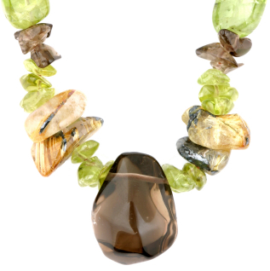

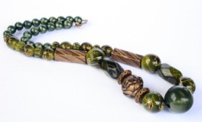

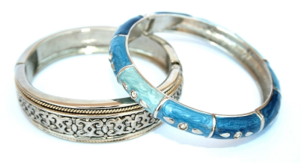

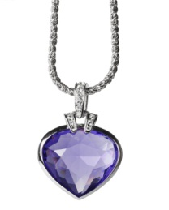

- Avoid very shiny metals. The majority of jewelry is some kind of metal. Variations of gold and silver are the most common, and in turn, they are the most commonly faked. You can find great fake gold and silver if the real thing is not in your budget, but you want to stick to more matte, textured looking pieces. There are some real metal finishes that are extremely shiny and smooth, but that look is difficult to fake, so it’s a better bet to choose something on the less shiny side. The same rule generally goes for leather purses, as most leather is not naturally shiny. Patent leather is the exception, so that is a little easier to imitate.
Down below is a gold necklace and a multi-colored rhinestone necklace. The gold necklace is more simple, classy and looks more expensive whereas the rhinestone necklace looks fake and cheap.
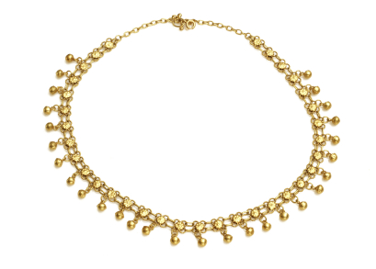

VS.

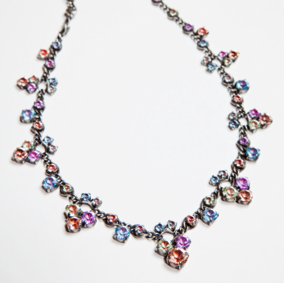

- Like we mentioned earlier, it’s in your best interest to invest in classic pieces, and buy trendier ones on the cheap. There are lots of trends in accessories that are here today, gone tomorrow. However, there are pieces that are classics that you could wear every day for the rest of your life. Save up or allocate more of your budget to timeless pieces like a simple string of pearls or a beautiful precious stone pendant. These will serve you well for years to come, and you can use whatever budget you have left over to spend on trendier pieces that you can wear for a shorter amount of time.

Down below is a classic pearl bracelet and a trendy bead bracelet. Both looks great, but it will be the timeless pearl bracelet that will stay classy and fashionable forever.

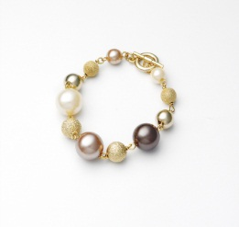

VS.
