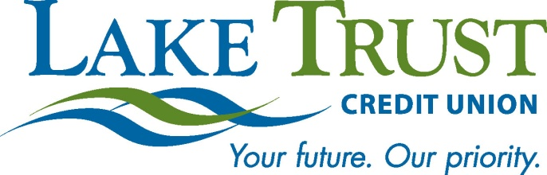

News Release
For Immediate Release

Website: laketrust.org

Lori Anderson
517-267-7242
landerson@laketrust.org

Lake Trust Credit Union Foundation Golf Outing Gives Back to Community
Lake Trust’s New Foundation’s First Outing

Lansing, Michigan – Recently, Lake Trust Credit Union announced the establishment of its Lake Trust Credit Union Foundation - and just a couple of short months later is planning the Foundation’s inaugural event, in the way of a first annual Golf Outing - to be held on June 17, 2013 at Eagle Eye Golf Course near Lansing. The event, in alignment with the Foundation’s mission, will bring people and organizations together to create strong connections in Michigan’s communities, which in turn creates diverse and vibrant neighborhoods.
Lake Trust’s Golf Outing, sponsored by Glenn Buege Buick GMC, NCR, Mortgage Center and Creative Benefit Solutions, LLC will give back to the Credit Unions’ lake-to-lake community, in the way of support received from additional sponsorships, donations, and golf packages for individual and golf foursomes. For golfers, the outing includes a breakfast, lunch, dinner, reception, entertainment and more.
“We’re excited to launch our Foundation’s first event,” said Lake Trust Credit Union President and CEO David Snodgrass. “This is a magnificent opportunity for us to work together to support those Michigan communities that mean so much to us.”

Snodgrass and Team Lake Trust are excited to see the Foundation come to life in this way, and are looking forward to the positive impacts it will have in Michigan.

“Our Golf Outing is our Foundation’s first occasion to bring our communities together to make a difference across the state,” said Lake Trust Director of Corporate Responsibility, Keith Koppmeier. “This event really gives our Foundation a running start for our always growing support in the communities we’re so appreciative of.”

Visit the Credit Union’s website for sponsorship information, to sign up for a golf package, and any questions about the Lake Trust Credit Union Foundation.

The Lake Trust Credit Union Foundation is a 501(c)(3) dedicated to making a difference by volunteering time and resources to Michigan. You can make a tax-deductible donation at any Lake Trust Credit Union branch. For more information, visit laketrust.org. Lake Trust Credit Union is Michigan’s fourth largest credit union with branches stretching from Lake Michigan to Lake Huron and Lake Erie. With more than $1.5 billion in assets, Lake Trust provides over 157,000 members with best-in-class products and offers individualized, trust-based member service. As a community-based credit union, Lake Trust strongly believes in supporting its communities and participates annually in Komen for the Cure® in Ann Arbor and Lansing, as well as nearly 100 events and causes annually throughout Michigan. Membership is open to anyone within its 35-county service area. Follow Lake Trust on Twitter @laketrust. Lake Trust is also on Facebook.

