

Contact: Jason Campbell
Manager, Marketing and Special Events
(914) 984-2531
Jcampbell@entandallergy.com

ENT and Allergy Associates®, LLP Climbs to New Heights, in Brooklyn Heights

Ear, Nose, Throat and Allergy practice reaches understanding, to open state-of-the-art clinical office at One Pierrepont Plaza

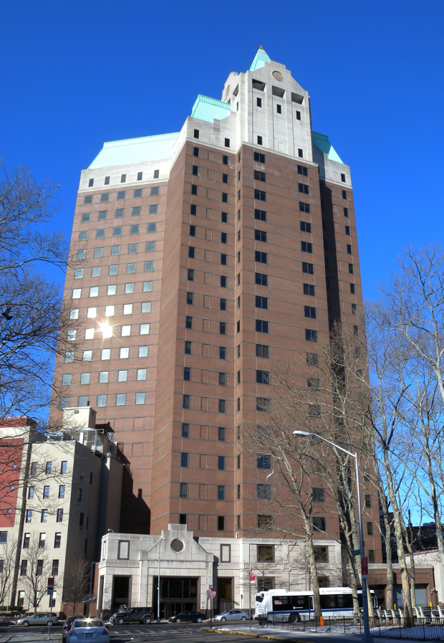

Tarrytown, NY. – April 1st, 2013- For ENT and Allergy Associates (ENTA), serving a community's needs is not a one-time event. Rather, it is a continuing and deepening commitment to ensuring that as an area's needs evolve, the Practice is equally fleet of foot.

With exactly that in mind, ENTA today proudly announced that it had reached a Memorandum of Understanding, to lease 12,000 sq ft of prime clinical space at One Pierrepont Plaza in Brooklyn Heights. ENTA's action, the latest in a series of growth initiatives in neighborhoods throughout New York and New Jersey where the practice's nearly 140 surgeons and specialists serve patients, means more convenient, more comfortable, more comprehensive, and more advanced solutions to the needs of the adult and pediatric patient populations of Brooklyn.

In fact, this facility will complement the Practice’s two existing locations in nearby Bay Ridge, resulting in unprecedented otolaryngological offerings to these deserving communities.

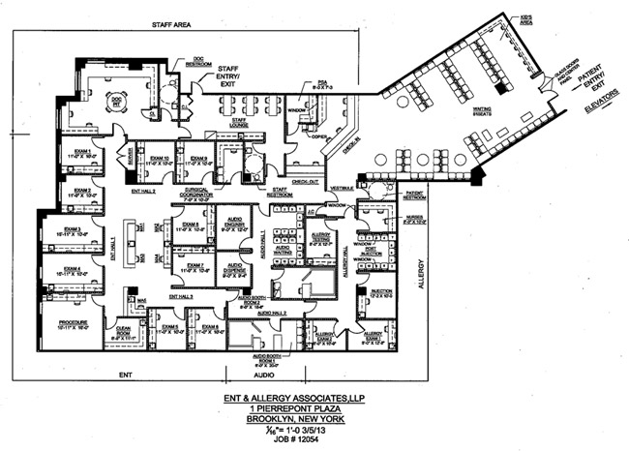

This state-of-the-art space will serve the patients of Brooklyn Heights, Cobble Hill, Downtown Brooklyn, Park Slope, Dumbo, Carroll Gardens, Clinton Hill, Fort Greene and Boerum Hills, and can be up and running as early as the late fall 2013. It will supplant the Practice's current office at 406 15th Street, Park Slope Brooklyn, NY. The new office at One Pierrepont is easily accessible with 13 Subway Lines, 15 Bus Lines and the LIRR.

The proposed ENTA clinical facility will house the entire roster of superb physicians currently practicing in Park Slope, including Dr. Ramez Habib (Otolaryngologist), Dr. Sheldon Palgon (Otolaryngologist) Dr. Christopher Song (Otolaryngologist), Dr. Francisca Yau (Otolaryngologist) and Dr. Milo Vassallo, Allergist and Immunologist. Working right alongside them is audiologist Sofya Shlafman, Au.D. Tahl Colen, MD, our Neuro-otologist from our Bayridge East office will also provide some session time in the future.

Ramez Habib, MD, the senior partner in this office and a Brooklyn native commented, “Brooklyn is an exciting place to live and work; our neighborhoods offer dynamic urban environments that lend themselves to both young professionals and families wanting to take full advantage of the New York metro region. Our new office is geared for the population growth and commercial revival in and around downtown Brooklyn.”

To provide an even broader array of services, the Practice is actively pursuing additional sub-specialists including those fellowship trained in Pediatric Otolaryngology, Facial Plastics and Rhinology. This office will truly provide a multi-disciplinary approach to Ear, Nose, Throat, Allergy and Audiology patient issues.

“This expanded, renovated and improved facility is yet another example of ENTA’s singular focus on both our patients’ healthcare, and the quality of their doctor visit experience,” noted Wayne Eisman, MD, President of ENTA, “Among other things, this new space means more comfort for everyone, and that’s very important”. Robert Glazer, CEO for ENTA described the new office as follows: “The space will contain eleven clinical Otolaryngology exam rooms, a four room audiology suite with two clinical diagnostic hearing booths; a five room allergy section and our customized Electronic Medical Records system that already interfaces all of our other 38 locations as well as with Mount Sinai Medical Center for tertiary care communications.”

Brooklyn Heights, and the adjacent Downtown Brooklyn, are storied sections of that borough's explosive growth, and represent the third largest central business district in New York City, (following Midtown Manhattan and Lower Manhattan). Located in the northwestern section of the borough of Brooklyn, the neighborhood is known for its substantial office and residential buildings which produce its own unique skyline. Since the rezoning of Downtown Brooklyn in 2004, the area continues to undergo a transformation.

About ENT & Allergy Associates, LLP:
ENT and Allergy has over 135 physicians in 38 office locations in Westchester, Putnam, Orange, Dutchess, Rockland, Nassau and Suffolk counties, New York City, Long Island and northern New Jersey. Each ENT and Allergy Associates clinical location provides access to a full complement of services, including General Adult and Pediatric ENT, Voice and Swallowing, Facial Plastics and Reconstructive Surgery, Disorders of the Inner Ear and Dizziness, Asthma, Clinical Immunology, Diagnostic Audiology, Hearing Aid dispensing, Sleep and CT Services. ENTA has a clinical alliance with The Mount Sinai Hospital for the treatment of diseases of the head and neck and esophageal cancer and a partnership with the American Cancer Society to educate and treat patients with smoking disorders and cancer. The Practice has also expanded its clinical capabilities to include advanced Immunodeficiency trials. Visit www.entandallergy.com for more information.

