Contact:  Kimberly Crites  Summerwinds Resort Services LLC  Phone: 800.699.3250 | 3179 N. Gretna Road  Branson, MO 65616  SummerwindsResorts.com  StormyPointVillage.com  1862DavidWalleysHotSpringsResort.com | 

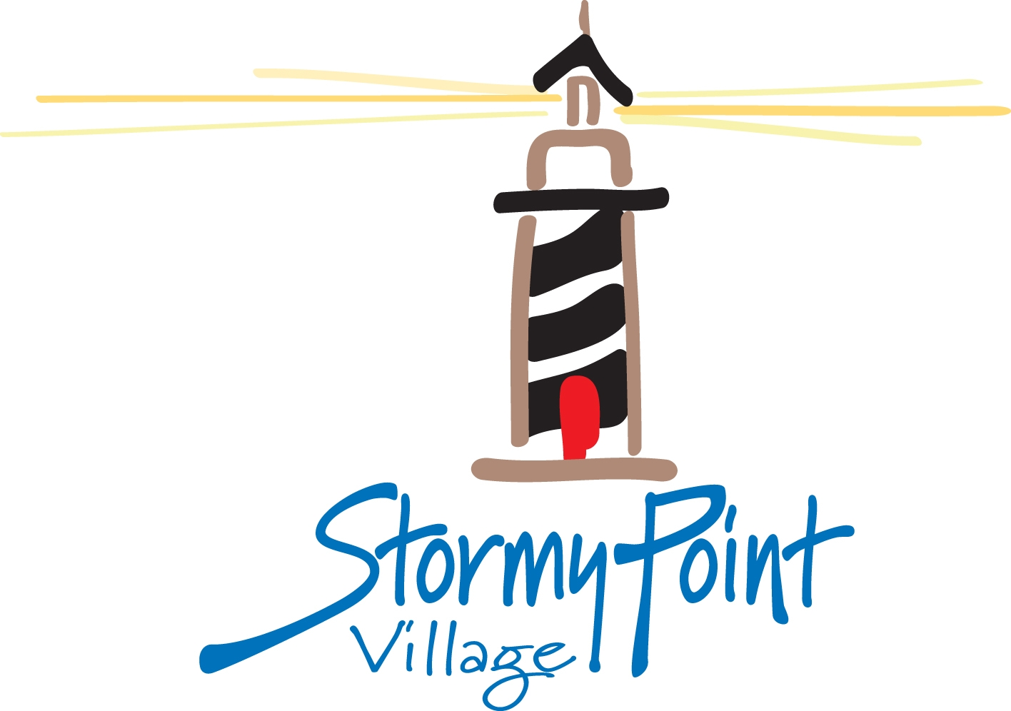
Press Release

Summer Winds Resorts and the Branson Auction help VCRA Raise Funds for Autism Awareness

Branson, MO | April 8, 2013

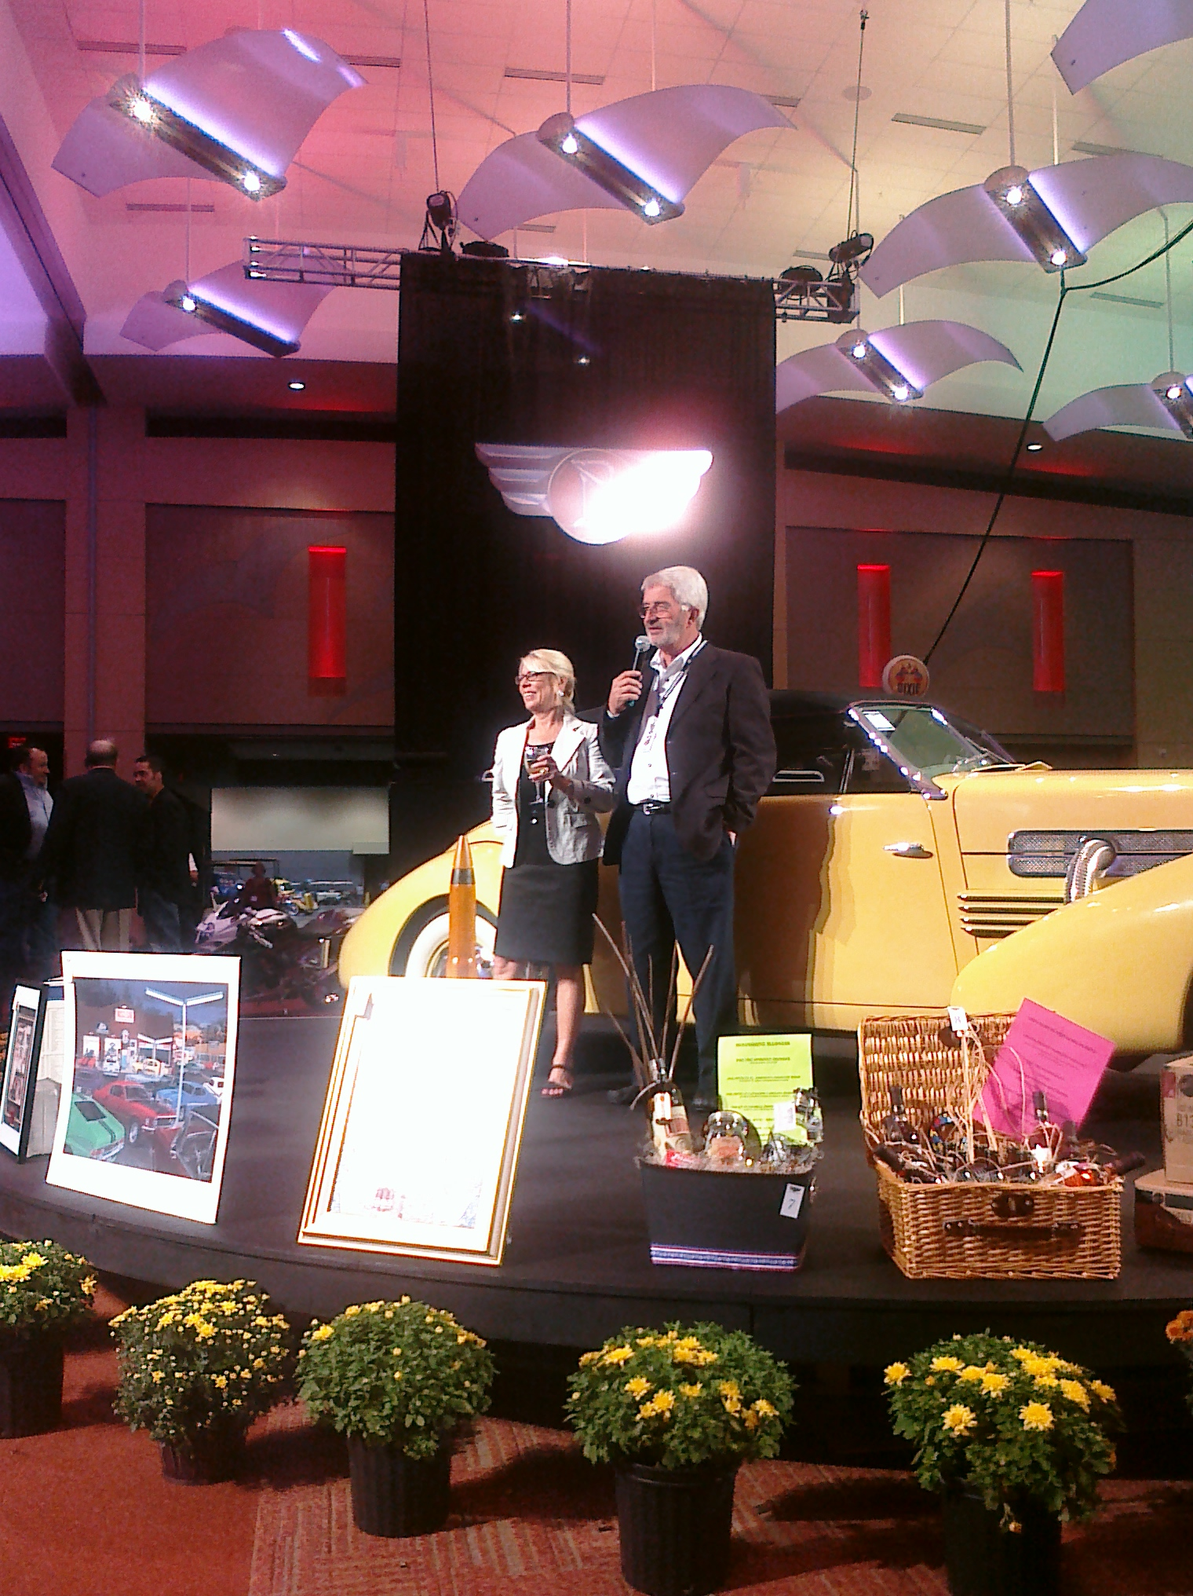
The Branson Auction announced today that the Spring Car Auction will be held April 12-13th at the Hilton Branson Convention Center in Branson, MO. Summer Winds Resorts will host a private reception and auction on April 11th with all proceeds benefitting the Vintage Car Rally Associations’ Autism Awareness and the Autism Society of America. Pat Joyce, President and CEO of Summer Winds Resorts stated, “We are proud to sponsor the cocktail party and honored to donate a week at our Stormy Point Village for a cause that is dear to our hearts.” Darren Abbott, Summer Winds Resorts Vice President of Sales added, “It’s a pleasure to once again join with the VCRA to focus on Autism Awareness. We encourage everyone to come to the auction, view some classic vintage cars, and show their support.”

The Branson Auction is celebrating its 33rd year of Collector Car Auctions held biannually at the Branson Convention Center. Jim and Kathy Cox, owners, have been presenters for more than 25 years. The Branson Auction is open to the public and begins Friday at noon and Saturday at 10AM.

Summerwinds Resorts Services, LLC operates and sells boutique themed resorts in Branson, Missouri and Genoa/Lake Tahoe, Nevada. Summerwinds Resorts has created the successful Stormy Point village at Table Rock Lake and is now reviving the historical charm and personality in 1862 David Walley’s Hot Springs Resort and Spa. Stormy Point Village is a Cape Cod; New England styled property with upscale services and amenities. 1862 David Walley’s Hot Springs Resort and Spa harkens back to the Pony Express days, as a rustic mining town with charming cabins and a historical themed clubhouse, nestled between native wetlands famous for its Bald Eagle sightings and the foothills of the Sierra Mountain Range. Summer Winds team consists of over 400 employees working in five states with a common goal: service to the customer.

