Lake Trust CU 1.eps

***Press Release***

For Immediate Release

|  |  |
| --- | --- |
|  | Website: [laketrust.org](http://laketrust.org/)  Lori Anderson  517.267.7242  [landerson@laketrust.org](mailto:landerson@laketrust.org) |

**Lake Trust Unveils New Look at Relocated Branch in Auburn Hills**

Credit Union Trains its Staff for a New Retail Experience

Auburn Hills, MI – Lake Trust Credit Union is celebrating the Grand Opening of its Auburn Hills branch, located at 2550 N. Squirrel Rd. The branch will hand out daily prizes and refreshments throughout the week of April 15.

The location is well-positioned in the busy storefront area of the Auburn Square Shopping Center, across from Oakland University, and will create a new experience for members. Lake Trust representatives specialize in service and are cross-trained in many specialty areas, creating more of a retail feel to the new location. At just 1,200 square feet, the location will be the smallest of all of Lake Trust’s branches.

“Our new branch brings a more significant presence in the area,” said Kimberly Oblak, Lake Trust Assistant Vice President of Retail Sales and Service. “It’s much more accessible for our members. We really hope everyone will enjoy our new location as much as we enjoy being a part of this community.”

In preparation for this new experience, Lake Trust staff took on additional training and held team-building sessions. Staff and Leadership teams worked side by side to learn to serve members in a new way. The organization is thrilled with the results, and is excited to showcase the branch during Grand Opening Week.

“The new model will serve members in a non-traditional, open banking environment kind of way,” said Terri Guastella, Lake Trust Project Coordinator. “It’s a great location to house this pilot right across from the university. We’ll get a chance to see just how well it plays out with many different segments of our membership.”

[Lake Trust Credit Union](http://www.laketrust.org), as Michigan’s fourth largest credit union and headquartered in Lansing, stretches from Lake Michigan to Lake Huron and Lake Erie. With over $1.5 billion in assets and 21 branches strong, Lake Trust provides its over 157,000 members best-in-class products and offers individualized, trust-based member service. Membership is open to anyone within its 35-county service area. Learn more about Lake Trust Credit Union at [laketrust.org](http://www.laketrust.org/).

*Follow Lake Trust Credit Union on Twitter at*[*http://twitter.com/laketrust*](http://twitter.com/laketrust)

=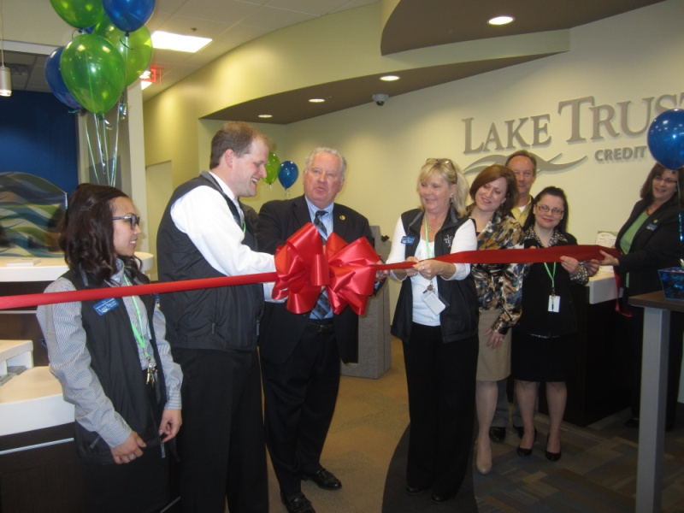

Ribbon-cutting with Auburn Hills Branch Manager Joseph Byers and Auburn Hills Mayor James McDonald