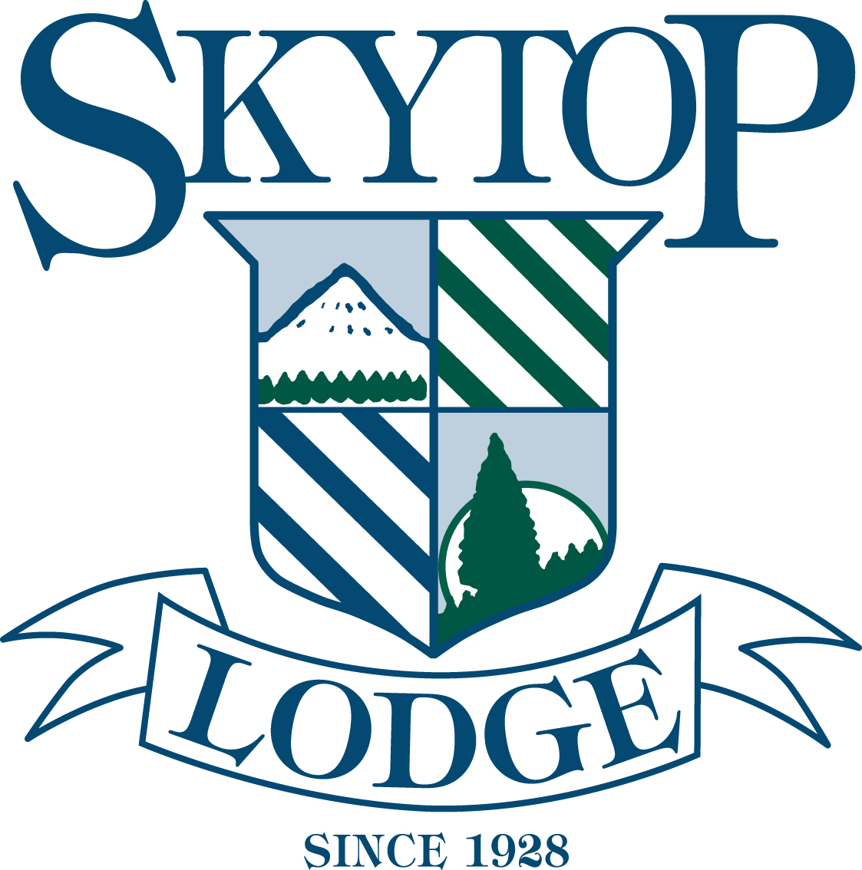Skytop Lodge – Media Contact: Laurie A. Guzda | 570.335.6824 | laurie@laguzda.com

The Adventure Heats up at Skytop Lodge

Skytop Lodge, one of America’s best all-inclusive resorts (Travel + Leisure), is an ideal getaway offering 5,500 of pristine natural beauty. From the Treetops Zipline/Challenge course to sporting clays to interpretive nature hikes, Skytop Lodge is the ultimate Pocono Mountains retreat.

Skytop offers outstanding themed weekends. Mother’s Day, May 10-12, is also Skytop’s anniversary weekend. This celebrates the 85th year and it is a weekend to be experienced! You’ll enjoy butlered picnics, sensational food and wine parings, dancing and a fabulous Mother’s Day Brunch. For the photographer or outdoor enthusiast, Skytop’s Wildlife Photography and Birding Weekend, May 17-19, features photography workshops, nature walks and expeditions set against a stunning backdrop of waterfalls, meadows, lakes and stunning mountain vistas.

This just in, Skytop is honored to present the screening of the Sundance Film Festival’s critically acclaimed Vanishing of the Bees. This exclusive viewing is part of the ‘Bee Mindful’ weekend, May 3-5, and initiative which is raising awareness of Colony Collapse Disorder which threatens the bee population and our food supply. This weekend we will also be breaking ground on a wildflower garden to promote a healthy habitat for local honeybees.

Memorial Day weekend, May 24-27, is a great way to kick off the summer at Skytop Lodge. In addition to the miles of hiking and biking trails as well as lake activities, Skytop offers an exciting Adventure Center including a three-tiered zipline/challenge course, as well as a shooting and fishing center. The Skytop Tennis Center features Mohesh R. Koregaokar. Affectionately known as “Moe”, he has over 30 years of playing, touring, coaching and consulting exposure at all levels of expertise and abilities. Having served as personal coach for Andy Roddick and Venus and Serena Williams, Skytop is honored to welcome Moe to the Skytop team. Skytop also offers an award-winning championship golf course under the direction of PGA professional, Brian Boyle.

Surrounded by stunning mountain vistas, Skytop’s 18-hole championship golf course features 6,656 yards of golf that tests all levels of play through rolling hills, open meadows, waterfalls, mountain streams and woodlands. The course has a rating of 72.0 and a slope rating of 133, which distinguishes it as a challenging course since an average course usually has a rating of 117. “The small greens are what make it more of a difficult course to score on,” said Skytop’s Director of Golf and Head Professional, Brian Boyle. “It puts a premium on a golfer’s chipping and putting.”

IT’S TEE TIME AT SKYTOP

Skytop offers a variety of golf clinics and private lessons with PGA professionals. As well as a fully stocked pro shop and practice range. Special midweek, off season rates are available. To book a tee time or for additional information contact the Pro Shop at 570-595-8910 or email golfproshop@skytop.com
The Mulligan Golf Package

Skytop’s ultimate golf package "The Mulligan" is perfect for the avid golfer or the casual player. With 3 meals per person per night's stay, unlimited golf for two with cart and one sleeve of golf balls per person you'll have everything you need for a perfect day on this award winning course!

May is MULLIGAN MONTH at Skytop. You’ll save 15% on your midweek stay.
Call 1-877-289-9552 to book this package, or email us at reservations@skytop.com 2 night minimum applies

Give dad an extra special father’s day gift – give him an experience with sporting clays, fly fishing, tennis or golf lesson. 4th of July is an event not to be missed at Skytop. You’ll enjoy fireworks, picnics, music and more! All summer long Skytop is the ideal destination of choice for a great family travel experience – traditional family, family of friends or your family reunion.

Skytop Lodge, one of America’s best all-inclusive resorts (Travel + Leisure), is an ideal getaway offering 5,500 of pristine natural beauty. For more information on these and other great packages, visit www.skytop.com/packages.

For more information on these and other fabulous theme weekends, visit www.skytop.com/themed-weekends.

About Skytop Lodge:
Experience the ultimate retreat by visiting one of the most esteemed lodges in the country—Skytop. This grand historic estate features the very best in accommodations, fine dining and limitless recreation including the new Adventure Center at Skytop. You and your family can explore 5,500 pristine acres of inspiring natural beauty while enjoying a range of seasonal activities. Choose from the adventurous—like clay shooting and zipline—to the serene—like nature hikes and full spa services. No matter your age, personality or desire, Skytop Lodge can make your next trip an unforgettable experience. Call 877-289-9552 or visit http://www.skytop.com

