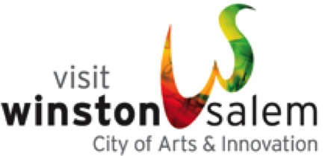
Winston-Salem Fun Facts
- In 1949, Winston-Salem became home to the first locally established Arts Council in the country, providing a model used by other cities across the country.

- Music to our ears: Prior to the union of Winston and Salem, Salem was the first city in the United States where classical music was composed.

- This city is home to the longest continually running Easter Sunrise Service in the country. Thousands flock to God’s Acre, the Moravian cemetery at Home Moravian Church to hear the 400-member brass band and see the sunrise against the backdrop of freshly scrubbed grave stones and fresh flowers.

- In 1963, Winston-Salem was selected as the campus for the new North Carolina School of the Arts, the first state-supported arts conservatory in the U.S. It eventually became the internationally regarded University of North Carolina School of the Arts with Tony, Grammy, Emmy and Academy Award winning faculty and alumni.

- The “Twin City” is home to six colleges and universities, including Wake Forest University and Winston-Salem State University. Salem College is the longest continually running educational institution for women in the country.

- Got a sweet tooth? Satiate it here. The city is famous for its Moravian cookies and bakeries. The 200-plus-year-old Winkler Bakery at Old Salem still uses wood-fired ovens to make traditional Moravian Sugar Cake, the paper-thin Moravian cookies and more. Three bakeries with national and regional fans grew out of the Moravian baking tradition: Dewey’s Bakery, Salem Baking Company, and Mrs. Hanes Cookies have been a favorite of Oprah.

- Today’s toast to agriculture: Winston-Salem is the gateway to the Yadkin Valley wine country. The Yadkin Valley is North Carolina’s first American Viticultural Area (AVA); from our city, you can explore 35 wineries growing European varietals.

- The Reynolds Building in downtown Winston-Salem (which once served as the headquarters for R.J. Reynolds Tobacco Company) was the prototype for the Empire State building in New York City. Both buildings were designed by architect William F. Lamb. When the Reynolds Building was completed in 1929, it was the tallest building in the United States south of Baltimore. Every year, the staff of the Empire State Building sends a Father's Day card to the staff at the Reynolds Building to pay homage to its role as predecessor to the Empire State Building.
For more information and images, contact Susan Dosier at susan@dkcommunicationsgroup.com, 704.993.7871 mobile; www.visitwinstonsalem.com

