RUBY CUP PRESS 2013
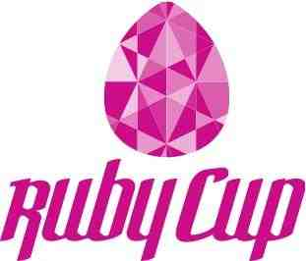

WOMEN: BLEED GREEN AND KEEP GIRLS IN EDUCATION
A new award-winning sustainable menstrual hygiene product is changing the lives for girls in poverty.

Ruby Cup is a menstrual cup, a sustainable menstrual hygiene product that is re-usable for 10 years. It's a hygienic and eco-friendly alternative to pads and tampons. It is made of 100% medical grade silicone and is re-usable for up to 10 years. The long life-expectancy makes the cups an extremely economical option, and the re-usability eliminates the waste that would be generated by thousands of disposable products (women use on average 11,000 items of disposable sanitary products in their lifetimes).

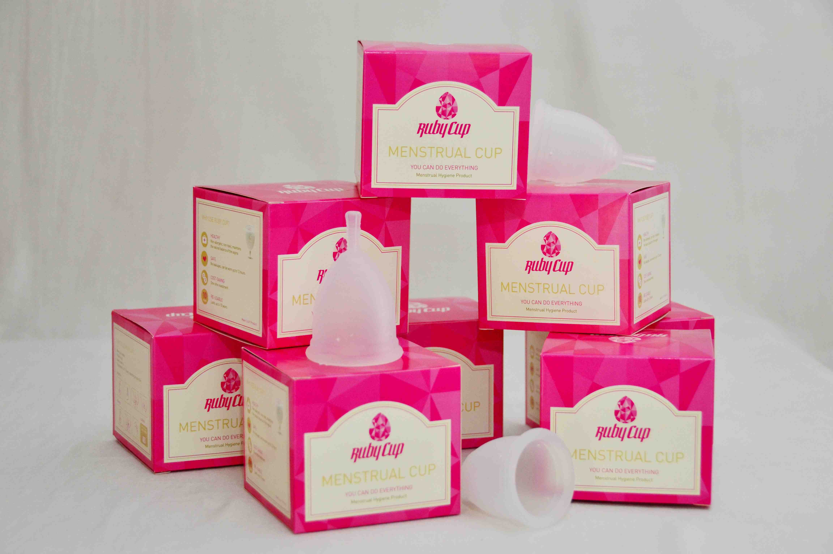

Buy One Give One
Menstruation is a main cause of school dropout for girls in poverty. Pads and tampons are too expensive or unavailable, and girls are forced to use alternatives such as mud, bark, rags, cloth or pieces of newspaper. As well as being undignified and unhygienic, these alternatives are not safe, and girls stay home. This amounts to 20% of their school time.
When you buy a Ruby Cup, you give one to a Kenyan schoolgirl. With one Ruby Cup, a girl can all the way from primary school through university without having to worry about her period again.

With an office in Nairobi, the three Danish female founders Julie, Maxie, and Veronica, have won several awards for their work on the ground. Ruby Cup is sold online to western markets, and when you purchase a Ruby Cup, you give one to a school girl in poverty.

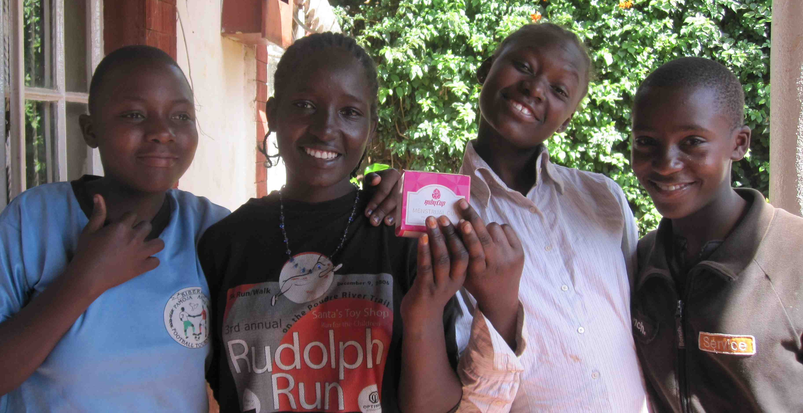
Awards:
- Winner of The Global Social Entrepreneurship Competition 2012 (US)
- Winner of Venture Cup 2012 (DK)
- A selected Sustainia100 Solution (World)
- Finalist in Ben&Jerry's Join Our Core 2012 (EU) Awarded Future Impact Award 2nd prize 2012 (CH)

About Ruby Cup
Ruby Cup is a wonderful menstrual cup that is re-usable for 10 years and designed by three young Danish women. It has a large capacity and an easy to grab stem. Its smooth consistency enables an easy open-up function, soft insertion and removal, and its frosted feel provides an easy to clean surface. When you use Ruby Cup, you almost forget you have your period!

Ruby Cup is made of 100% top quality medical grade silicone. It comes in a pink biodegradable envelope and contains a beautiful 100% cotton Ruby bag and a leaflet with instructions for use.
Ruby Facts:
- Ruby Cup contains no harmful chemicals, absorbency gels, additives, or perfumes, with no side effects nor Toxic Shock Syndrome associated with it.
- Ruby Cup is One Size that fits comfortably both before and after child-birth.
- Ruby Cup is started by three young Danish women who believe all women deserve the best.
- With every purchase, you give a Ruby Cup to a school girl in poverty
- Ruby Cup is reusable for up to 10 years. For every woman who switches to a Ruby Cup, 4000 pads or tampons are saved from ending up as waste.
- Already, the young social business has eliminated the potential waste generated by 8,400,000 tampons (5.46 metric tonnes).
- In the United Kingdom, 4.3 billion disposable sanitary products are used every year.
- It takes six months for a tampon to biodegrade. Pads and tampon applicators take a great deal longer – on average they take more than 25 years to biodegrade.

Follow us @
www.ruby-cup.com
www.facebook/rubycup
www.twitter/rubycup

Get Ruby Cup and:
- Contribute to an eco-friendly planet
- Invest in your own health and well-being.
- Save money
- Support a Kenyan schoolgirl.

