Press Release 10 May 2013

BabyPing wins ‘Best Sound & Vision Baby Monitor’ in Bizziebaby Awards
Honest reviews by real parents gives BabyPing a Silver Award for 2012/2013
BabyPing, the number one Wi-Fi baby monitor for iOS devices owners, has been presented with the Silver Award for Best Sound and Vision Baby Monitor in the 2012/2013 Bizziebaby Awards.
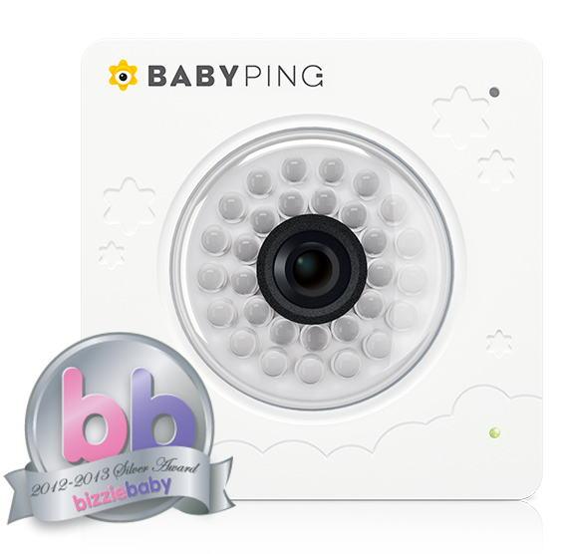
Launched in 2008, the Bizziebaby UK Annual Awards are judged by real families - with each product evaluated by parents in real-life situations. By placing the product in the hands, or nurseries, of those that can truly test their functions and features, the Bizziebaby Awards truly reflect the best products available on the market.

BabyPing offers parents a true alternative to traditional baby monitors by combining the latest technology with the core functionality of a traditional baby monitor to offer parents a smarter way to monitor their baby. Using their iPhone, iPad or iPod Touch, parents or loved ones can now connect to their baby, where ever they are, over Wi-Fi, 3G or 4G.

The real parent reviewers were unanimous in their decisions; “I could easily see my baby on the monitor during the day; the camera itself is very impressive and very clear. The night camera again was surprisingly clear. It definitely gave me reassurance seeing and hearing her especially as a nervous first time mum” with another parent going on to say “It’s a brilliant product especially for nervous first time mothers - with the added bonus of being able to view the camera when outside of the house”

The Bizziebaby Award adds further achievement to the BabyPing monitor, adding to their growing number of accolades which include the Kind und Jugend Innovation Award 2012, Practical Parenting & Pregnancy Gold ‘New to Market’ and Silver ‘Innovative Product (over £30) awards, plus being shortlisted for the soon to be announced ‘Most Innovative Product’ Junior Design Awards 2013.

Spokesperson for BabyPing, James Hunt, commented “This is a superb achievement and we are delighted to gain another award, especially one that is specifically chosen by parents who have tested BabyPing with their families. We understand how important a product like BabyPing can be when providing security and peace of mind for parents, therefore to beat off stiff competition in a category as versatile as ‘best sound and vision monitor’ we are extremely proud.”

For more information about BabyPing, please visit: www.babyping.com.

BabyPing retails at £149.99 and is stocked in leading stores such as Mamas & Papas, JoJo Maman Bébé and is distributed in the UK by Bébélephant - http://www.bebelephant.com/

-ENDS-

Editors’ Notes:

BabyPing Wi-Fi Baby Monitor – Product Code: BABYV002 - RRP £149.99
Website: http://www.babyping.com
Twitter: @BabyPingUK
For further information and images please contact:
James Hunt, james@babyping.com, +44 (0)20 8334 7364, http://www.babyping.com/media

About Bizziebaby

Bizziebaby one of the most advanced review websites on offer to parents with growing families which features online product reviews covering products from pregnancy to retirement. Currently hosting over 11,000 reviews online, featuring in depth reviews from their team of diligent Bizziebaby Testers, Bizziebaby delivers in-depth reviews or real people.

