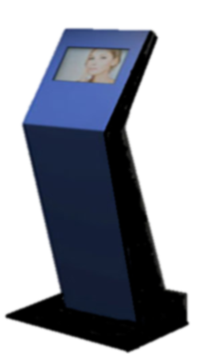vrlogo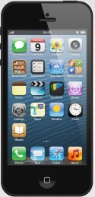

*The Company’s wireless remote systems are newly developed and operate with proprietary software. This version of our software can be used in retail community hotspots, homes or remote environments worldwide, and is sufficient for communications*

*with a much*

*faster connection*

*for processing*

*votes utilizing*

*cloud based servers.*

*This system also allows a novice to secure the vote in any type of election. Results are transmitted within seconds to our*

*secured servers for immediate*

*review.*

*Remote voting can be utilized at*

*home, or on the go (Mobil) from*

*anywhere in the world by going*

*To:* ***www.votritenow.com***

***Caesar IV is a self-contained electronic wireless touchscreen voting machine on a Kiosk application.***

***Global Voting Securely***