For immediate release

Y-cam Solutions announces integration with ASUSTOR
LONDON, UK – Tuesday 14st May 2013 – Award-winning British wireless camera specialist, Y-cam Solutions Ltd, the leading provider of affordable and easy-to-use security cameras, announced today that it has collaborated with ASUSTOR Inc, a leading innovator and provider of network storage solution. All ASUSTOR NAS devices will now be fully compatible with Y-cam IP cameras, providing home and small business environments with an optimal and cost-effective surveillance solution.
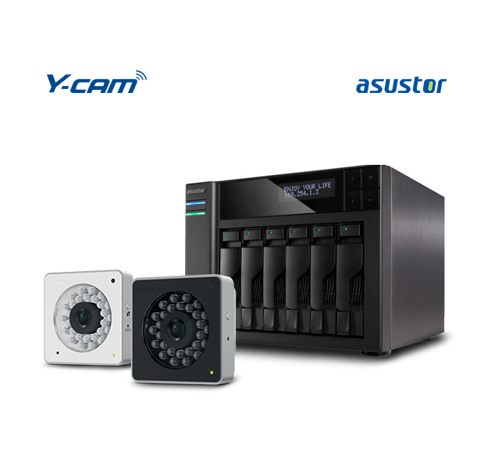ASUSTOR NAS provides users with efficient and stable network storage. All ASUSTOR devices come equipped with cross-platform file sharing and multi-tasking capabilities, making it an optimal platform to build a surveillance system on. As well, all devices come preinstalled with ASUSTOR’s Surveillance Center application. Users need only enable this application in App Central to receive 4 free IP camera channels with which they can quickly set up their own surveillance system. Surveillance Center features a web-based interface that allows users to easily monitor cameras, execute real-time recordings, schedule recordings, playback video and more. Presently, ASUSTOR NAS is compatible with over 100 different IP cameras models from the most popular brands. ASUSTOR’s collaboration with Y-cam Solutions creates yet another reliable and sound surveillance solution for the consumer market.
“Enhancing customer experience has always been our top priority, therefore maintaining compatibility with supporting manufactures that mirror our beliefs in quality, integration and providing future-proof solutions is crucial. ASUSTOR create outstanding recording solutions and we are delighted that this partnership will add an extra dimension of support for all of our customers” explains Commercial Director at Y-cam, Simon Carr. “Y-cam customers are already taking advantage of our extensive compatibility and it’s a pleasure to add the ASUSTOR range of products to this list - further enhancing our customers’ experience by combining their storage expertise and smooth surveillance software with our professional quality IP cameras”
“We are very happy to announce this integration with Y-cam Solutions. ASUSTOR has taken advantage of its expertise in storage and surveillance management to continually expand its support for a growing number of IP camera models and brands,“ said James Su, Product Manager at ASUSTOR. “The ease of use and all around quality of Y-cam cameras have been widely espoused by the European media. This integration will also include the new night vision Y-cam Cube range of cameras as well as their waterproof models, which gives users greater options for 24/7 surveillance both indoor and outdoor.”
All of ASUSTOR’s AS 6 Series devices come equipped with the Intel® Atom™ 2.13 GHz dual-core processor and 1GB RAM (expandable up to 3GB), combining supercharged performance with low power consumption. As well, all devices come preinstalled with the ASUSTOR DATA MASTER (ADM) operating system which features an intuitive and user friendly interface, true multitasking and background operation, and a real-time application search for instant launches. ASUSTOR NAS provides users with features such as cross-platform file sharing, comprehensive backup and data protection solutions and the App Central NAS App library which lets users create an optimized device for business or personal use.
For more product information, please visit: http://www.y-cam.com

-ENDS-

About Y-cam Solutions

Y-cam Solutions Ltd is a British manufacturer of affordable and easy-to-use remote monitoring solutions designed for residential and small-medium business users. Founded in 2005, Y-cam is a young and dynamic company that creates innovative wireless cameras, apps and services that help people stay connected to whatever is important to them. For more information, visit www.y-cam.com and follow Y-cam on Facebook (www.facebook.com/ycamsolutions) and on Twitter @ycamsolutions.

Press contact: marketing@y-cam.com

About ASUSTOR

Founded in 2011, ASUSTOR Inc., a subsidiary of ASUSTeK Computer Inc., is a leading innovator and provider of private cloud storage (network attached storage) and video surveillance (network video recorder) solutions. ASUSTOR is devoted to providing the world with unparalleled user experiences and the most complete set of network storage solutions possible.

Press contact: marketing@asustor.com

Editor’s notes

Y-cam VGA and HD 720 resolution IP cameras are fully compatible with ASUSTOR Network Attached Storage (NAS) drives. Compatibility with Y-cam HD 1080 IP cameras will be added summer 2013.

