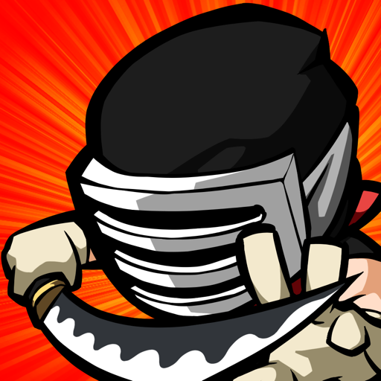
Title: Ninja Wrath

Price: $0.99 USD or equivalent (offers in-app purchases)
Genre: Game / Action / Arcade / Adventure

Developer: XLUSH / Jinho Lee

Availability: iTunes App Store https://itunes.apple.com/app/ninja-wrath/id635492232
App Compatibility:
- Ninja Wrath is compatible with iPhone 4, iPhone 4S, iPhone 5,
iPad 2, New iPad (iPad 3 & 4), iPod Touch 5th gen (16 GB and above).
- Sorry, Ninja Wrath is NOT compatible with iPod Touch 4th gen and lower, iPhone 3GS and lower, iPad 1.

Media/Press Kit, Screenshots, Icon Download: https://dropbox.com/sh/kpnd1xx57zhso04/Udi7vHlcFO?lst
Trailer Video (youtube HD) : http://youtu.be/00H7VZVywAA (also available in above Dropbox link)
Promo/review code request, Media Contact: Ernest Woo / press@contentsfirst.com

==----------------==
App Store Description:
▪ True Arcade Action on the go! ▪ Real ninjas slice bodies, not fruit! Use real arcade controls to become a deadly force of lightning-fast attacks! Pulverize anything that gets in your way with powerful combos and ninja skills!

PRECISE ARCADE CONTROLS FOR ULTIMATE COMBAT
String up deadly attacks and special move combos with responsive, natural controls like never before on the iPhone and iPad. Pick up and play just like the old days, as NINJA WRATH brings back the fast-paced action of classic beat-em-ups right to your hands – this ain’t no “one-button brawler!” Crash the castle, dodge traps and avoid attacks with a quick dash, then strike down your foes where it hurts!

DEFEAT HORDES OF SCUM AND VILLAINY
- Enemies are everywhere across 60+ stages! Lay down the smackdown on waves of flying ninjas from above, clay warriors from below, samurai, yetis, zombie pirates, gunslingers, blade wielders, possessed beasts, brutes, bosses and more!
- Test your mettle and complete missions through Bonus levels, Time Attack and Survival Mode

MASTER THE WAY OF THE NINJA
- Level up your stats to increase strength and attacks, unlock new combos
- Upgrade weapons, customize scrolls and accessories for various booster effects!
- Inflict magical damage to crush, poison, burn, freeze and destroy!

FLUID ANIMATION, TOP-TIER GAMEPLAY
- Every strike, slash and dash has been expertly hand-drawn, animated and optimized for the iPhone
- Rack up Game Center achievements
- Bask in the high-quality sound and music, seamless framerates and hours of addictive non-stop action.

Download now and Unleash your NINJA WRATH!

Follow us on Facebook for the latest updates!
http://facebook.com/XLUSHgames

▪ Compatibility:
- Ninja Wrath is compatible with iPhone 4, iPhone 4S, iPhone 5, iPad 2, New iPad (iPad 3 & 4), iPod Touch 5th gen (16 GB and above).
- Sorry, Ninja Wrath is NOT compatible with iPod Touch 4th gen and lower, iPhone 3GS and lower, iPad 1.
▪ Quotes from our Fans
"Excellent game! Love the integration of swiping, buttons, and the number of combination moves unlocked over time." - Gtrs1
"Ninja Wrath is a hack n slash title with Xbox-like controls and quick stages. A great game that I would fully recommended." - Pocketnova
"Makes you feel like you're actually killing your enemies. Easy controls and lots of combos. The new must have on the App Store!" - Ties Groen
"Fast paced action game that will keep you playing for a long time. You'll keep telling yourself, Just one more game..." -TRB4
▪ Notes:
- We highly recommended that you upgrade your device to the latest iOS version.
- Parents: you can turn off In-App purchasing in the iOS settings.
Check out more games by XLUSH on the App Store!
- Watchtower: The Last Stand
===
Media Contact:
Ernest Woo
press@contentsfirst.com / +1-(347) 422-7655 / skype: w_ernest ###

