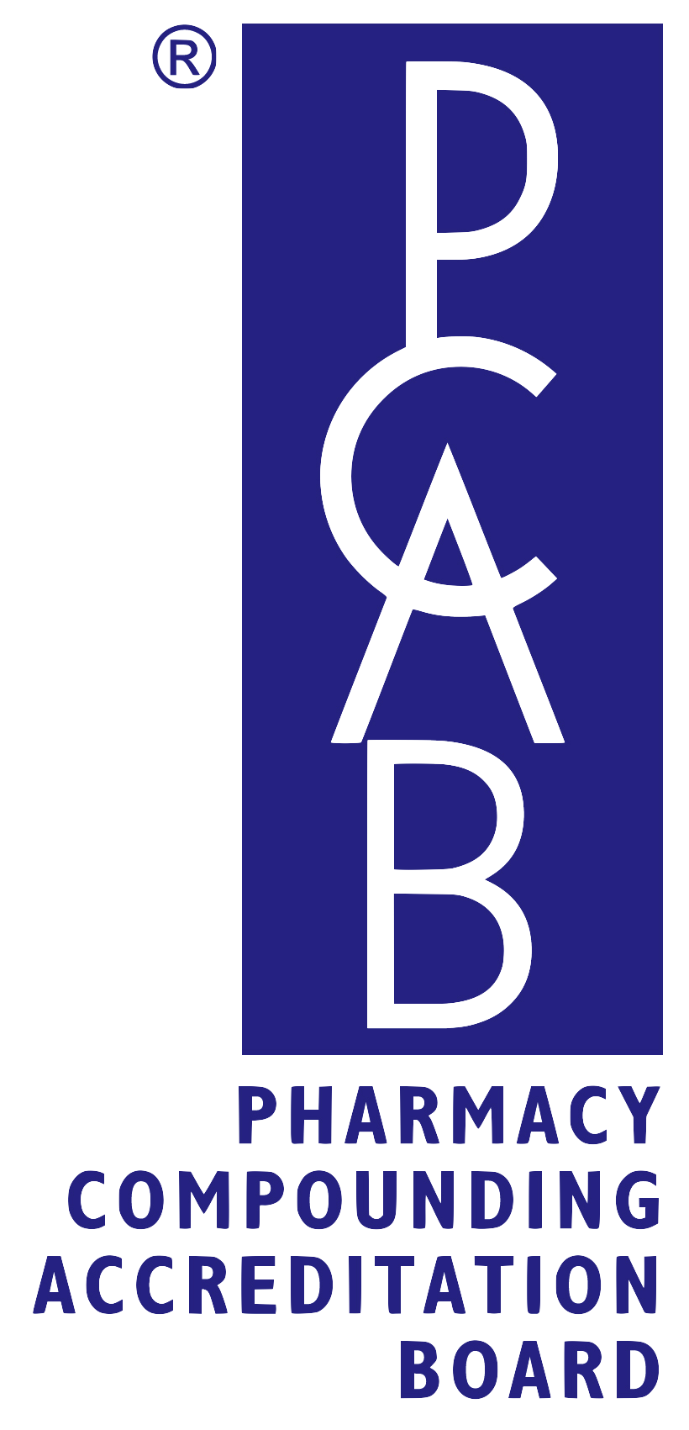
FOR IMMEDIATE RELEASE Contact: Accreditation Services
May 9, 2013 1.866.377.5104, ext. 806

Pharmacy Compounding Accreditation Board (PCAB®)
ANNOUNCES CHANGES IN SURVEY PROCESS
PCAB improves recognition of pharmacy compounding accreditation by implementing unannounced survey policy

Cary, North Carolina, USA--The Pharmacy Compounding Accreditation Board (PCAB®) today announced the approval of its unannounced survey policy for renewal and interim surveys. In a move to improve the accreditation process and garner greater recognition and acceptance of accreditation as a standard for compounding pharmacies, PCAB® rolled out its plans to implement unannounced surveys for compounding pharmacies renewing their accreditation. Unannounced renewal surveys will begin on Sept. 1, 2013.

“Participation in this unannounced survey process is another indication of an accredited pharmacy’s commitment to the adherence to quality standards. This sets accredited pharmacies apart from others in their communities and gives the public another compelling reason to select a PCAB® accredited pharmacy.” said Joe Cabaleiro, Executive Director of PCAB®.

PCAB® accredited pharmacies are very supportive of the unannounced survey policy. When asked what this means to them, they responded:

“We are excited to be one of the first PCAB pharmacies to receive the new unannounced survey because it further demonstrates PCAB’s commitment to quality, and reflects our philosophy to approach every day as an inspection day,” said Eric Everett, Owner of O’Brien Pharmacy in Mission, Kansas.

“We welcome the unannounced surveys,” said Charles Leiter, President and CEO of Leiter’s Compounding Pharmacy in San Jose, CA. “This new process helps level the playing field for all of us. Now if a hospital, patient or doctor needs a compounded preparation and they select a PCAB accredited pharmacy, they can feel comfortable with their decision.”

PCAB® will work closely with currently accredited pharmacies and new applicants to assure that the process of transitioning from announced to unannounced surveys goes smoothly. Participation in this unannounced survey process is a further indication of an accredited pharmacy’s commitment to the adherence to quality standards. This sets our accredited pharmacies apart from others in their communities and gives the public a higher level of assurance in their selection of an accredited pharmacy for their compounding needs.

ABOUT PCAB®
The Pharmacy Compounding Accreditation Board (PCAB®) is a nonprofit organization that provides a voluntary accreditation program for compounding pharmacies nationwide. Formed by eight of the nation’s leading pharmacy organizations, PCAB® promotes, develops and maintains principles, policies and standards for improving the quality of pharmacy compounding nationwide. For more information, visit www.pcab.org.

###

