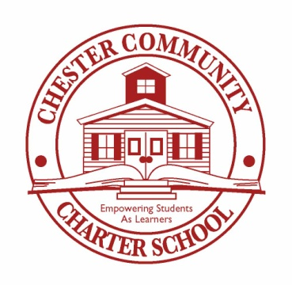
News Release

FOR IMMEDIATE RELEASE

Contact: Meaghan F. Washington
Millennium 3 Management
Tel: (215)-751-0140
Email: mwashington@m3mpr.com

Chester Community Charter School Parents Have Winning Grades, Earn Prizes
Pennsylvania’s Largest K-8 Charter School Rewards This Year’s Most Active Parents at 10th Annual Parents Award Dinner

Chester, PA., June 4, 2013 – More than 200 parents of Chester Community Charter School, the largest K-8 charter school in Pennsylvania, were recognized at the school’s recent 10th Annual Parents Award Dinner, held at the Clarion Hotel, in Essington, PA. Attendees received a catered dinner and a chance to win a television, various electronic devices, and the grand prize, an all-expense-paid trip to Walt Disney World, for their active participation in the Parents’ Report Card program.

The criteria for the Parents’ Report Card are based upon the parents’ contribution to the Parent-Teacher Association (PTA), their children’s completion of homework, attendance, and adherence to the school’s uniform and behavior policies. As a result, Chester Community Charter School has become an institution where parents are expected, and encouraged, to be involved in their children’s academic experience.

After dinner, parents were selected, at random, during a raffle drawing, to receive prizes. Kenneth Baker and his wife, Krystal, were recipients of the grand prize, an all-expense-paid trip to Walt Disney World. Baker, commenting on being the night’s big winner, said, “It’s a great feeling to have your child’s school recognize your efforts, especially with a vacation. Most of us participate in this program, not for the gifts, but, because we love our children and care for their school. Chester Community Charter School is a great place because of the Parents’ Report Card program; it makes us, as parents, even more aware of our children’s interactions in school.”

Dr. David Clark, CEO, Chester Community Charter School, who presented the prizes to the parents, said, “The Parents’ Report Card program is a staple, here, at Chester Community Charter School. We, as administrators, teachers, and parents, hold each other accountable, and together, through this program, improve the quality of education for our students’ success. At our school, the relationship between teachers and parents is not estranged. Both groups communicate effectively with each other to address our students’ needs. We thank all parents, and teachers, for continued support of this program.”

About Chester Community Charter School
Chester Community Charter School opened its doors on September 9, 1998, serving 97 students from its modest, four meeting rooms, in the lobby of the Howard Johnson Hotel. Since that time, the school has steadily grown to include 3,200 students in nine state-of-the-art-buildings, spanning two campuses. http://chestercommunitycharter.org

-MORE-

Photo Captions

Photo 1

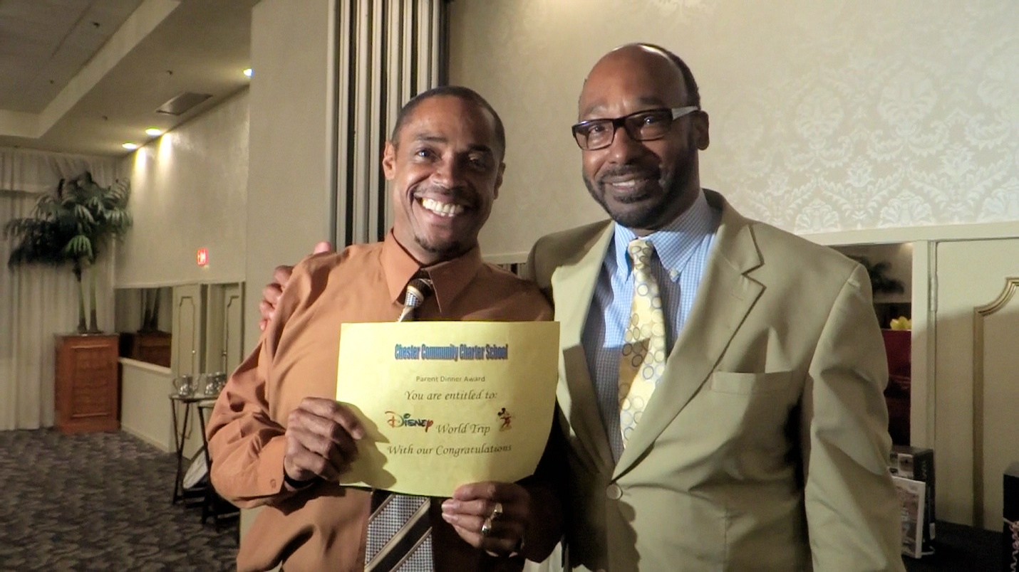
Caption 1
Kenneth Baker (left) stands with Dr. David Clark, CEO, Chester Community Charter School (right), at the recent Parents Award Dinner, where Baker and his wife, Krystal (not pictured), won an all-expense-paid trip to Walt Disney World for their participation in this school year’s Parents’ Report Card program. Parents are graded based upon criteria set by school administrators and faculty. The top 200 parents, with the highest grades, were invited to the event, where they were treated to a catered dinner and were included in a raffle drawing for the chance to win various prizes.
Photo 2
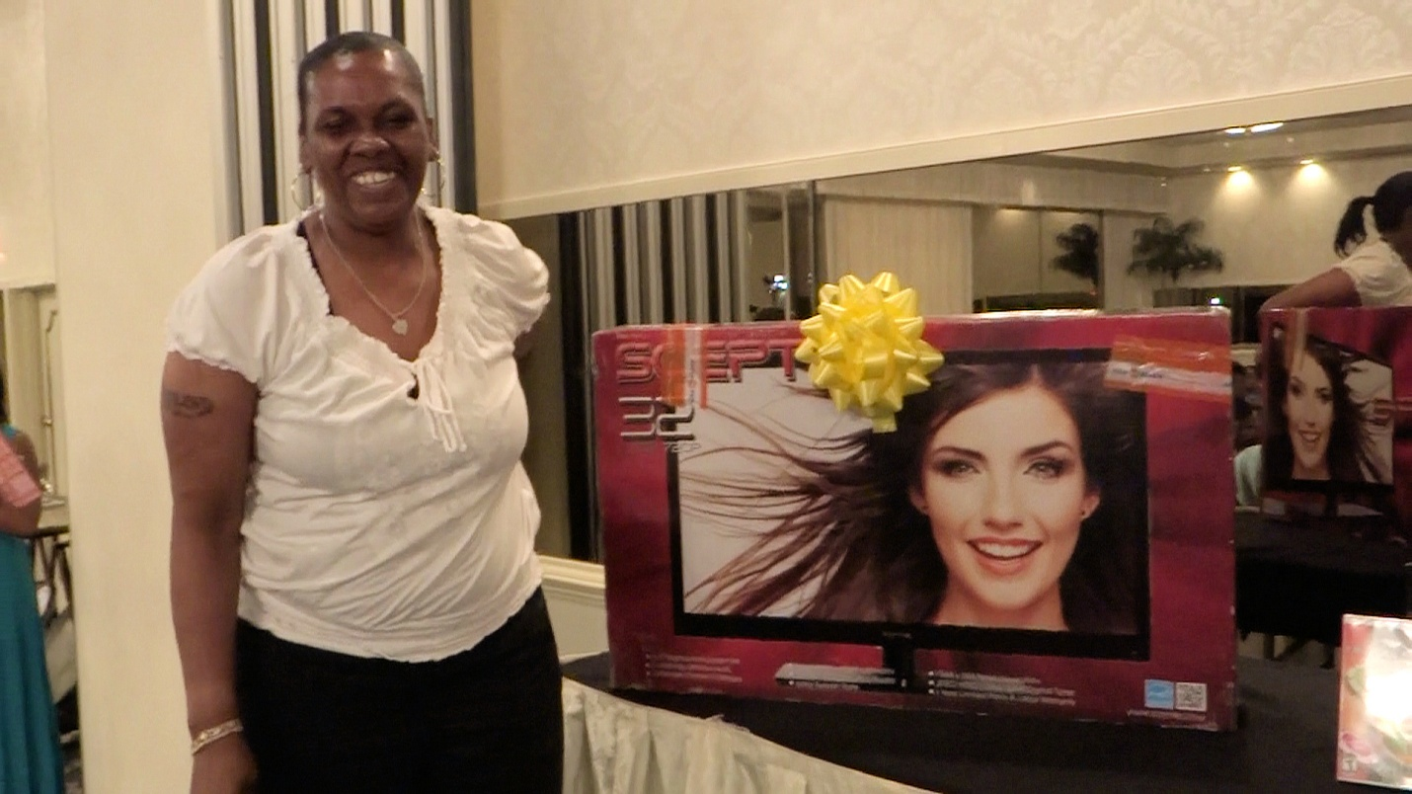
Caption 2
Approximately 200 parents attended Chester Community Charter School’s recent Parents Award Dinner, where attendees were publicly recognized for receiving the highest grades on their Parents’ Report Card. Parents were graded based on their contributions to the Parent-Teacher Association (PTA), their children’s completion of homework, attendance, and adherence to the school’s uniform and behavior policies. Shirley Spence (left), a parent in one of 11 families selected as winners in the dinner’s raffle drawing, poses with a 32” flat screen television, which she won at the event.

Photo 3

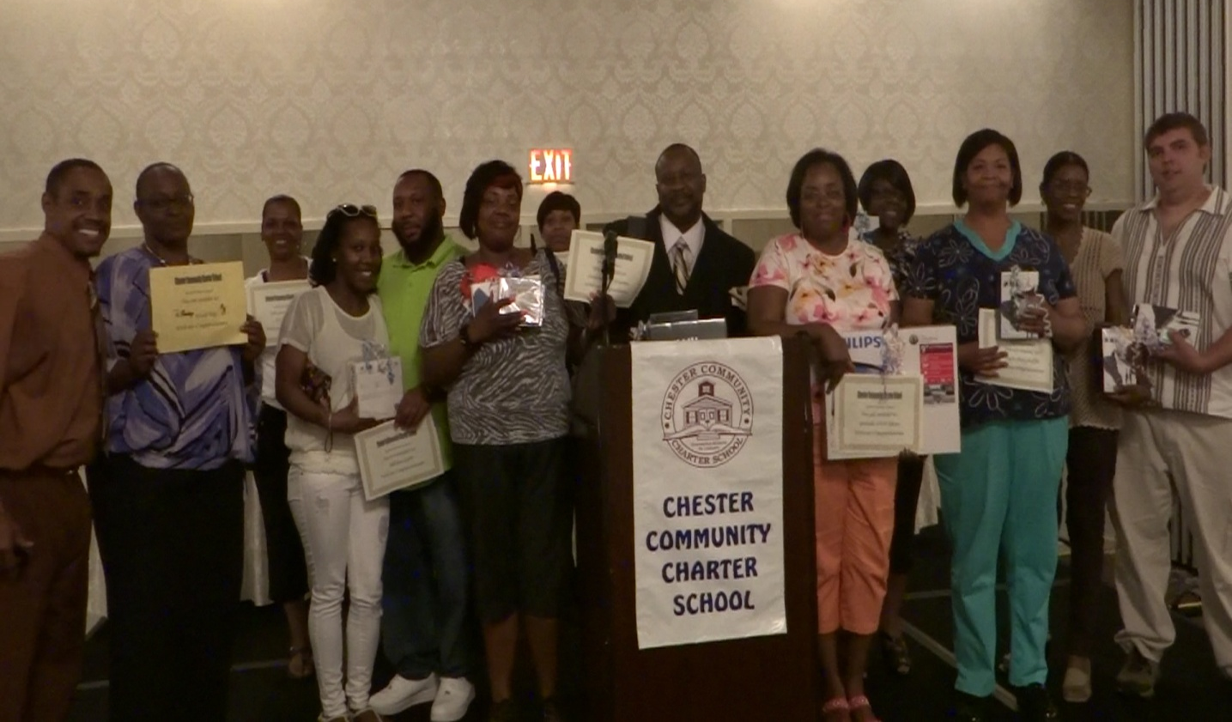

Caption 3
At the recent Chester Community Charter School Parents Award Dinner, approximately 200 parents were treated to a catered dinner, and 11 families (pictured), were selected, from a raffle, to win prizes that included a 32” flat screen television, four iPod shuffles, a Kindle Fire, a portable DVD player, a Wii gaming console, a Nintendo DSi, a TomTom GPS navigation device, and the grand prize, an all-expense-paid trip to Walt Disney World. Parents were invited to the dinner and received gifts for their participation in this year’s Parents’ Report Card program. Their children’s teachers graded them throughout the school year, based on their contribution to the Parent-Teacher Association, their student’s completion of homework, attendance, adherence to the school’s uniform policy and behavior.
###

