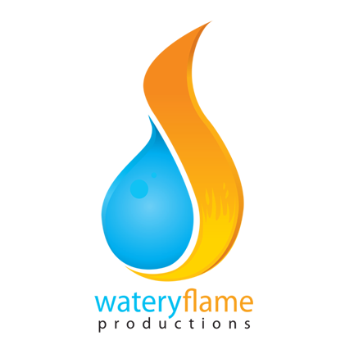
FOR IMMEDIATE RELEASE
Contact: Sarah Urban
Phone: 702/ 469-0613
email: sarah@wateryflameproductions.com

VEGAS ARTS AND ENTERTAINMENT SECTORS SEE INDUSTRY REBIRTH:
Crowdfunding Helps the Downtown Project Turn Economic Recovery into Boom

With the Downtown Project making international headlines with its plan to revitalize Downtown Las Vegas, it seems no wonder that the art and entertainment industries there are finally recovering from decades of neglect and the economic crash of 2007. What is spoken of less frequently is the role that crowdfunding is playing in that recovery, as artists and media persons of all stripes reach out to the Internet to create their personal vision. Practically unmentioned are the indicators that this recovery is rapidly shifting into a boom, fueled by a public hungry for entertainment but unwilling to spend on Hollywood any longer due to past disappointments.

Crowdfunding sites like Indiegogo have been vital to the rebirth of the arts and entertainment sectors. From independent First Friday artists to the “Save the Historic Huntridge Theater” grassroots campaign to celebrity infused documentary films like “The Last Formula”, the laidback format and versatility of crowdsourcing seems like the ideal vehicle to fund New Downtown. It matches the funky eclectic emerging spirit in the area, as a variety of personal artistic visions fuse to create a culture that manages to be both offbeat and upscale.

Local filmmaker and long-standing member of the Las Vegas film and television community Denny Morales, producer of The Last Formula, first heard about the benefits of crowdfunding when he attended a local boot camp on the subject. Morales is pleased to put all that he learned there to great use, with his celebrity packed documentary bringing the Downtown cycle full circle by including Tony Hsieh as an interviewee.

“I feel that The Last Formula is something desperately needed and missing in society. It is meant to help enrich people’s lives, for people to live out the dreams of their careers and lift morale and spirit within the business world. This is what the project of downtown Las Vegas is all about, it’s about enriching ourselves and our businesses, which leads to enriching the community, therefore our lives and the lives around us. Crowdfunding can help bring these things to people. If they want it, they will ask for it, and will know to fund it.” To learn more about The Last Formula, you can visit its Indiegogo website page .

Whether merely a recovery or the beginning of a true economic boom, the Las Vegas Art and Entertainment scene shows all the markings of an impending force to be reckoned with. Perhaps the long wait for culture in Las Vegas is nearing an end, albeit with a fresh and colorful result.

Watery Flame Productions is a company established in 2011 as a creator of personally enriching and spiritual content. Their upcoming docu-film, “The Last Formula” is scheduled to be released in June of 2014.
# # #
If you'd like more information about this topic, please contact Sarah Urban with the information above.

