FOR IMMEDIATE RELEASE

Carpet Maker Beaulieu® Announces Summer Sweepstakes and Manufacturer’s Rebate
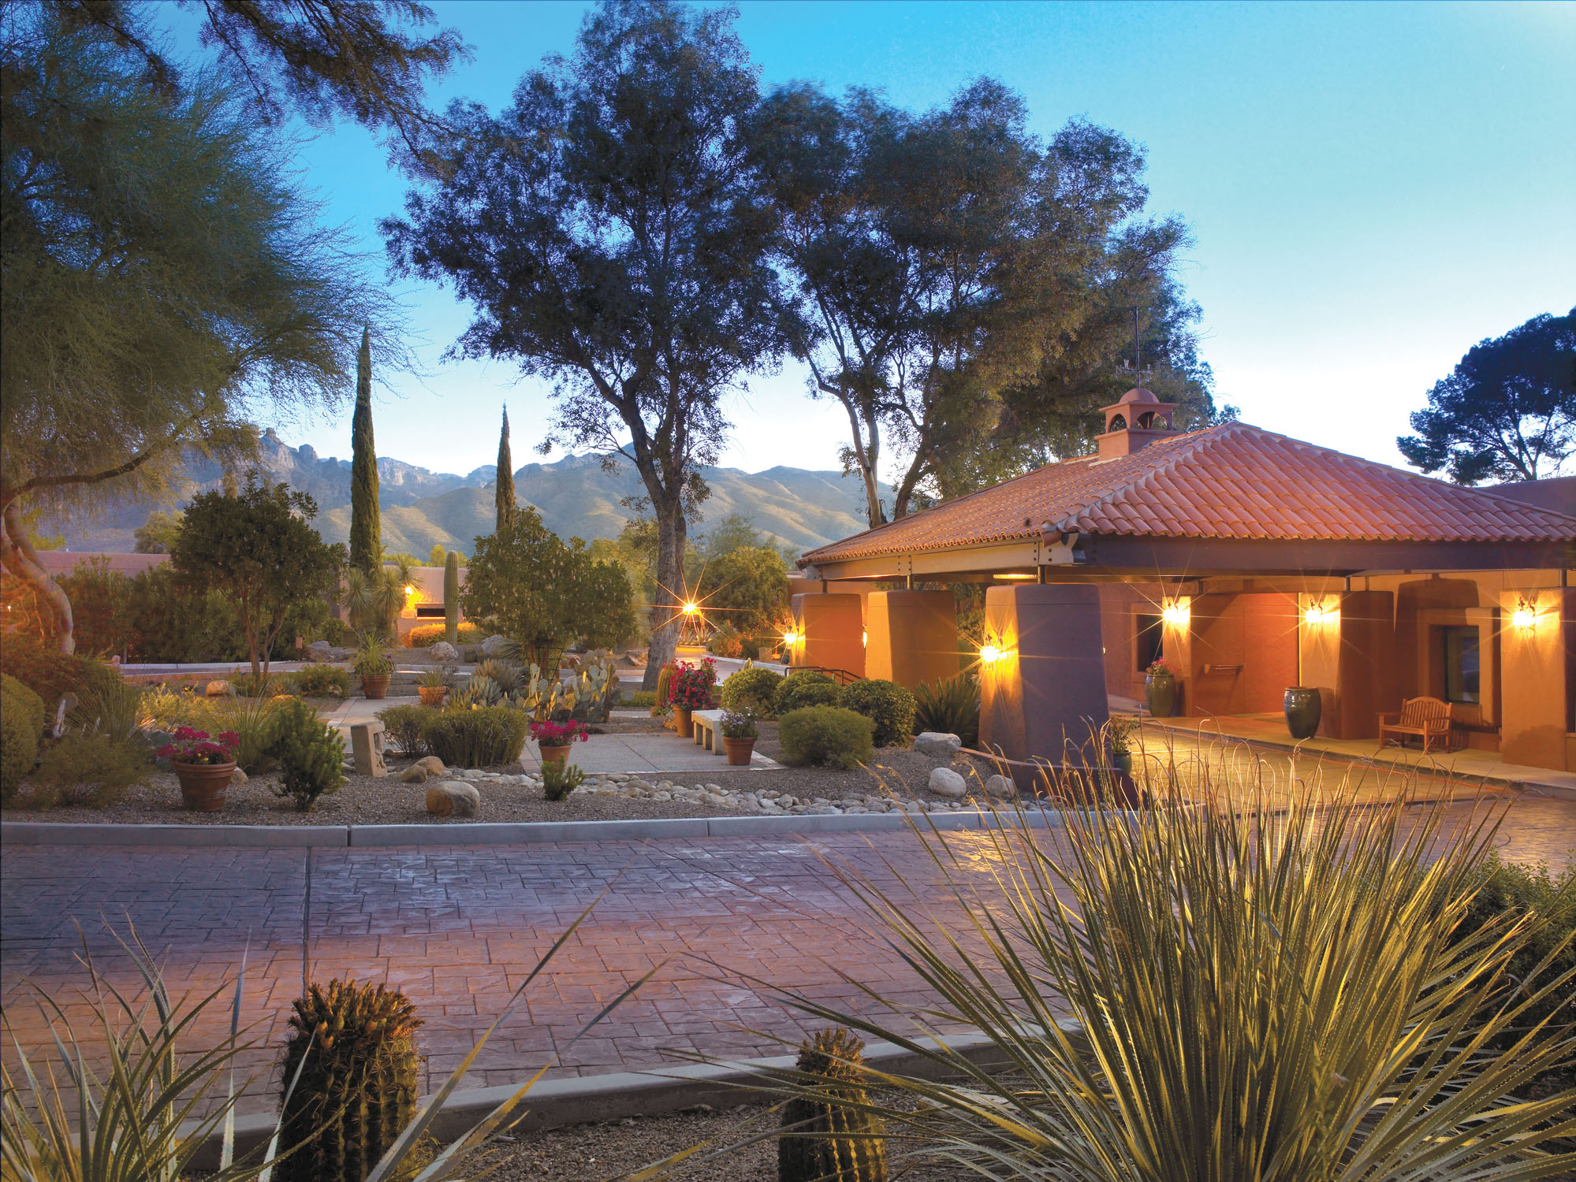
DALTON GA, June 25, 2013– To support its new Bliss Indulgence™ super-soft solution-dyed nylon collection, carpet maker Beaulieu America announces “The Bliss Indulgence Sweepstakes” with the top prize of an all-expense paid, 5-night trip for two at the world famous Canyon Ranch® resort in Tucson, Arizona. The sweepstakes starts July 1 and goes through September 30. Beaulieu will also offer a $100 manufacturer’s coupon rebate on 40 yards or more of Bliss Indulgence carpet purchased during the promotion period.

“Our grand prize goes perfectly with our luxuriously super-soft Indulgence line,” commented Mike McAllister, Director of Marketing for Beaulieu. “The same prize will also be available to win by some lucky Bliss Indulgence dealer.”

In addition to the grand prize of a get-away trip to Canyon Ranch, there will be 2nd place winners of $500 Amex Gift Cards. Consumers can enter the sweepstakes by going to BlissFlooring.com and there is no purchase necessary. Complete rules are at BlissFlooring.com and at participating Bliss Indulgence dealers.

NO PURCHASE NECESSARY. A PURCHASE WILL NOT INCREASE YOUR CHANCES OF WINNING. Must be legal resident of the 50 United States (D.C.), 21 years or older as of the start date. Sweepstakes ends 9/30/13. For entry and official rules with complete eligibility, prize descriptions, odds disclosure and other details, visit www.blissflooring.com. Sponsored by Beaulieu Group, LLC. Void where prohibited.

For more information, contact: support@blissflooring.com
To learn more about Beaulieu of America and its collection of quality carpets, visit: www.BlissFlooring.com

About Beaulieu America

Beaulieu America makes carpet for residential, commercial, and specialty markets. Headquartered in Dalton, Georgia, Beaulieu designs, manufactures and markets BLISS carpet for residential replacement, HOLLYTEX main street commercial carpet, BOLYU carpet for specified commercial, AQUA carpet for the hospitality industry.

About Canyon Ranch Resorts
Visit www.CanyonRanch.com

Beaulieu®, Bliss®, Hollytex®, BOLYU®, and Aqua® are registered trademarks of Beaulieu Group, LLC

