
N E W S R E L E A S E

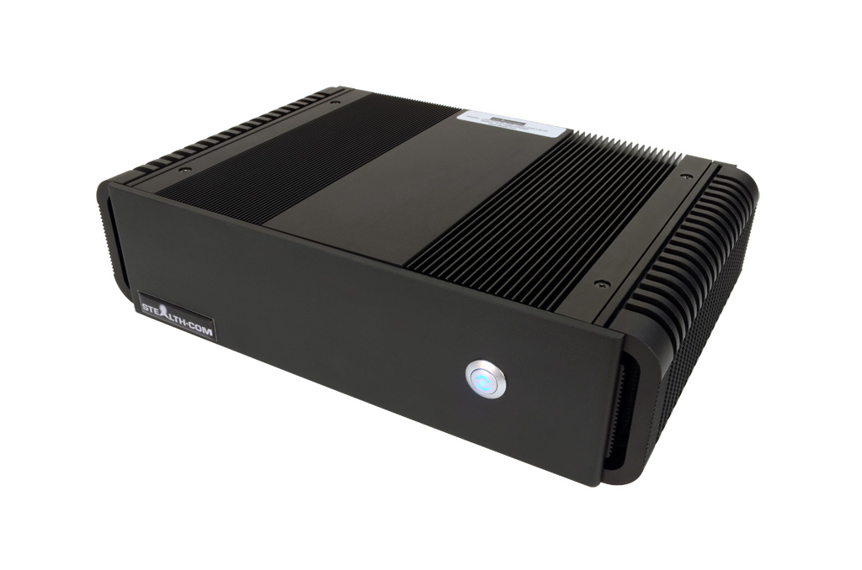
FOR IMMEDIATE RELEASE
Contact: Andrew Pakula, 905-264-9000 ext #243
marketing@stealth.com

For high quality digital images
of this product, click here.

Stealth.Com Introduces a New Powerful Fanless Mini PC
with PCI or PCIe Expansion Slot Capability

Toronto / San Jose ~ July 2013 – Stealth.Com Inc. (Stealth Computer), a leading ISO 9001 manufacturer of industrial rugged computers and peripherals has released a new powerful Fanless Mini PC model LPC-700F featuring built-in PCI or PCIe expansion slot capability.

The LPC-700F outperforms other small sized PC systems due to the integration of the latest Intel® 3rd Generation Core™ i7 mobile processors. The LPC-700F ships standard with an Intel® i7 Processor 3610QE CPU exceeding the performance of computers many times its physical size. The LPC-700F fanless mini PC features a multitude of I/O connectivity built directly into its impressively small design such as; 4x USB 3.0, 6x RS232/Serial, 2x Gigabit LAN ports, VGA, DVI-D & HDMI video connectors and Audio In/Out. The LPC-700F fanless computer comes standard with a 128GB solid state drive (SSD).

“Our new Stealth Model: LPC-700F is the most powerful and technologically advanced fanless PC we have introduced to date. Our full featured machine features built in PCI or PCIe expansion card slots for applications requiring additional expansion capability”, stated Ed Boutilier CEO of Stealth.com Inc.

Stealth.Com Introduces a New Powerful Fanless Mini PC with PCI or PCIe Expansion Slot - Page # 2

Stealth's LPC-700F is a powerful diminutive computer that operates without noisy cooling fans that could draw in dirt and dust potentially causing catastrophic failures. Stealth's fanless computers are encapsulated in a rugged extruded aluminum chassis performing as a heat sink to dissipate heat build-up.

Systems are compatible with Microsoft Windows 7/8/XP, Linux etc and can be custom configured to meet the exact needs of the OEM or end user. RAM memory is expandable to 16GB for additional performance requirements. The LPC-700F is currently shipping with base pricing starting at $1995.00 USD.

Stealth’s LittlePC products serve a demanding market where small and powerful solutions are being deployed in space-challenged applications around the world. Embedded Control, Digital Signs, Kiosks, Mobile Navigation, Thin-Clients, POS & Human/Machine Interface are just a few of the applications that are ideal for Stealth’s industry trusted products.
About Stealth
Founded in 1990 Stealth.Com, is a leading manufacturer of specialized Computers and Peripherals. The company is ISO 9001 registered and continually develops innovative products designed to meet the exact needs of their clients. For over two decades Stealth has provided thousands of proven reliable product solutions that have assisted clients with a myriad of applications. Our impressive customer base includes a wide range of customers from single man operations to Fortune 500 companies, Military installations and Governments worldwide. www.stealth.com
#########
For more information, press only:
Andrew Pakula, Stealth Computer, PH: 905-264-9000 ext #243
E-mail: marketing@stealth.com
For high quality digital images of Stealth’s products (300 DPI): www.stealth.com/photos
Stealth’s main website and corporate information is available at: www.stealth.com

