Press Release Contact
For Immediate Release Finitely International
International Media Dept.
+39 045 8101447
media@vinitalytour.com
www.vinitalytour.com
Twitter: @VinitalyTour
Join Vinitaly International Network on LinkedIn

Since when has Vinitaly started selling wines online?
Vinitaly from off-line to online, an instrumental to penetrate China

Verona, 10th August 2013 – Vinitaly has traditionally been known as the world’s largest wine fair. Vinitaly Wine Club, instead, is the innovative e-commerce platform launched by Vinitaly in April this year, and plans to travel to China to partake in an expanding online wine market. At a time when counterfeited wines are on the rise in the Middle Kingdom spreading fear among local wine consumers, Vinitaly Wine Club seeks to act as a guarantor of original Italian wines by offering Chinese wine drinker the opportunity to buy top quality bottles directly online.

According to CAWS, China ranks as the 5th Wine Market in the World and 1st in Asia since 2011 with 390 million litres of wine (USD 1.5 billion worth) imported in 2012.
In the same year, E.U. wine exports accounted for more than half, with Italian wine ranking at the 5th place and taking up an 8% import volume and a 6% import value market-share (vinitalytour.com, 8 April 2013 - http://tinyurl.com/qd2wppd).
Amid China’s booming wine market, though, supermarkets and restaurants are experiencing an increasing threat from counterfeit wines, particularly in second and third tier cities where consumers have less knowledge of wines and are not able to distinguish an original bottle from a counterfeit one. Given the high margins and the demand, the phenomenon seems to have particularly hit European Fine wines, with France being the most affected: imports from the country account for more than half of the total from Europe. The most talked about counterfeited bottles seem to be the top Bordeaux labels but less-prestigious and lower-priced ranges of wines are abundant as well.

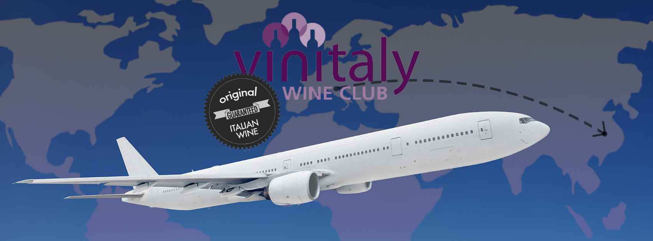

“Currently, online wine sales are dominated by the French and often Italian wines tend to be scarce and highly priced compared to wines from other countries. Vinitaly Wine Club plans to fill this gap by supplying high quality and more affordable mid-range wines.”, affirms Stevie Kim, who leads Vinitaly International. “Our mission is to help Italian producers sell one more bottle of wine offline through our many B2B platforms. Now we are also ready to facilitate them through the Web. We wish to introduce Chinese consumers to the great diversity of Italian wines and offer them the opportunity to try different bottles at an affordable price, without compromising the authenticity of their origin.”

After redefining online wine sales in Italy and, more recently, in the UK, Vinitaly has been intensifying talks with Chinese Giants in on-line trade such as Vinehoo and Tmall with the aim at reaching an agreement for the launching of Vinitaly Wine Club in China.

About:
Veronafiere is the leading organizer of trade shows in Italy including Vinitaly (www.vinitaly.com), the largest wine event in the world. The 47th edition of Vinitaly counted some 148,000 visitors (+6%), of which 53.000 were international attendees (+10%) visiting from 120 countries. On 95.000 square meters, 4.200 exhibitors welcomed trade professional, media and producers alike. The next instalment of the fair with take place on 6th-9th April 2014. The premier event to Vinitaly, OperaWine (www.OperaWine.it) “Finest Italian Wines: 100 Great Producers” will unite international wine professionals on April 5th 2014 in the heart of Verona. Veronafiere also created Vinitaly International www.vinitalytour.com in 1998 to develop a global platform for the promotion of companies in the Italian wine and food sectors.

Vinitaly Wine Club manages an exclusive Wine Club, which offers members access to some of Italy’s finest wines at great prices as well as weekly offers and limited edition wine collections. The innovative e-commerce platform also features a premium online Wine Shop with an ever changing collection of over 200 Italian wines and producers, selected by Vinitaly Wine Club staff in collaboration with its leading partner, Slow Food.
###

