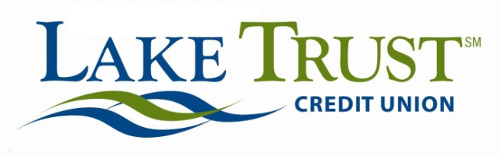
News Release
For Immediate Release

Website: laketrust.org

Lori Anderson
734.462.7242
landerson@laketrust.org

Lake Trust Credit Union Welcomes Jack Martin, Vice President of Information Services

Lansing, Michigan – Lake Trust Credit Union is excited to welcome Jack Martin, Vice President of Information Services. Martin will be responsible for directing strategic planning, security development and monitoring the areas of Lake Trust’s Information Services Department.

Through his education, 15 years of team management and over 20 years of tech experience, Martin brings with him a wealth of knowledge in the Information Systems area. Martin earned a Bachelor of Science degree in Computer Science from Central Michigan University. Previous to his role at Lake Trust, Martin was Director of Application and Integration Services at Citizens Republic Bancorp, Inc., and was responsible for managing and supporting all computer applications and technology services aligned to corporate project activities. Prior to that, Martin managed Packaged Software Solutions at R.L. Polk. He’s also held positions at Pfizer Global Research & Development and Michigan National Bank.
“It’s been a great pleasure to accept this position with the Credit Union,” said Martin. “Lake Trust shares my passion for providing quality experiences to the people whose lives we touch: our members and teammates, and I’m really looking forward to being a part of that.”

Through his leadership, Martin will work to maintain and create successful relationships and integrate new, beneficial procedures to benefit both the organization’s members and staff.

“We’re thrilled to have Jack on the team, and we’re looking forward to learning everything he has to teach us,” said Lake Trust Credit Union President and CEO David Snodgrass. “We’re excited to see the benefit that his commitment and knowledge will bring to our members and Team Lake Trust alike.”

Lake Trust Credit Union, as Michigan’s fourth largest credit union and headquartered in Lansing, stretches from Lake Michigan to Lake Huron and Lake Erie. More than $1.5 billion in assets and 21 branches strong, Lake Trust provides its almost 158,000 members best-in-class products and offers individualized, trust-based member service. Membership is open to anyone within its 35-county service area. Learn more about Lake Trust Credit Union at laketrust.org.

