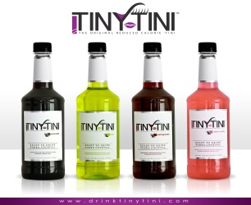
Contact: Aaron Walton For Immediate Release
Public Relations Specialist
Office Direct: 775-741-5041
EM: walton.aaron2@gmail.com

Shake Things Up With a Unique Food and Martini Pairing

TinyTini is making meal pairing fun and interesting again! Food and wine pairings have been popular for years, and beer dinners are increasing as well in the food scene. This season you can shake things up and get creative with TinyTini.

TinyTini is the original reduced calorie, ready-to-drink martini. Created by martini connoisseurs Derek and Jamie Asmis, TinyTini provides a higher alcohol content of 18 percent in four unique flavors: Pear, Pomegranate, Cotton Candy and Chocolate. All flavors have a low calorie count, with only 35 total per ounce. These chill and pour pre-mixed martinis are versatile and delicious, and work great with any meal.

“Although food and wine pairings are fun, TinyTini gives you the opportunity to do something new by pairing your food with one of our four chill-and-pour martinis,” said Derek Asmis, COO of TinyTini.

Babe Matteri’s, a restaurant with American inspired cuisine, recently created a steak dish to be specifically paired with TinyTini’s chocolate martini, showing that the chill and pour drink goes well with any meal.

“The sweetness of the chocolate martini pairs well with the spicy crust on the steak and is counter balanced with the chocolate demi glaze,” said Steve DiPietro, chef at Babe Matteri’s. (See recipe below)

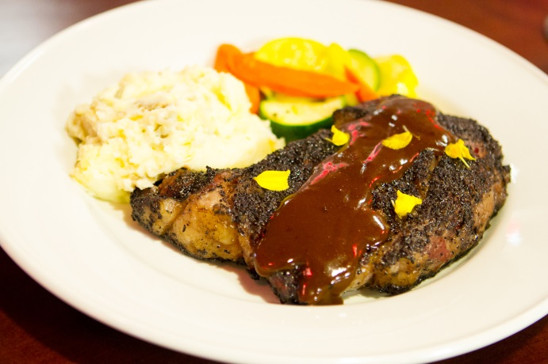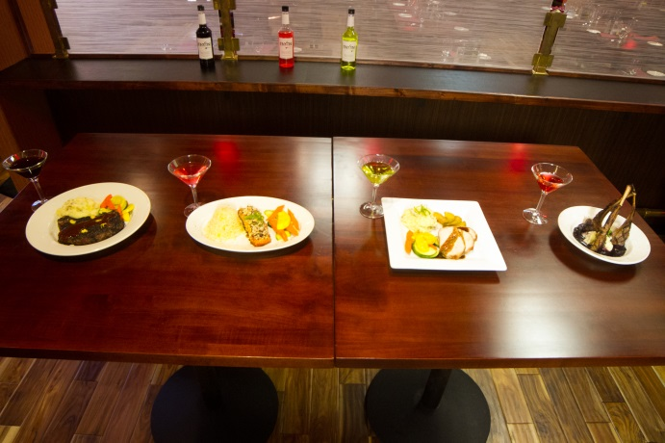
Babe Matteri’s cocoa crusted steak and sauce Shake things up with a unique food and
(Recipe below) martini pairing.

Babe Matteri’s Cocoa Crusted Steak
4 Tablespoons ground coffee
1 Teaspoon pepper
1 Teaspoon salt
1 Teaspoon garlic
1 Teaspoon onion powder
1/4 Teaspoon Cayenne Pepper.
-Combine all ingredients and cover both sides of the steak.
-Sear steak on both side and finish in oven to your preferred liking.

###
TinyTini was founded by Jamie Asmis to satisfy the desire for best-of-class martini flavors with fewer calories. TiniTini’s mission includes a sustained commitment to creating contemporary, innovative, and appealing spirit-based adult beverages in the US that provide a guilt-free indulgence and a delicious drinking alternative.

If you would like more information, please use the contacts provided above or visit: http://www.DrinkTinyTini.com and Facebook: https://www.facebook.com/DrinkTinyTini

