Your first bike, do you remember the joy it gave you? Would you like to be a part of an event that will help raise bikes for children this holiday season? BikesForGood will be leveraging social media to challenge 100 cities to each raise 100 bikes that will be donated to deserving children this holiday season. A goal of 10,000 bikes while audacious- we believe is achievable- partly in fact due to prior successes. However we can’t do this alone, and need your help.
How you can help: Pick your level of involvement
- Follow, Like, Tweet, Share, and Pin us on social media.
- Send us a photo of you and your bike with a sentence of encouragement mentioning BikesForGood.
- Make a 1-2 min. YouTube video about your 1st bike, and mention BikesForGood; send us link.
- Share BikesForGood with friends and coworkers.
- Want to be more involved? Have other ideas? Please email Steve@BikesForGood.org.

Background:
Gunnery Sergeant Steve Gardner, received a community service award from the state of Virginia for his efforts running 1/3 of Virginia’s Toys-for-Tots program during the late 90’s and helped raise over 5,000 new bikes for the children of Roanoke, VA. (Reference: http://tinyurl.com/BikesForGood ).
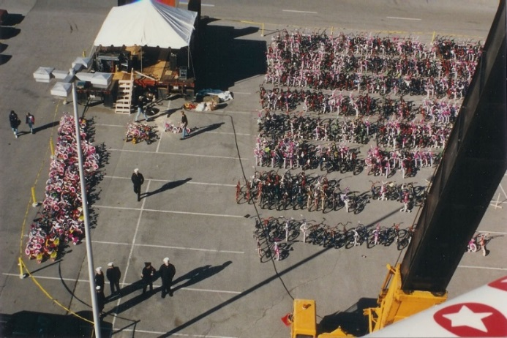  Sea of bikes collected at Roanoke, VA. in the 90's | Steve’s vision is to inspire the world to donate 1 Billion community service hours. BikesForGood is a way of building on the Roanoke, VA’s bike collection and helping children across the USA (and maybe the world) realized the joy of receiving a bike and the lifelong enjoyment that can follow.  Consider helping put a smile on a child by simply following on twitter, posting a pic, or sharing an encouraging video, and consider sharing with your friends this challenge to society.  100 Cities x 100 Bikes  BikesForGood is in the process of becoming a 501©3 tax exempt organization, and is part of Challenge2Society, a registered Virginia benefits corporation, member of 1%ForThePlant, and Richmond2015-(World Cycling Championship race to be held in Richmond, Va.)  Steve can be reached directly: Steve@BikesForGood.org
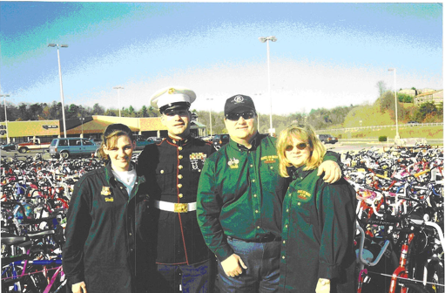
GySgt Steve Gardner & friends at end of the 90's bike event

