Sandhi Schimmel Gold
Paper Mosaics - Mixed Media Artist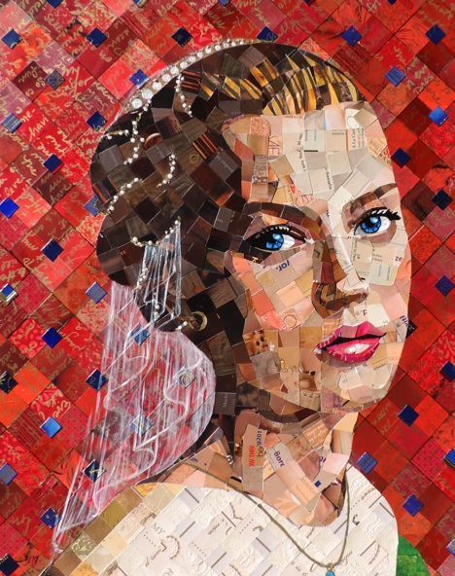
“Rennassance”
Call it Paper Mosaic, call it Recycle Art, call it Mixed Media, call it Papier Collé...

Sandhi embraces a refreshingly innovative art form which transforms her original paintings into fascinating Papier Collé Mosaic Portraits. They are beautiful, tactile adventures which reflect on beauty, and promote positive energy. Using precision and skill, unrelated text, images and symbols are juxtaposed to form compositions that mimic ancient mosaics while referencing pop art, celebrity culture, ancient history, fashion or an emotion.
This primarily self-taught artist’s style is ever evolving, but defined by a common thread.
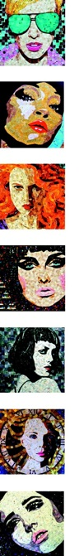
A visionary pioneer in the green fine art movement, Sandhi’s collection is a balance of elegance, creativity and environmental impact. Only water-based, acid-free and non-toxic materials are used.
Her work graces the walls of private collectors' homes, is featured in numerous corporate collections as well as permanent museum collections.

If a picture is worth a thousand words...
these are made from thousands more.

“My work reflects society's obsession with beauty in advertising; images that bombard us daily. I re-imagine those pictures and reuse the paper in my work. My mosaic portraits are a purposeful intermix of advertising messages - junk mail, postcards, etc. that arrive through my mailbox. I hand cut, sort and manipulate thousands of pieces to assemble a newly envisioned portrayal of beauty - and the story behind the eyes - an eclectic and highly textured portrait, utilizing materials that would otherwise go to waste."
- Sandhi Schimmel Gold

