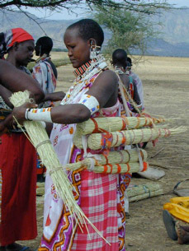 

Harvested Zulugrass Maasai beadmaking

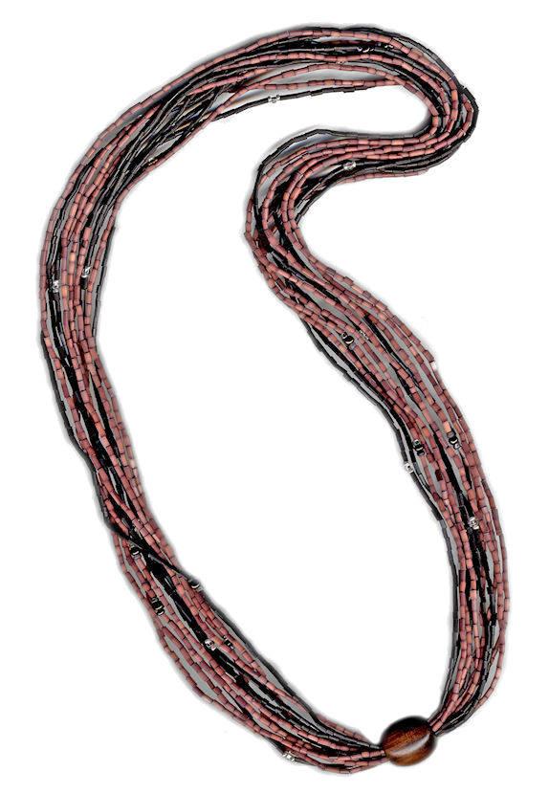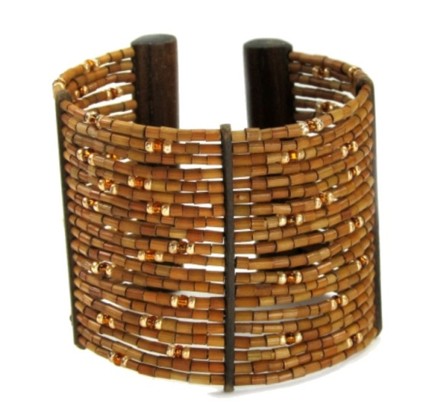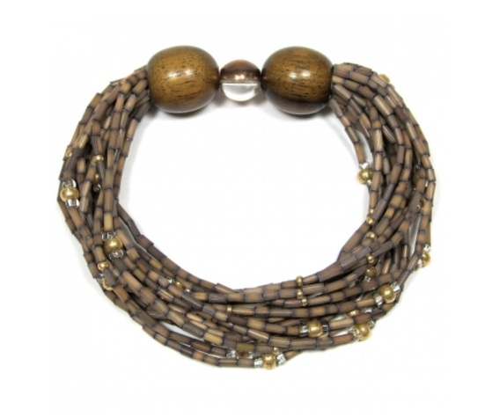

Olkerii Zulugrass Necklace Zulugrass Cuff Bracelet Multi-Strand Bracelet