Scribble Mirror
Now that I have talked of why you stopped being an artist and why you should start now let us start with your very first warm up exercise.
You scribble, scribble and scribble.
Preferably use your non dominant hand, if you are right handed use your left hand and vice verse and also close your eyes while scribbling. Try to fill the entire paper.
The idea is to scribble without your brain being able to control it. To achieve this you close your eyes and use your left hand so your "thinking brain" cannot control on what you are scribbling. You should scribble so as to fill your paper. You can open your eyes intermittently to check whether you filled the entire paper.
Once done open your eyes for good and see if you see any pattern emerging, much like you can see a camel or a shoe in clouds. Highlight the pattern that emerges with a bolder strokes or just fill it with colour. If you cannot see anything walk away from it for a little while and you will see something after the break. Once you identify you will find a new art vocabulary emerging... A cute fish, an unlikely caricature here, a strange animal there.
What you find emerging in scribble will be highly abstracted motifs of what you see in day to day life. May be what you think is a shoe may look like fish to someone else. A flower to your friend may look like a poodle to you. So the patterns you see emerging will be unique to you. Do not try to make any sense of it, or understand why you see what you see, just keep doing this without thinking consciously.
Repeat these exercises over and over as many times as you want. You may find it silly but doing this actually frees you up and relaxes you.
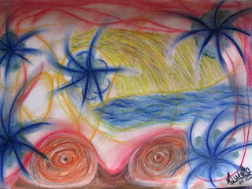
The attached image is result of one my exercises. I did this one with three colours initially. Then I enhanced the patterns I saw and coloured some other portions and added repeated structures from my initial drawing to make a pleasing picture. Initially in its raw form it was completely meaningless.. You can still see the lines running across the picture.

