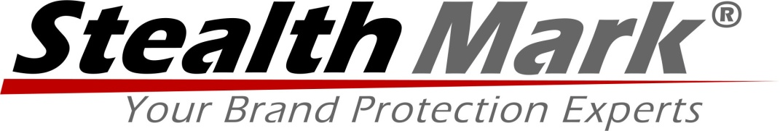

Brand Protection Provider Stealth Mark Partners with the Lauterbach Group for Advanced Security Labeling

The partnership provides state-of-the-art security solutions for any organization that seamlessly integrate into existing manufacturing and distribution supply chains.

Centerville, MN – December 5, 2013 – Stealth Mark, a leading provider of brand protection security solutions, announced a new partnership with the Lauterbach Group to provide the most advanced security labeling solution available on the market. The labels incorporate the sophisticated security technologies of Stealth Mark with the advanced security printing capabilities of the Lauterbach Group, providing state-of-the-art brand protection for any organization.

The combined offering from Stealth Mark and the Lauterbach Group provides a complete solution for product authentication throughout the entire supply and distribution chains. The solution is based on patented encrypted microparticle technology, state-of-the-art printing technologies, and a reader that can be used with an iPhone. The reader, working in conjunction with Stealth Mark’s serialized track and trace software, authenticates the microparticle mark and captures the unique ID, location, QR code, and any other information our clients want to track.

Stealth Mark and the Lauterbach Group have provided solid security in an easy-to-use labeling format that is not intrusive to existing operations or branding strategies. Learn more about the partnership at www.stealthmark.com.

# # #

About Stealth Mark
Stealth Mark is a global product authentication solution provider specializing in brand protection. Offering one the most advanced product security solutions, we protect companies and governmental agencies from unauthorized reproduction (counterfeiting), diversion or theft of their most valued assets. For years, Stealth Mark has delivered security solutions that emphasize four key principles: security strength, ease of implementation, authentication speed/simplicity, and total cost of ownership.

For a more comprehensive brand protection solution, visit www.stealthmark.com, and follow Stealth Mark at www.twitter.com/stealthmark.

“Our partnership with the Lauterbach Group allows Stealth Mark to take a huge step forward in helping our customers protect their brands, by providing a solution to reduce the chances of their products being counterfeited that is cost effective, easy to deploy and virtually impossible to detect,” said Mike Ducatelli, CEO of Stealth Mark.

CONTACT
Mike Ducatelli, CEO

About Lauterbach Group
The Lauterbach Group is a manufacturer of marking and packaging products for the Direct Response, Food and Beverage, Health and Beauty, Brand Security, and Authentication Industries. The Lauterbach Group invests in the latest graphic technology, and supports those investments with Group Members that have years of experience and expertise in labeling, packaging, and converting.

“We believe in creating an exceptional client experience through ease of doing business, protecting the client’s brand and keeping promises… and we make great packaging and label products,” said Shane Lauterbach, CEO of the Lauterbach Group.

CONTACT
Derek Wilcox, Director of Marketing

