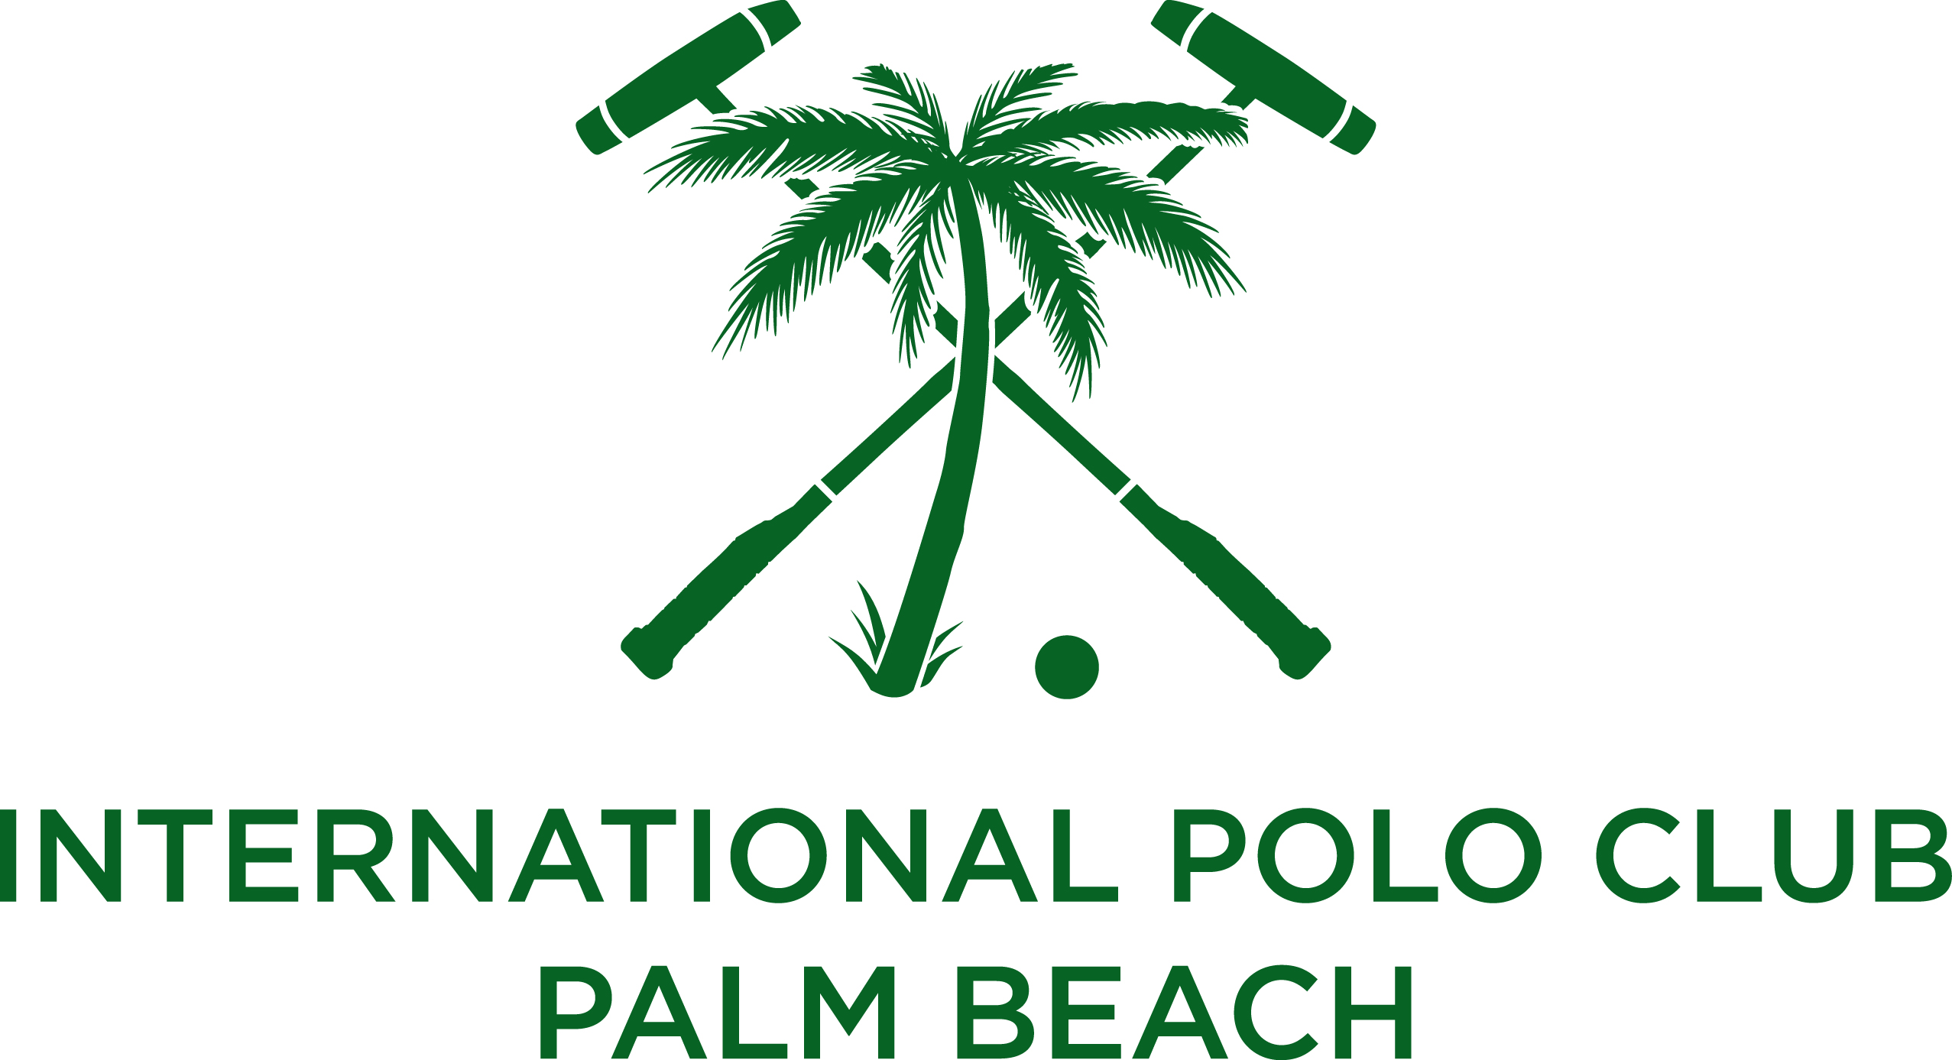

Horsepower and Star Power Arrive at the 11th Season Opener
of the International Polo Club Palm Beach

Wellington, Fla. (December 16, 2013) – Gentlemen, start your engines. The SuperCar HorsePower Show will be revving up the action (along with plenty of testosterone) on opening day at the famed International Polo Club Palm Beach, along with Broadway’s legendary song and dance man, Tommy Tune. From polo watching and stylish tailgaiting to celebrity spectating and champagne toasting, there is literally something for everyone at the International Polo Club!

As part of SuperCar Week, a nine-day, regional exotic car extravaganza, guests and turbo enthusiasts will have an opportunity to preview a plethora of high-end, high-performance, and very high-octane supercars throughout the day.

Nine-time Tony Award winner, Tommy Tune, will perform the opening day honors with the coin toss at the International Polo Club on Sunday, January 5, 2014. Tune will also croon to the crowd with his boot-tapping rendition of the National Anthem. The match starts at 3 p.m.

IPC club president, John Wash, foresees another sold-out season and forecasts an increase in the international audience, in addition to the local community coming out for the Sunday brunch and popular weekend tailgating.

“2014 is going to offer even more fun and surprises for our guests, and it’s going to be one of the most exciting seasons the club has ever hosted,” said Wash. “From attracting the top players from around the world to showcasing the best entertainment around the country, I would say we have created the footprint to long-term success at IPC.”

Throughout the upcoming season, all six of the United States Polo Association’s 10-goal rated polo players, including Adolfo Cambiaso and Facundo Pieres, will compete in IPC tournaments. With 10 goals being the highest handicap that can be attained in polo, local fans are guaranteed to see the game’s most elite players.

Some of polo’s most prestigious tournaments are scheduled at IPC this season, including the C.V. Whitney Cup, the Piaget USPA Gold Cup®, and the Maserati U.S. Open Polo Championship®.

“If you’re looking for the perfect place to spend a Sunday afternoon, replete with champagne, fashion, and plenty of world-class polo,” Wash added, “then IPC is a wonderful choice.”

Ticket prices for Sunday polo at the world-famous International Polo Club range from $10 for general admission to $120 for box seating. Tickets for Sunday brunch at The Pavilion and its reception start at $55, upward to $330 for the Veuve Clicquot brunch package for two.

For more about IPC, tournament information, sponsorship, and tickets, please call 561-204-5687 or visit InternationalPoloClub.com.

About International Polo Club Palm Beach
The International Polo Club Palm Beach is the premier polo destination in the world, hosting the largest field of high-goal teams and the most prestigious polo tournaments in the United States. Polo enthusiasts descend upon Wellington, Fla., each winter season to enjoy their love of the sport in the most prominent and well-equipped polo facility. The 2014 Palm Beach Polo Season will open on Sunday, January 5, and will conclude 16 weeks later with the Maserati U.S. Open Polo Championship® final on Sunday, April 20. Polo matches are open to the public, with a wide range of hospitality and guest seating that includes elegant grandstand viewing, field tailgating, lawn seating, field-side champagne brunch at The Pavilion, and exclusive sponsor boxes. Tickets start at $10. For ticketing and sponsorship information, or to book a special event year-round, please call 561-204-5687 or visit InternationalPoloClub.com.

Media Contact
Enid Atwater, Venue Marketing Group
561-844-1778, ext. 21
enida@venueadv.com

