Press Release Contacts:
For Immediate Release Vinitaly International
International Media Dept.
+39 045 8101447
media@vinitalytour.com
www.vinitalytour.com
Twitter: @VinitalyTour
Join Vinitaly International Network on LinkedIn

Vinitaly International Academy stops in New York and then Chengdu, China

Always with an eye towards offering added value to Italian producers and making the difference, Vinitaly International will soon be launching Vinitaly International Academy (VIA), an innovative educational initiative that will allow members of the wine trade to deepen their knowledge of Italian wine and assist them in their effort to sell one more bottle of Italian wine in top international markets. The new project will be launched on the occasion of Vinitaly USA, to be held on the 3rd of February 2014 at the Metropolitan Pavilion in New York and will then follow the Ambassador of Italian wine in it’s promotional tour around the world throughout 2014 and in the years to come.

To lead the initiative, Managing Director Stevie Kim has chosen an internationally renowned wine expert to complement the promotional expertise of Vinitaly International. An acclaimed wine journalist in the media realms of US, UK, Canada, France, China and Italy, Dr. Ian D’Agata regularly writes for Stephen Tanzer's International Wine Cellar and Decanter. He has also won grants in molecular biology research and his laboratory experience, combined with his mastery of the international wine market, are well paired with Stevie Kim’s global vision for the advancement of Italian wine: “He is a clear choice for VIA, because he is part of international culture, not just in terms of language, but in terms of recognition and market expertise. As domestic wine consumption in Italy has plateaued, the international market is increasingly important for our producers. Ian brings positive energy, academic rigor, and a global perspective.”

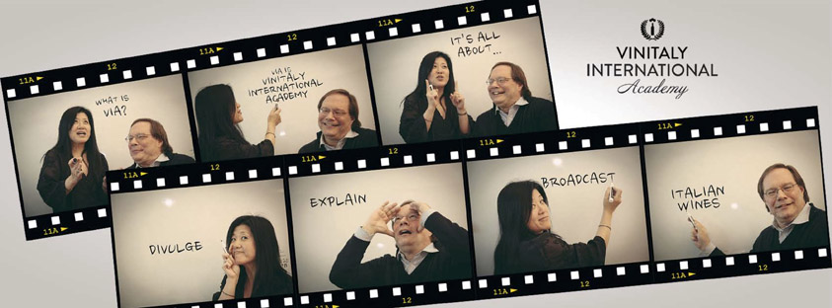

The exclusive Masterclass series will combine focused tastings with academic lectures on Italian grapes and will be open to a restricted number of attendees selected from top names of the international world of wine. A certificate of attendance will be given to all those taking part in each educational session.

Given the great diversity of Italian grapes and terroirs, the aim of the Academy is to simplify complexity by explaining, divulging and broadcasting the characteristics of Italian wine for all levels of wine knowledge from novice to expert, tailored to each international market: an introductory course will offer a first insight into the intricacies and uniqueness of Italian wine whilst Advanced and Focus levels will explore the characteristics of a single grape variety or region.
This edition of Vinitaly USA will be featuring three second and third level courses to satisfy the demand of a more mature and wine-savvy US market. The three Master Classes “Barolo’s Cannubi: Italy’s oldest and most famous Grand Cru”, “Italy’s answer to Champagne: Franciacorta”, “The velvet underground of Amarone: treasures to be shared” will be focusing on three top Italian wines, the Barolo from the legenday Cannubi vineyard (Focus level), Fraciacorta and Amarone (Advanced levels).

Though estimates vary, Italy today counts the largest number of single grape varieties in the world, approximately 378 of which (but there are likely many more as yet unidentified cultivars) are native grapes. “This is both the strength and weakness of Italian wine and most certainly it is its uniqueness” explains Ian D’Agata who has recently finished writing “Native grapes from Italy” for the University of California Press, a likewise unique 650 page long volume entirely dedicated to Italian native grape varieties. “Italian wine offers a plethora of aromas and flavours but is also extremely complex. We need to make complexity easier and help importers and distributors, as well as wine lovers, understand the characteristics of each wine, especially the true-to-type color, aroma and flavour profiles of Italian native grapes, so that everyone can be in a better position to sell more bottles and to appreciate them.”

To see an interview with Ian D’Agata and Stevie Kim, please visit http://tinyurl.com/p4x5y2f

About:
Veronafiere is the leading organizer of trade shows in Italy including Vinitaly (www.vinitaly.com), the largest wine event in the world. The 47th edition of Vinitaly counted some 148,000 visitors (+6%), of which 53.000 were international attendees (+10%) visiting from 120 countries. On 95.000 square meters, 4.200 exhibitors welcomed trade professionals, media and producers alike. The next instalment of the fair will take place on 6th- 9th April 2014. The premier event to Vinitaly, OperaWine (www.OperaWine.it) “Finest Italian Wines: 100 Great Producers”, will unite international wine professionals on April 5th 2014 in the heart of Verona. Veronafiere also created Vinitaly International in 1998 to develop a global platform for the promotion of companies in the Italian wine and food sectors.

# # #

