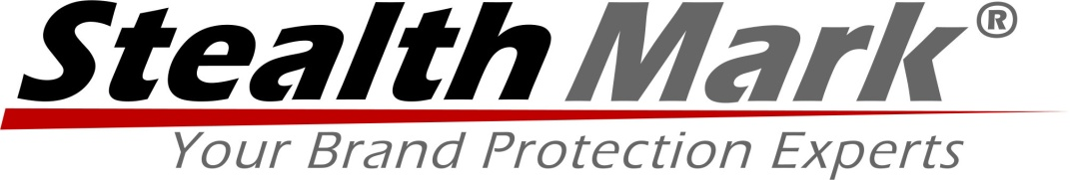

Brand Protection Provider Stealth Mark Announces Improvements to Mobile Security Application

The StealthFire™ brand security software for the iPhone is now available for download from the Apple App Store.

Centerville, MN – January 8, 2014 – Stealth Mark, a leading provider of brand protection security solutions, announced a significant addition to its StealthFire™ security software suite. The StealthFire™ security software suite now includes a mobile application for the iPhone.

Stealth Mark recently partnered with the Lauterbach Group to provide the most advanced security labeling solution available on the market. The labels incorporate Stealth Mark’s sophisticated security technologies with the Lauterbach Group’s advanced security printing capabilities, providing state-of-the-art brand protection for any organization.

The StealthFire™ Mobile Track and Trace application, a free download available from the Apple App Store, takes brand protection on the road with the simplicity of an iPhone. Our new application allows Stealth Mark customers to quickly and accurately track and determine authenticity of items or products, and to identify the source stream of diversion (grey market) activities directly on their iPhone.

Utilizing secure data within the Stealth Mark cloud-based Security Management Portal, the iPhone app can quickly and easily display product information, descriptive elements of the products, scanning of the unique 16-digit secure ID number including date and time, label image, and location; the latter providing the ability for GPS-driven map and satellite views. Customers can also use the mobile application to read a 2D barcode printed on our secure label, which could include customer-specific marketing and tracking data like lot numbers, manufacturing locations, links to websites, etc.

Scanning a label automatically creates a history of the scanned data, including a saved image of the label. Such historical data can be accessed and reported on at any time.

Some of the new iPhone application’s features and functionalities include:
- Convenient, advanced 2D barcode scanning functions
- Easy capturing of Chain of Custody information
- Authentication of secure unique ID numbers
- Instant access to product and product element information
- Capturing of GPS and location information, including actual map and satellite views
- Ability to capture covert microparticle images
- Ability to capture images of overt features from the secure label or seal

Stealth Mark and the Lauterbach Group have provided solid security in an easy-to-use labeling format that is not intrusive to existing operations or branding strategies. Learn more about the partnership at www.stealthmark.com, and click here to download the iPhone application.

# # #

About Stealth Mark
Stealth Mark is a global product authentication solution provider specializing in brand protection. Offering one the most advanced product security solutions, we protect companies and governmental agencies from unauthorized reproduction (counterfeiting), diversion or theft of their most valued assets. For years, Stealth Mark has delivered security solutions that emphasize four key principles: security strength, ease of implementation, authentication speed/simplicity, and total cost of ownership.

For a more comprehensive brand protection solution, visit www.stealthmark.com, and follow Stealth Mark at www.twitter.com/stealthmark.

CONTACT
Mike Ducatelli, CEO

