Michigan inventor and manufacturer team up to launch new consumer product which saves money and helps the environment by reusing plastic grocery bags

Do you ever ask, “What can people do with all of these used plastic grocery bags?”
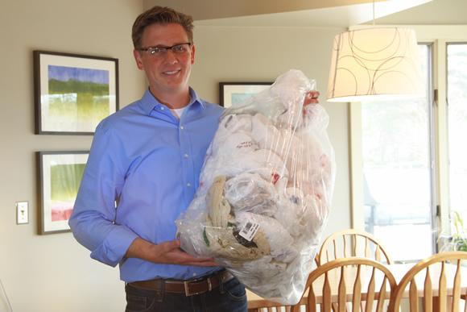
If you are like most people, you take home plastic grocery bags from more than one shopping trip each week. These plastic grocery bags(sometimes called ‘single-use’ plastic bags and T-shirt bags) have become the mainstay of retailers for carrying groceries and other goods home from the stores because of their strength and low cost. Most of us keep a collection of these bags stuffed in a kitchen drawer or closet and reuse them whenever we can. Grocery bags are frequently re-used for everything from carrying lunch to work to cleaning up after Fido. While most people re-use these bags from time to time, they don’t fit in regular garbage cans and there are very few good options available to fit these bags.

“My motivation was to find a way to use these bags and get the big ugly trash can out of my kitchen.” Says Gabriel Beverlsuis, inventor/designer of BagSavr+. “As I looked at my own collection of used bags and wanted to find a better way to make good use of these bags in order to save money and help reduce waste through re-use.

“I searched in vain to find an existing product that would work the way I wanted. Since I could not find a good solution I decided to make my own. Initially I made 2 prototypes by forming sheets of plastic into a container that could be mounted on my cabinet doors. It worked so well that about a month later we got rid of our regular garbage can and I realized that I had stumbled upon a design that really needed to be shared with the world.”

Gabriel then began searching for a manufacturing partner and came into contact with Courtney Gust, President of Camcar Plastics Inc. “I get approached with new product ideas all the time and I jumped at the chance to take on BagSavr+. It’s not very often in your life that you get to work on a project that is so profoundly positive. This one is a Win-Win-Win with benefits for the environment, consumers saving money and for supporting manufacturing here in the USA.” Says Courtney Gust, “It’s exciting!”

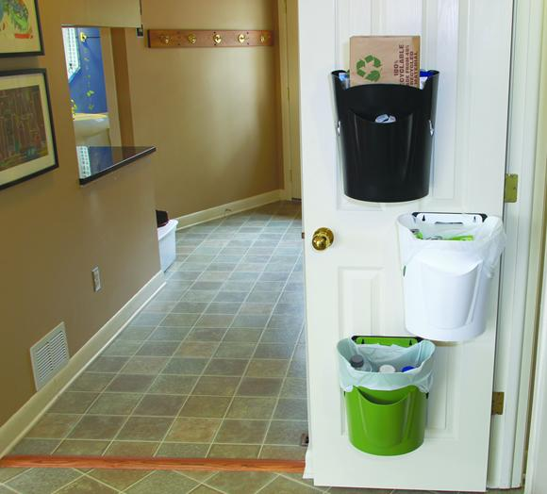
With BagSavr+ final design, several patent-pending features make it user-friendly and versatile. It can be mounted and removed from any surface in the house, garage or camper and with it’s freestanding base it also works in the bedrooms, bathrooms or office.

Sized to perfectly fit the plastic grocery bags and the inside of a kitchen cabinet door
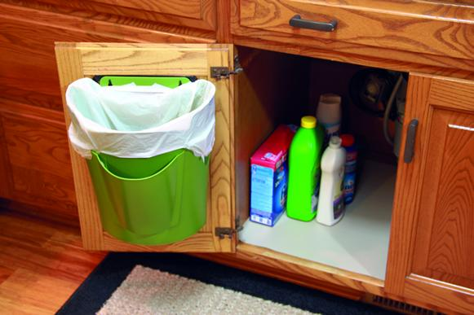

The front pocket stores up to 10 additional bags right where they are needed
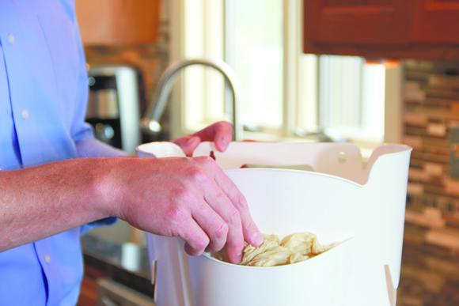

The built-in handle makes it easy to take anywhere.
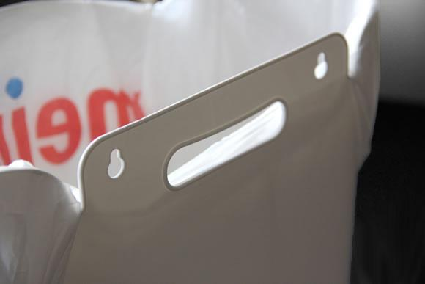
Works Beautifully in a Bedroom
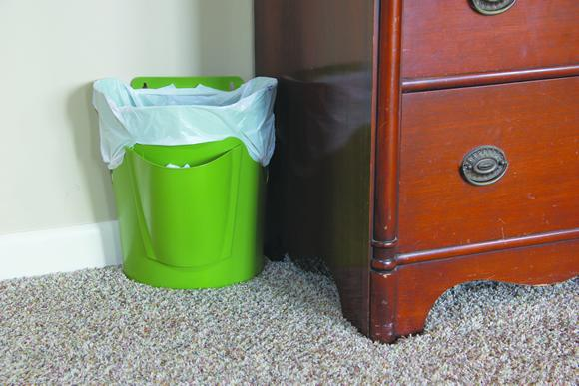

With 8 designer color options available, everyone will find one that works in any room
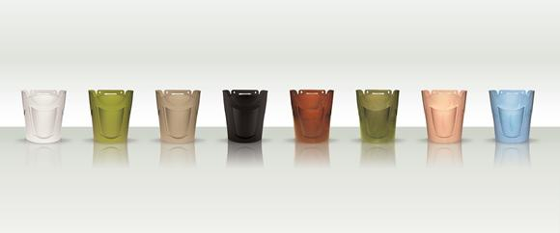

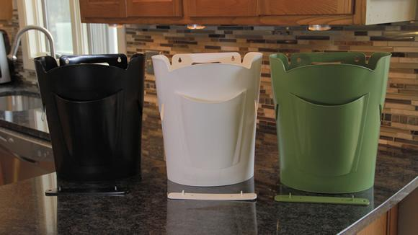
BagSavr+ has just become available for the first time through the company’s website bagsavr.com and Amazon.com. Products That Work is also actively engaging retailers across the USA for mass distribution.

Gabriel Beversluis
Products That Work, LLC
Grand Rapids, MI
gabriel@productsthatwork.co

