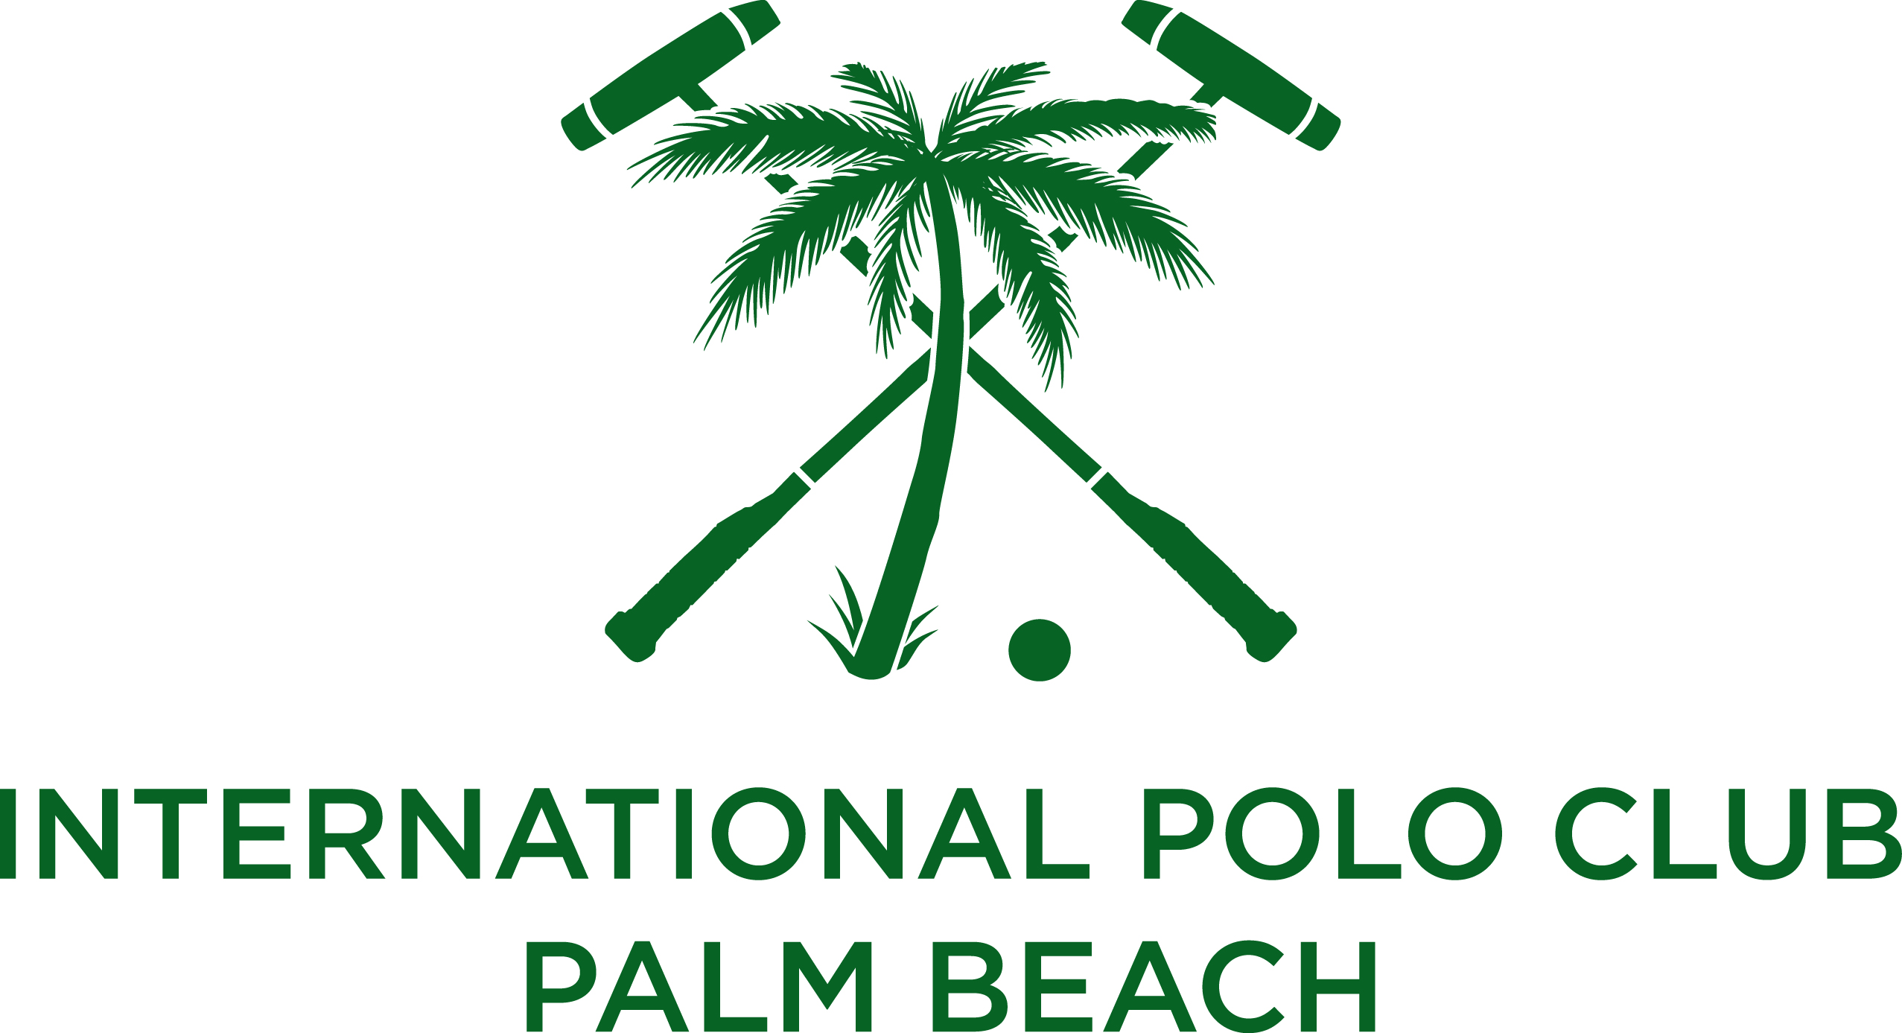

International Polo Club Palm Beach Welcomes
Piaget as Title Sponsor of the 2014 Piaget Gold Cup
Wellington, Fla. (January 21, 2014) – Legendary polo players, gallant ponies, and luxury timepieces will be on display when Swiss watchmaker and jeweler, Piaget, returns to International Polo Club Palm Beach for its seventh consecutive year as the title sponsor of the world-class Piaget Gold Cup.

“Elegance and cultivating a spirit of luxury are what Piaget brings to the International Polo Club and our upcoming 2014 season,” said John Wash, president of the International Polo Club (IPC). “Piaget’s reputation for excellence and flawless craftsmanship make them an ideal partner for this prestigious event.”
Piaget has been a principal partner of IPC since 2006 and will host the Piaget Gold Cup tournament for the 2014 season. The House has been associated with the sport of kings since the 1970s when Mr. Yves Piaget became a major supporter of polo in Palm Beach. His belief that polo embodied the same attributes as the brand, including precision, performance, and perfection, led to the creation of the first Piaget Polo timepiece in 1979.
“As the exclusive watch and jewelry sponsor, and the official timekeeper of the International Polo Club Palm Beach, we are beyond thrilled to be back for the Piaget Gold Cup,” said Larry Boland, president of Piaget. “It’s the perfect marriage of brand legacy and the international jet-set lifestyle.”
The prestigious Piaget Gold Cup is grace and athletic ingenuity at its finest. First played in 1974 at Oakbrook Polo Club in Illinois, the tournament made a series of pit stops before coming home to the breathtaking greens of IPC. When the USPA awarded the International Polo Club the Gold Cup in 2007, it sealed IPC’s place in history as the proud host of America’s 26-goal Triple Crown polo tournaments – the USPA C.V. Whitney Cup, the USPA Gold Cup, and the U.S. Open Polo Championship®. This year’s Piaget Gold Cup matches will be played on consecutive Sundays – March 9, 16, and 23.

# # #

About Piaget
Piaget has stood as an icon of excellence and creativity since its founding in 1874, elevating the manufacture of fine jewelry and timepieces to an absolute art. The firm is known for its legendary Piaget Polo timepieces, as well as for its ultra-thin movements and artistic dials, including chronographs, tourbillons, perpetual calendars and the complicated minute repeaters. Piaget is one of the only remaining watchmakers that designs and crafts its own cases, bracelets, and movements. For more information, please visit Piaget.com.

About International Polo Club Palm Beach
The International Polo Club Palm Beach is the premier polo destination in the world, hosting the largest field of high-goal teams and the most prestigious polo tournaments in the United States. Polo enthusiasts descend upon Wellington, Fla., each winter season to enjoy their love of the sport in the most prominent and well-equipped polo facility. The 2014 Palm Beach Polo Season will open on Sunday, January 5, and will conclude 16 weeks later with the Maserati U.S. Open Polo Championship® final on Sunday, April 20. Polo matches are open to the public, with a wide range of hospitality and guest seating that includes elegant grandstand viewing, field tailgating, lawn seating, field-side champagne brunch at The Pavilion, and exclusive sponsor boxes. Tickets start at $10. For ticketing and sponsorship information, or to book a special event year-round, please call 561.204.5687 or visit InternationalPoloClub.com.

Media Contact
Sally Shorr, Venue Marketing Group
561.844.1778, ext. 31
sallys@venueadv.com

