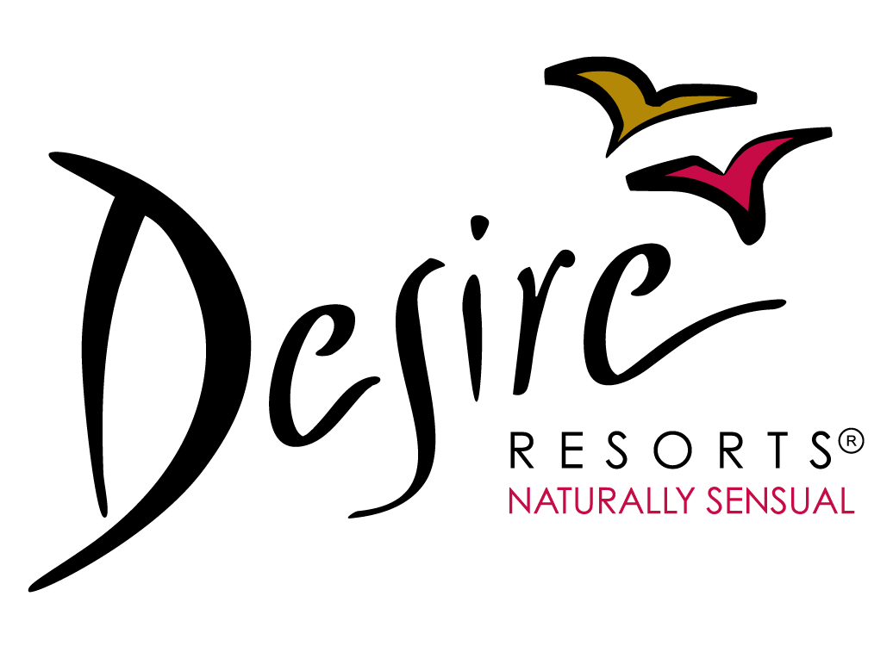
For Immediate Release
THE SEXY, YOUNG AND WILD EVENT
DISCOVER THE WILDEST SIDE OF DESIRE

Cancun, February 20th, 2014. Desire Resorts, our clothing optional hotels in the Riviera Maya have the pleasure to remind you that for the month of August, 2014, both Desire Resort & Spa and Desire Pearl Resort & Spa will be hosting their one and only "Sexy, Young & Wild" event.
Starting on August 3rd, the party will not stop all month long for all the sexy people who are young at heart and like to enjoy their sensuality like there is no tomorrow.
And for this great event, Desire Resorts, always synonym with wild, fun and sensual fantasies, are giving a little turn for the wilder, inviting all threesomes (2 women, 1 man), couples and single females to discover paradise while they revitalize their bodies and minds in ways they could never imagine.
While the high-end services of our resorts will keep our guests’ needs satisfied, the most alluring events and night themes will surprise and tantalize their senses in every moment. Then, it will be time for our Pole Dance Lessons, Sin Circus Party, Daring Sun Busters, Foam Party, Beach Night Party, Skinny Dipping Jacuzzi Fest, XS Night without forgetting our Campus Desire.
Details on our night themes and dress codes can be found at sexy-young-wild.com
Moreover, we will have a wild line up of famous DJ’s and celebrities as our friends from Play Boy Radio that will be hosting some of our parties and broadcasting live from our sensual Desire Resorts.
For more information, please visit:
bit.ly/1lJZFeF
Contact us:
info@desireresorts.com
by
desireresorts.com

