Lift Labs Launches March Match Campaign for National Essential Tremor Awareness Month
Crowdfunding initiative will put tremor-canceling Liftware devices into the hands of those struggling with everyday tasks like eating

San Francisco, March 3, 2014 - Lift Labs, a group of scientists and engineers working to develop new technologies for people with Essential Tremor (ET) and Parkinson’s disease, today launched March Match, an Indiegogo crowdfunding campaign in honor of National Essential Tremor Awareness Month. Through March Match, Lift Labs is matching contributions collected on Indiegogo dollar-for-dollar (up to $50,000) to purchase tremor-canceling Liftware devices for those struggling with ET and economic hardship.
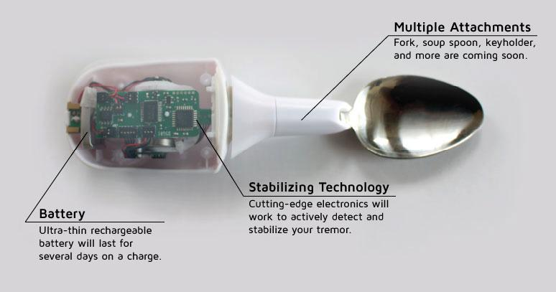
Liftware devices (pictured right) use sophisticated stabilizing technology to electronically detect and stabilize hand tremors, helping those living with ET take control of, and enjoy, simple tasks like eating. Comprised of a rechargeable battery, stabilizing base and spoon attachment, Liftware provides 70% tremor cancellation in a device the size of an electronic toothbrush, making it highly effective, compact and portable.

An estimated 10 million people in the United States have essential tremor, a neurological condition that causes shaking of the head, hands and voice. While not life threatening, ET is a serious and progressive condition that can significantly affect a person’s quality of life – socially, professionally and emotionally.

“Liftware was inspired by friends and family who struggle to complete tasks due to their tremor that should be simple and enjoyable,” said Anupam Pathak, CEO of Lift Labs. “In honor of National Essential Tremor Awareness Month, we are working to create a real impact in the lives of those who need this technology but cannot afford it.”

Contributions will be collected via Indiegogo through March 31st, 2014. At the end of the campaign, Lift Labs will send all of the devices paid for by the March Match campaign to the International Essential Tremor Foundation, who has partnered with Lift Labs to distribute Liftware devices to individuals in need.

About Lift Labs
Lift Labs is a group of scientists and engineers developing cutting-edge technologies that will improve quality of life and human performance for people living with Parkinson’s and Essential Tremor (ET). Headquartered in San Francisco, Lift Labs’ initial product is Liftware, a revolutionary device that detects and stabilizes hand tremors to assist with the everyday and often difficult task of eating for those suffering from ET or Parkinson’s. Developed by a team of mechanical engineers led by Berkeley Engineering trained CEO and Founder, Anupam Pathak, Ph.D, Liftware is designed to respond to the user’s tremor movements and actively cancel them out. Liftware is manufactured in the United States and has demonstrated 70% tremor reduction in clinical trials. For more information, please visit our website www.liftlabsdesign.com

March Match Campaign: http://igg.me/at/liftware/x/6434858
Media Kit: www.liftlabsdesign.com/news.html
Twitter: @LiftLabsDesign

About International Essential Tremor Foundation
Headquartered in Lenexa, KS, and founded in 1988, the International Essential Tremor Foundation is the leading organization in the world dedicated to those affected by essential tremor. The mission of the IETF is to fund research that will find the cause of essential tremor and lead to better treatments and a cure, increase awareness about ET, and provide educational materials, tools and support to healthcare providers, the public, and those directly affected by ET. To learn more about essential tremor and the IETF mission, visit the IETF website at www.essentialtremor.org.

Media Contact:
Kyla Westphal
kylawestphal [at] gmail [dot] com
415.307.9547

