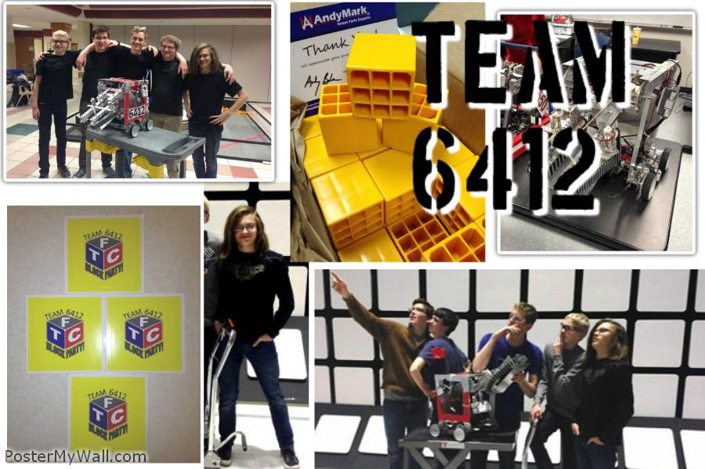
We are HuskrBot Team 6412

We need your help! For more info, visit our Kickstarter page.
You could be a part of something awesome!

HuskrBot is a robotics team. We Design - Build - Program - & Compete in the national FIRST Tech Challenge series.

Team HuskrBot was created in 2011 and competed in the Ring it Up challenge. We are based out of NCEE Labs in Lincoln Nebraska and were one of the first Nebraskan teams. Two of that year’s team members are on this year’s team; Charlie and Max. This year’s team consists of Andrew, Tristan, and Riley, who are all amazing programmers which enabled our team to progress much quicker than last year as well as Ben, Max, and Charlie, who designed and refined the physical aspects of the robot.

Be AWESOME!!!
http://huskrbot.weebly.com/
donate.html

Be AWESOME!!!
http://huskrbot.weebly.com/
donate.html

Be AWESOME!!!
http://huskrbot.weebly.com/
donate.html

Be AWESOME!!!
http://huskrbot.weebly.com/
donate.html

Be AWESOME!!!
http://huskrbot.weebly.com/
donate.html

Be AWESOME!!!
http://huskrbot.weebly.com/
donate.html

Be AWESOME!!!
http://huskrbot.weebly.com/
donate.html

Be AWESOME!!!
http://huskrbot.weebly.com/
donate.html

Be AWESOME!!!
http://huskrbot.weebly.com/
donate.html

Be AWESOME!!!
http://huskrbot.weebly.com/
donate.html

Be AWESOME!!!
http://huskrbot.weebly.com/
donate.html

Be AWESOME!!!
http://huskrbot.weebly.com/
donate.html

Be AWESOME!!!
http://huskrbot.weebly.com/
donate.html

