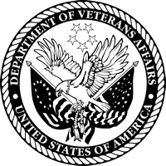 | News Release | 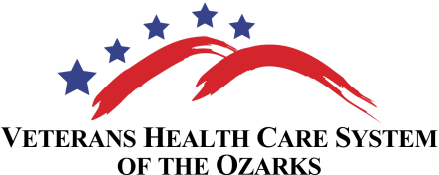
For Further Information Contact:
Wanda Shull, Public Affairs Officer
(479) 443-4301, ext. 65127
or Sarah McBride, Public Affairs Specialist
(479) 443-4301, ext. 63114
For Immediate Release:
May 16, 2014
VA2K Walk and Roll Supports Homeless Veterans
Fayetteville, AR –The Veterans Health Care System of the Ozarks (VHSO) will host a VA2K Walk and Roll on May 21, at 11:00 a.m. at VHSO’s Medical Center in Fayetteville, AR to encourage healthy activity while supporting homeless Veterans.
This year’s honorary chairman and guest speaker at the event will be University of Arkansas head coach Bret Bielema. Coach Bielema and his wife Jen will be at the event to speak about the importance of health and fitness in our busy schedules and join participants in the 2K.
The VA2K Walk and Roll is free and open to employees, Veterans, and the general public. The VHSO 2K will be held at the VHSO’s Medical Center, at 1100 N. College Ave, Fayetteville, AR. Registration will take place outside of Building 3 from 11:00 a.m. – 1:00 p.m. Pre-registration is not required and those interested in participating should plan to arrive no later than 10:45 a.m. In the event of inclement weather, the VA2K will be held in the auditorium of Building 3.
In lieu of a registration fee, participants are encouraged to bring a donation for the VHSO Homeless Veteran’s program. Donation items in need include: bug spray, deodorant, detergent, toilet paper, paper towels, diapers, cleaning supplies, sunscreen, paper plates and plastic utensils. However, there is no requirement for a donation in order to participate.
“Wellness activities like this one enhance employee engagement and contribute to a more productive and healthy workforce,” said Dr. Mark A. Enderle, Medical Center Director. “Last year, the VA2K was extremely successful. This year our goal is to collect even more in-kind donations and involve more participants in support of wellness and homeless Veterans.”
The VHSO event is just one of many VA2Ks taking place May 21 at other VA facilities across the country. The event is open to people of all fitness levels and can be done over a lunch break. Whether you team up with a coworker, a friend, or participate on your own, there’s no better time than now to step up your fitness level and help improve the lives of homeless Veterans. For additional information and more event details, please contact the VA2K coordinator, Heather Ghormley at 479-443-4301 ext. 65259 or via email at heather.ghormley@va.gov.
# # #
The Veterans Health Care System of the Ozarks (VHSO) consists of one Veterans Health Administration (VHA) facility located in Fayetteville, Arkansas. VHSO has Community-Based Outpatient Clinics (CBOCs) in Fort Smith, Harrison and Ozark, Arkansas; Branson and Mount Vernon, Missouri; and Jay, Oklahoma. VHSO is a 73 bed facility providing various inpatient, outpatient specialty care, and primary care services. VHSO is a Robert W. Carey Award Circle of Excellence Winner (2013).

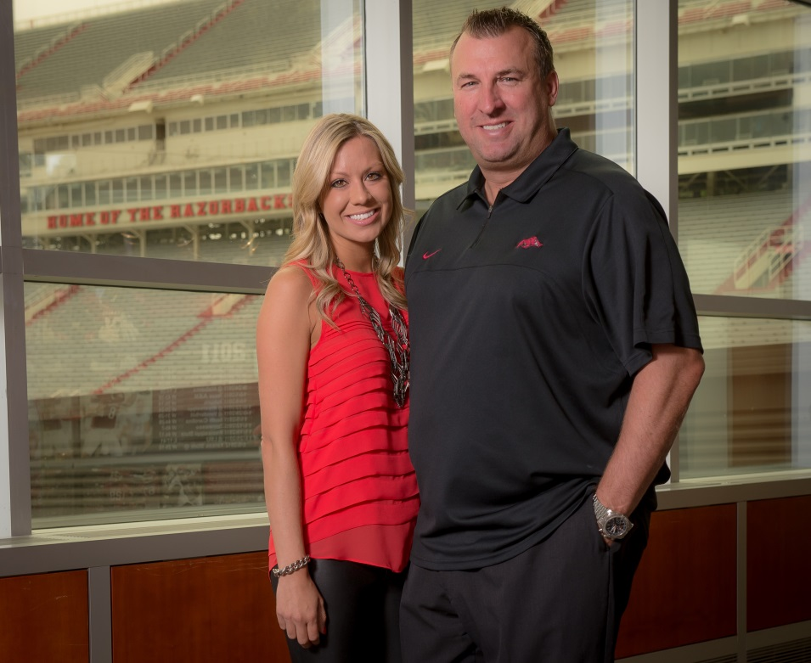
University of Arkansas Head Football Coach Bret Bielema and his wife Jen will join the VA2K this year as the honorary chairman, in support of physical activity and homeless Veterans.
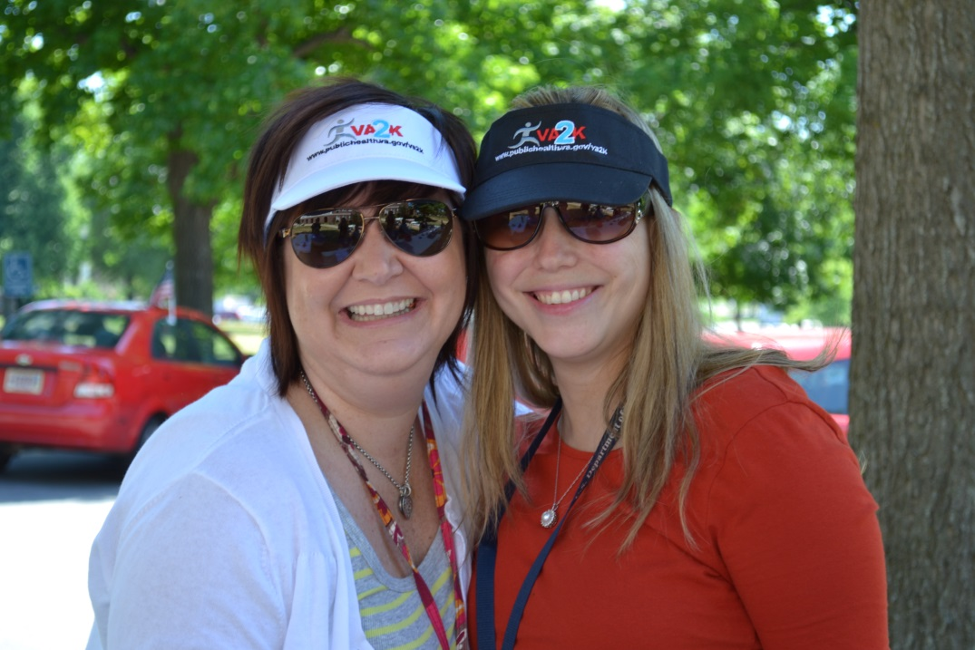

VHSO staff have participated in the past, but this year the VA medical center hopes to reach out to more of the community in an effort to help support the Homeless Veteran Program.
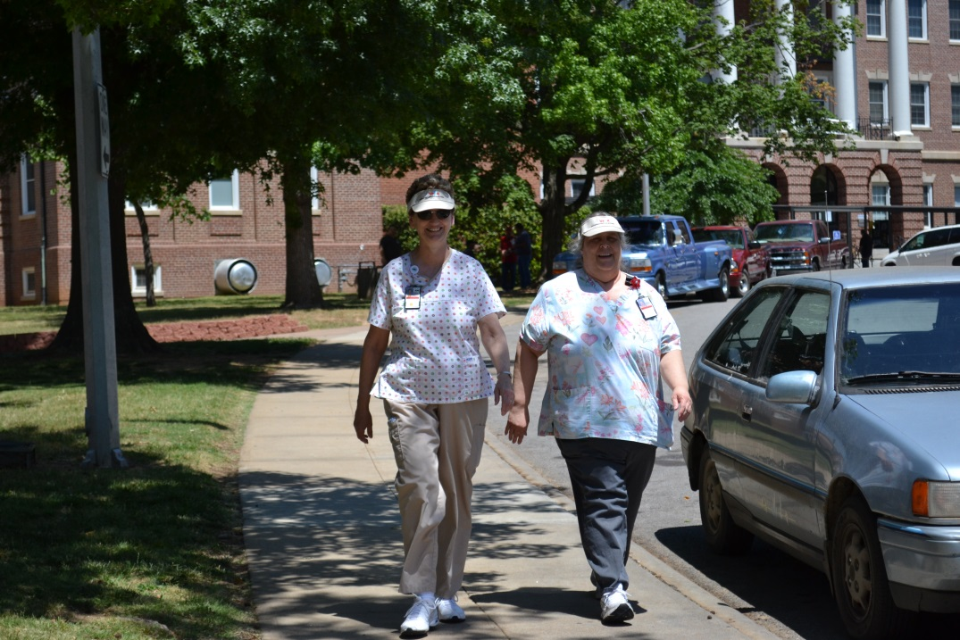
VHSO staff walk the VA2K in support of homeless Veterans, and to promote daily physical activity.

