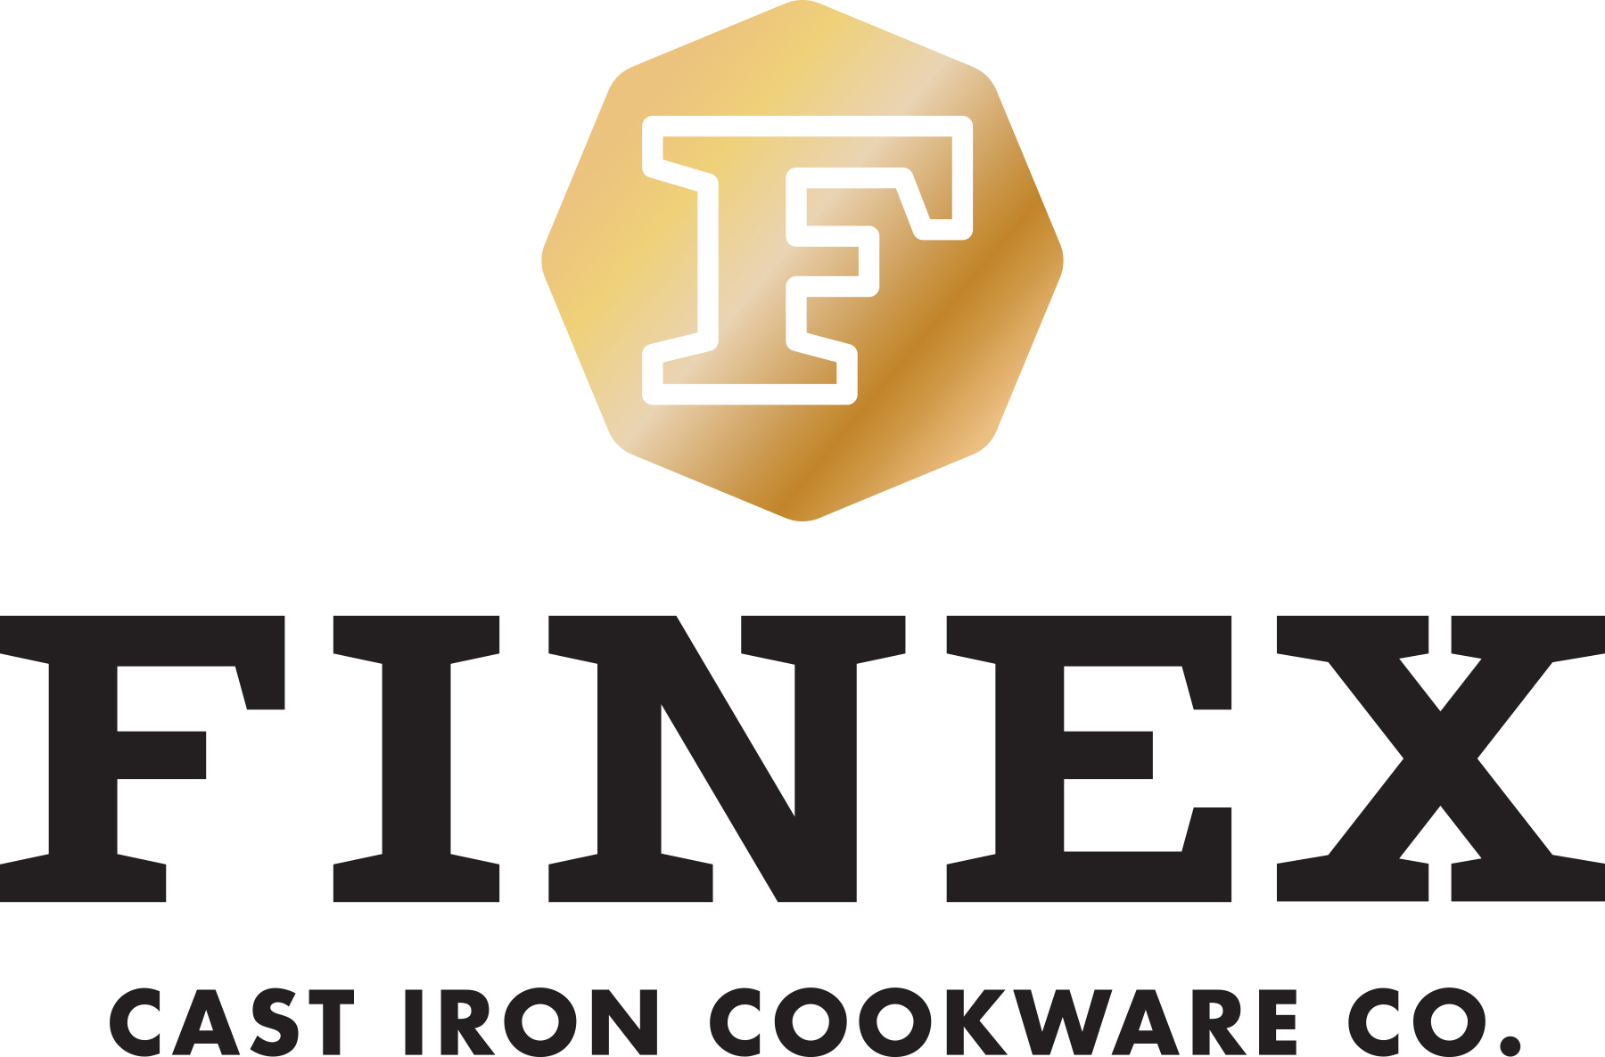
NEWS RELEASE
For immediate release

FINEX™ Brings Premium Cast Iron Skillets Back to America
A True Re-Invention of a Beloved Classic

Portland, Ore. (May 20, 2014) — Portland, Ore. innovative cookware maker, FINEX Cast Iron Cookware Co., is celebrating the launch of their new premium 12” Cast Iron Skillet. The FINEX Skillet received an extremely positive response during its successful Kickstarter campaign. Its revolutionary design attracted over 1,500 backers and helped FINEX exceed their funding goal by 844% in 30 days. Now for the first time the FINEX Skillet is finally available to the general public.

The FINEX 12” Cast Iron Skillet is a long overdue redesign of a beloved classic. Its patented octagonal shape provides every chef and aspiring chef with six pouring directions for crowded stovetop use. The stainless steel “Speed Cool” spring handle dissipates heat and comfortably fits any hand. It is computer machined to create a smooth, easy release cooking surface and even comes pre-seasoned with organic flaxseed oil. The FINEX skillet has been covered and anticipated by multiple local and national media outlets including Wired.com, Core77, The New York Times and Portland Monthly.

“We are just so happy to be crafting heirloom quality cast iron cookware in America for the first time in over half a century. This skillet is a perfect combination of our technical experience and passion for cooking – we are proud of how beautifully it both looks and cooks,” explains founder Mike Whitehead. This is FINEX’s first offering in an entire family of innovative cookware to be released over the coming year. As cooks around the world re-discover cast iron cooking FINEX is on track to bring its advantages back to your kitchen.
FINEX Cast Iron Skillets are made in the USA and are available for $195 at www.FINEXUSA.com.
________
FINEX Cast Iron Cookware Company is a small team of Portland-based perfectionists dedicated to making heirloom quality cast iron cookware in America. For information, visit www.FINEXUSA.com.
# # # #
For more information on the FINEX 12” Cast Iron Skillet or more information on FINEX Cast Iron Cookware Co., please contact Shauna Bilicic, FINEX Cast Iron Cookware Co.; email: cookwithus@FINEXUSA.com.
For hi-res sample and product images please visit http://finexusa.com/press-resources/

