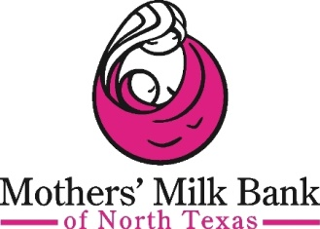 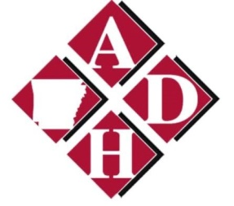 ADD THIRD LOGO FOR WIC

Donor Human Milk – A gift for a lifetime!

Our office is an official depot for Mothers’ Milk Bank of North Texas, which accepts donations of breastmilk from healthy, lactating women. It’s free and easy to become a milk donor. To begin the process, simply contact the Mothers’ Milk Bank of North Texas at 817.810.0071 for a short phone screening to test donor eligibility.

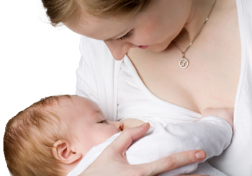
Donor mothers must be:
- In good health
- Willing to have blood tests to rule out communicable diseases
- Not regularly using medications except for progestin-only birth control, thyroxin, insulin, prenatal vitamins, iron or calcium
- Free from smoking, illegal drug use and regular alcohol use
- Donor mothers must be willing to donate a minimum of 100 ounces.
Donated milk is pasteurized to kill bacteria or viruses. It is then frozen for up to one year.

Donor Health Screening
Donor mothers are screened for health history and medication use. A blood test screens for HIV, HTLV, hepatitis B & C, and syphilis. Any positive blood test makes a woman ineligible to donate milk. The Mothers’ Milk Bank of North Texas will cover the cost of blood screenings for donor mothers.
A woman may NOT donate if:
- She is at risk for HIV or has a sexual partner at risk for HIV
- She uses illegal drugs
- She smokes
- She regularly drinks more than 2 oz of liquor daily
- Her doctor believes there is a contraindication to milk donation
- She is taking anything to enhance her milk production
- She is taking anything including fenugreek

FAQ
Are donors able to send their breastmilk from out-of-state?
The milk bank will gladly send insulated boxes and cover all shipping expenses for donors who wish to send their milk from out-of-state.
What kind of storage containers are recommended for donated breastmilk?
Any type of storage container donors wish to send to the milk bank is acceptable. However, the milk bank can provide storage containers so that donors do not have to purchase their own.
Do donors have to send 100 ounces of breastmilk at a time?
There is no minimum or maximum amount you may donate at one time. Donors are asked to commit to donating 100 ounces over their donation period.
Should breastmilk be fresh or frozen when sent to the milk bank or drop off site?
The milk bank receives frozen breastmilk that has previously been stored in freezers.
How old can breastmilk be when donated?
MMBNT prefers to receive milk before it is 6 months old. If you have milk that is older than 6 months, please contact MMBNT for further assessment.
Can donors take supplements containing fenugreek to help increase their production of breastmilk? Unfortunately, mothers are unable to donate their milk containing fenugreek.
Where is my breastmilk sent following the pasteurization process?
After the pasteurization process and lab testing, donor breastmilk is sent primarily to local Neonatal Intensive Care Units. Some out-of-state hospitals also receive donor breastmilk for their NICUs.
Are mothers compensated for donating their excess breastmilk?
Donors do not receive any payment for their donations.
Can donors send the milk already stored in their freezers (before lab testing or screening)?
Donors may send any frozen breastmilk (within the acceptable age range and free of restricted medications) that may be currently stored.
How long can donors donate?
Approved donors are allowed to donate for as long as they wish, regardless of the age of their baby.
What is the first step to begin to donor process?
Simply contact the Mothers’ Milk Bank of North Texas at 817.810.0071 for a short phone screening to test donor eligibility.

