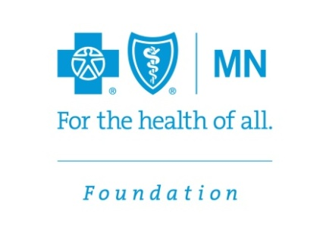
CONTACT:

CONTACT: News Release
Julie Eastling, Blue Cross and Blue Shield of Minnesota Foundation
(651) 662-6574
Julie_A_Eastling@bluecrossmn.com

Grants Awarded to Increase Participation in Parent Aware Ratings
Blue Cross Foundation Awards Grants to Increase Quality of Early Care and Education Programs

EAGAN, Minn. (June 30, 2014) — The Blue Cross and Blue Shield of Minnesota Foundation awarded $390,435 to increase participation by licensed family child care programs in Parent Aware, Minnesota’s quality rating system. The funding also will be used to encourage parents to use the ratings when choosing early care and education programs for their young children.
“We know that 69 percent of children under age two and 82 percent of children aged three to five are in some type of early care and education program,” said Foundation Executive Director Carolyn Link. “A high quality early experience sets them up for a better learning experience throughout their school career and a lifetime of better health.”
The five grants include:
- Anoka County Community Action Program, $15,435, for a peer mentoring program to help others become Parent Aware rated
- Northland Foundation, $100,000 to expand a pilot, encouraging programs to become rated through training incentives, quality improvement grants, resources and peer learning support networks
- Parent Aware for School Readiness, $75,000 to support an awareness program to drive demand by parents for quality rated programs
- Southern Minnesota Initiative Foundation, $100,000 to expand a pilot project to help providers become Parent Aware rated
- Think Small, $100,000, to offer free provider training to meet Parent Aware requirements, support providers’ professional development, provide quality improvement grants to providers and recruit Parent Aware champions to provide peer support in addition to enhancing parent outreach
For more information on Blue Cross’ grantmaking programs, call (651) 662-3950 or toll free at 1-866-812-1593.
The Blue Cross and Blue Shield of Minnesota Foundation makes a healthy difference in communities by advancing health equity and improving conditions where people live, learn, work and play, awarding more than $37 million since it was established in 1986.

–30–

