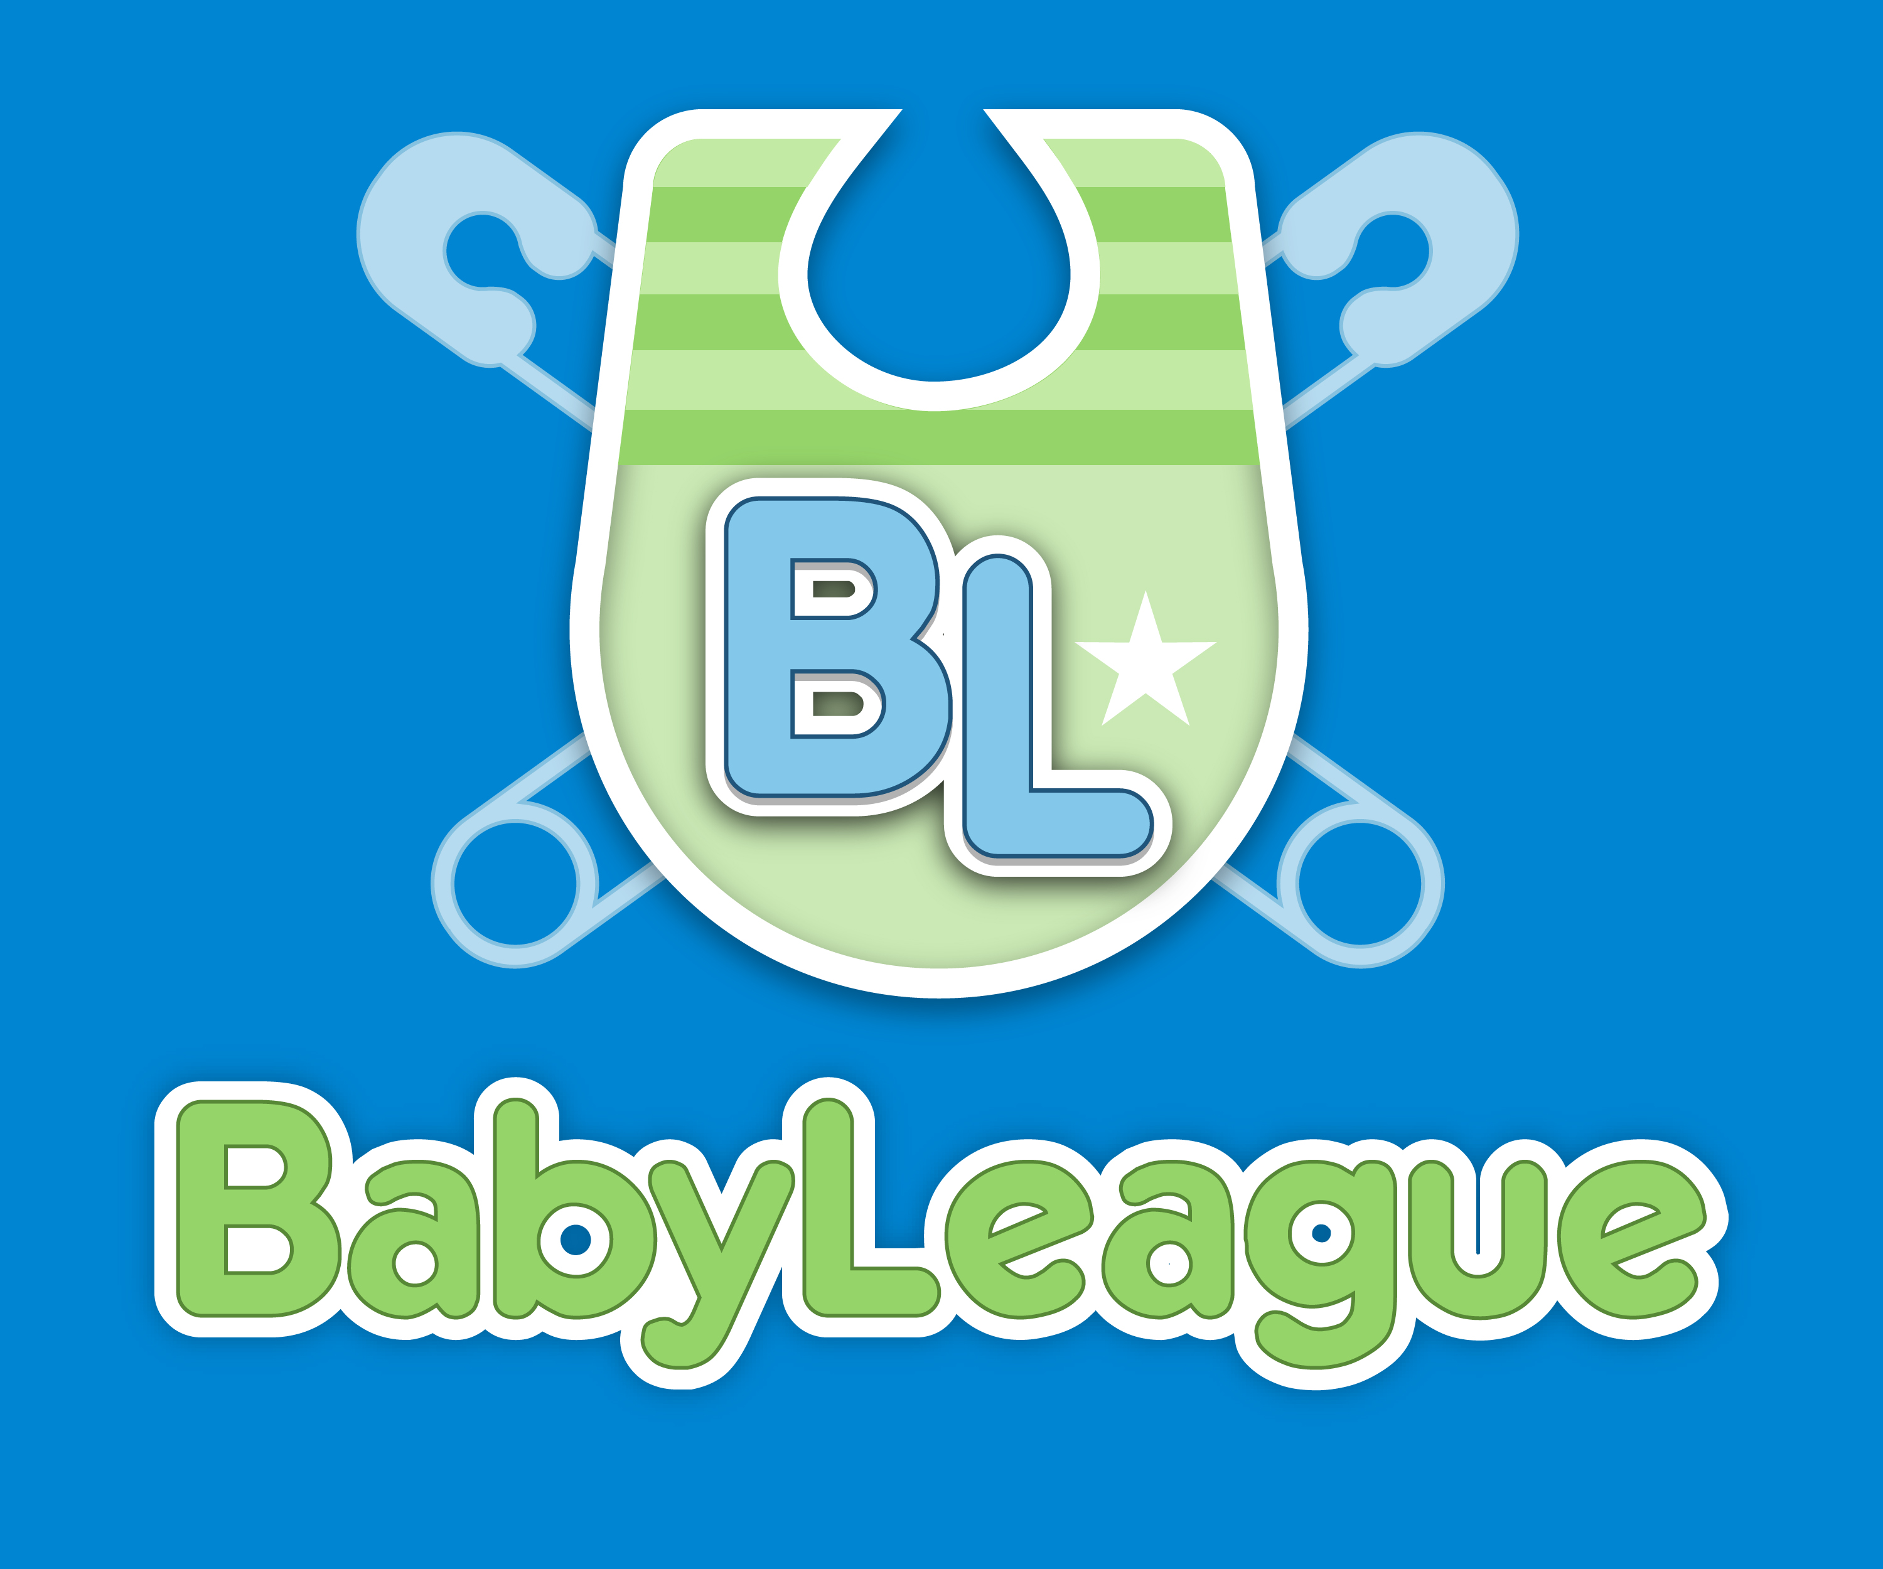

“LOOK WHO’S VLOGGING” SEASON 2
PREMIERES JULY 14th ON BABYLEAGUE.COM

(Beverly Hills) July 14, 2014 – BabyLeague®, a premium YouTube family channel, has announced the debut of Season 2 of its original, hit comedy series “Look Who’s Vlogging™: Daily Bumps” on Monday, July 14, 2014. The series star, Oliver, is a clever, fast-talking 11-month old baby who steals every scene with his comedic one-liners and his hilarious point of view on life with his “roomies,” parents Bryan and Missy.

Season 1 Highlights: http://youtu.be/MimsfhN5HfM

With Season 1 of “Look Who’s Vlogging: Daily Bumps” amassing nearly 1 million views in less than four months, Season 2 is set to explode on to the YouTube scene this Summer to delight fans with added surprises, including the arrival of new co-star: Karma, the family’s talking dog.

“BabyLeague is thrilled to collaborate with Bryan and Missy Lanning, Oliver’s incredibly talented and dedicated parents, to bring you the finest in family entertainment and fun,” states Aimee Helfand, BabyLeague’s founder and CEO.

"Watching Baby Ollie interact with Karma, our dog, has been so amazing because it’s like they’re really brothers! Season 2 is going to be so fun to make!" exclaims Missy Lanning, series co-producer and mom.

“Seeing the fans react to Karma in the preview episode has been hilarious! I think we’re really pushing the fun meter up even higher for Season 2 of LWV," states Bryan Lanning, series co-producer and dad.

“Look Who’s Vlogging: Daily Bumps,” is a once-weekly original series featuring rising YouTube stars and creators, Bryan and Missy Lanning with their adorable 11 month-old baby, Oliver. Airing exclusively on the BabyLeague YouTube channel every Monday, “Look Who’s Vlogging” has quickly become a smash hit with viewers worldwide.

BabyLeague is a fun, informative and premium YouTube channel created specially for moms, dads and caregivers needing a little advice and support with a lot of laughs. Regularly scheduled weekly programming provides parenting expert tips, baby care basics, baby product reviews, family adventures and entertainment by the some of the most popular online influencers and experts in the world.

Tune in Monday, July 14, at 6 a.m. (PST) for the Premiere of “Look Who’s Vlogging: Daily Bumps” Season 2 on BabyLeague!

Watch “Look Who’s Vlogging” Season 2 Preview: http://youtu.be/Ug2ykxfqb-o

# # #

Media Contact:
Phillip Nakov
Marketing/Publicity
Phillip@BabyLeague.com

