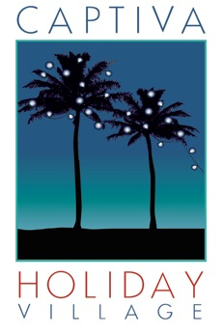
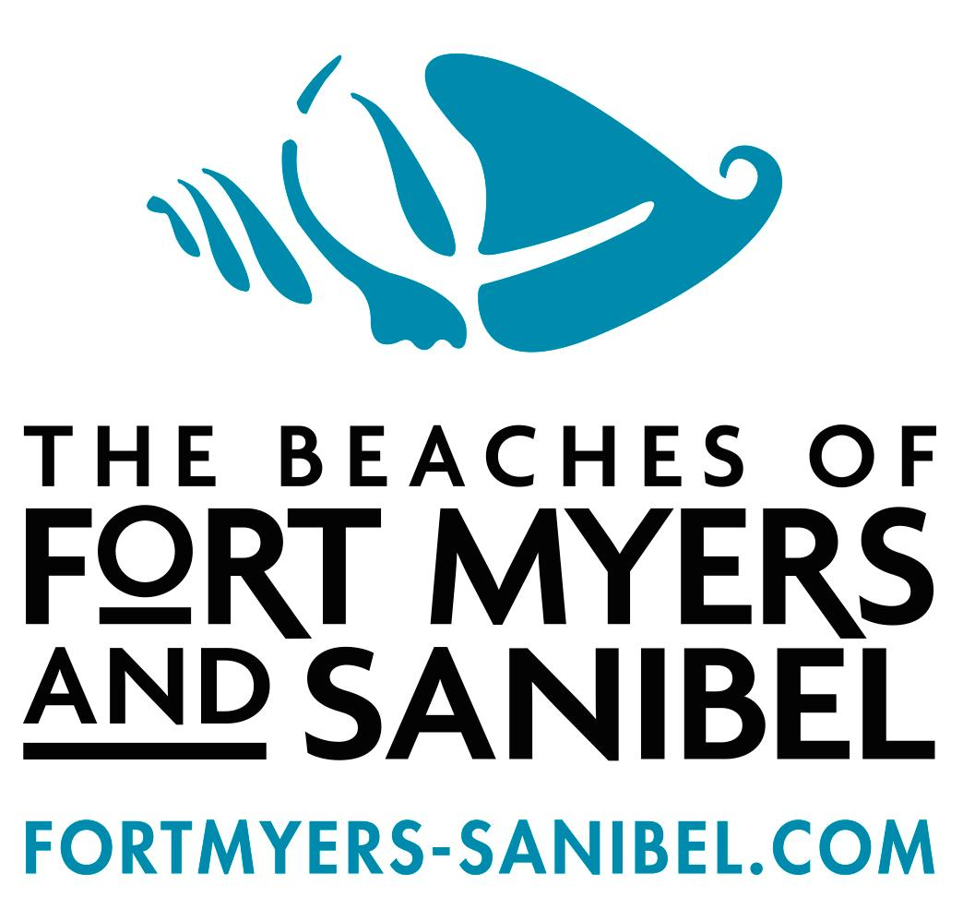

FOR IMMEDIATE RELEASE

Captiva Holiday Village 2014 schedule of events
Happiest Seaside Town in Florida will have special hotel packages available for holiday fest

CAPTIVA ISLAND, Fla. (July 25, 2014) – The hoteliers, merchants, attraction owners and restaurateurs of Captiva Island are getting into the holiday spirit and busily preparing for the fifth annual Captiva Holiday Village.
The three-weekend-long Captiva Holiday Village launches its 2014 spectacular the Friday after Thanksgiving with fireworks, tree lightings, holiday readings, musical performances and more.
Each special-themed weekend will be a fun-filled extravaganza of sight and sound, set against the backdrop of the Gulf of Mexico and evening sunsets. During the event weekends, visitors will enjoy everything from decorated golf cart and lighted boat parades to Junkanoo dancers, live music and even a Marching Mullet Parade.
Last year’s event raised $50,000 for the Golisano Children’s Hospital of Southwest Florida.
“Captiva is a remarkable island village and known as a magnet for creative people,” said Paul McCarthy of Captiva Cruises. “It’s famous for its beautiful beaches, wildlife-filled waters, family-friendly atmosphere and a quirky, relaxed way of life. This island is a perfect place to unwind from holiday stress.”
Coastal Living Magazine recently named Captiva the Happiest Seaside Town in Florida.
According to the magazine, “The slender barrier island in the Gulf of Mexico west of Fort Myers has pale, powdery sands graced with more than 250 types of seashells.”
“It’s never too early to begin preparing for our boat and golf cart parades,” said 2014 Golf Cart Parade Chair Denice Beggs. “These are such unique and fun events for locals and visitors to be involved in, and the competition has really increased with many participants planning their decorations a year in advance.”
Each year, Captiva visitors and locals try to outdo each other by extravagantly decorating their personal or rented golf carts in lights, garland, hats and even plastic flamingos. Fun, festive and sometimes gaudy outfits go along with the tradition.
The Golf Cart Parade begins at South Seas Island Resort at 3:30 p.m. on Saturday, Dec. 6 and is limited to the first 100 entries. All entries must incorporate a holiday theme. The parade route travels from South Seas to Andy Rosse Lane then loops around Chapin and Wiles Drive and back past the Green Flash restaurant before returning to South Seas. A portion of the $20 entrance fee will benefit the Sanibel Captiva Conservation Foundation. Prizes will be awarded for the best entries.
The Boat Parade will take place at 6 p.m. on Saturday, Dec. 13 just outside Roosevelt Channel, Marker #2. The route will follow Roosevelt Channel to ‘Tween Waters Inn and back. There is no entry fee for the boat parade and prizes will be given for the best-decorated vessels. A minimum of 100 lights is required for entry but more are encouraged. Best Boat Club & Rentals at South Seas Island Resort will rent boats to resort guests if they want to decorate and participate in the parade.
Captiva Island resorts, inns, cottages and vacation homes are also offering lodging specials in conjunction with this year’s event.
To learn more about Captiva Holiday Village, visit www.CaptivaHolidayVillage.com.

The 2014 event schedule:

Friday, Nov. 28
• Tree Lighting and Fireworks at ‘Tween Waters Inn

Saturday, Nov. 29
• South Seas Tree Lighting and Children’s Classic Holiday Reading
• Sunset Arias at ‘Tween Waters Inn

Friday, Dec. 5
• Sunset Arias at ‘Tween Waters Inn
• Sanibel Luminary
• Sanibel-Captiva Conservation Foundation’s Nature of Captiva

Saturday, Dec. 6
• Royal Shell’s Decorated Golf Cart Parade
• Golf Cart Awards & Party
• Captiva Luminary

Friday, Dec. 12
• Mullet March at Jensen’s Twin Palms 30 minutes before sunset.
• Sanibel-Captiva Conservation Foundation and Captiva Island Historical Society’s Holiday film at Jensen’s Twin Palms

Saturday, Dec. 13
• Fishing & Mullet Festival at Jensen’s Twin Palms all day
• Junkanoo Parade
• Lighted Boat Parade
• Post Boat Parade Party

Sunday, Dec. 14
• Carol Sing at Chapel By the Sea

About Captiva Island
Captiva Island is a barrier island in the tranquil Gulf of Mexico on Florida’s southwest coast. North of Sanibel Island and west of Fort Myers, world-renowned Captiva is also just three hours from Tampa and Fort Lauderdale by car. A narrow seashell-laden island famous for its dramatic sunrises and sunsets, celebrity visitors and creative residents, Captiva is home to private waterfront estates, two large resorts and several charming small inns. The heart of the island is its vibrant ‘downtown,’ coined “the village,” in which visitors and locals stroll among colorful galleries, shops and restaurants with live music and water views. As the gateway to the out-islands within Pine Island Sound, Captiva is also a watersports destination and offers boaters multiple marinas with overnight dockage. It has been featured in countless magazines and newspapers around the world.

-30-

Contact: Melinda Isley, APR, m.creativepr, 239-274-7736, cell: 239-565-1630, melinda@mcreativepr.com
www.CaptivaHolidayVillage.com

