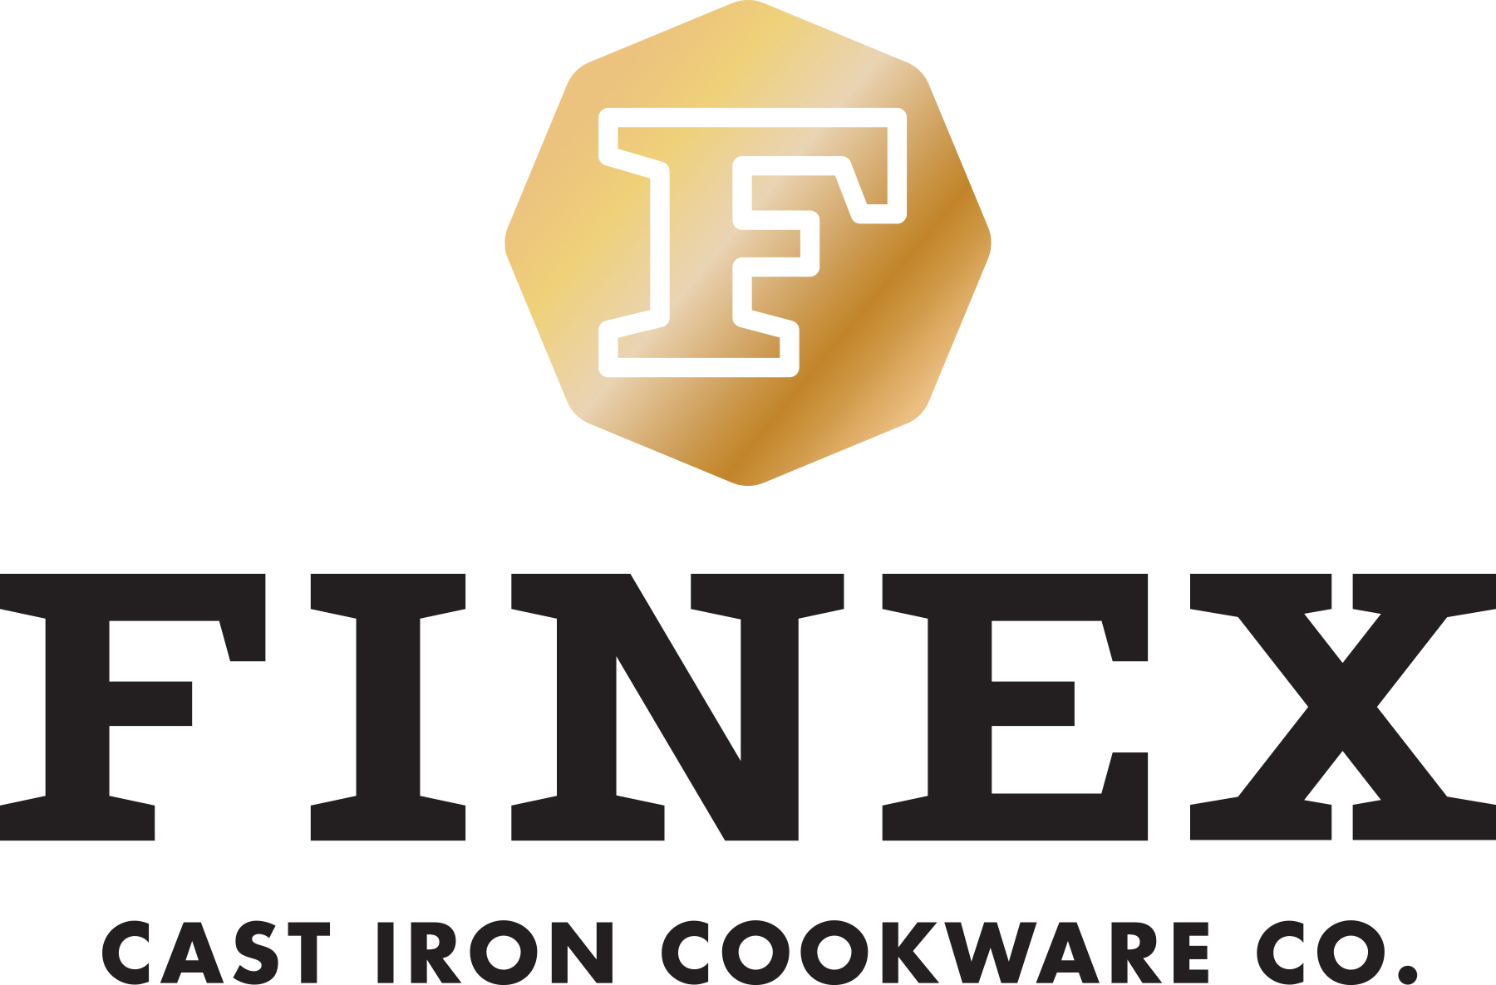
NEWS RELEASE
For immediate release

Crowdsourcing Heats Up U.S. Cast Iron Cookware Market

FINEX® Cast Iron Cookware Co. taps Kickstarter to meet cook’s ever growing demand for premium American-made cast iron cookware.

Portland, Oregon (August 7, 2014) --- America’s love of cast iron cooking is hotter than ever and FINEX® Cast Iron Cookware Co. (www.FINEXUSA.com) is meeting this demand with the Kickstarter launch of an 8-inch version of their iconic heirloom quality skillet on August 7, 2014. The FINEX 12-inch ultra-smooth skillet is already in thousands of homes around the world searing, grilling and sautéing on the healthiest surface you can cook on.

This American designed and manufactured 8-inch FINEX Skillet is another long overdue redesign of a beloved classic featuring:

- Iconic Octagonal “Multi-Pour” Design
- Ergonomic “Speed Cool” Spring Handle
- Polished Easy Release Cooking Surface
- Pre-Seasoned with Organic Flaxseed Oil
- “Good Forever” Warranty

“Our new FINEX 8-inch Cast Iron Skillet is lighter but no lightweight in the kitchen,” says founder Mike Whitehead. “This is your perfect everyday skillet and the design will make you want to give one to your family and friends to share the joy of cast iron cooking.”

The FINEX team is dedicated to crafting heirloom quality cast iron cookware in America for the first time in over half a century. FINEX, a Portland, Oregon company, received an extremely positive response to their 2013 Kickstarter campaign for a new 12-inch skillet. This revolutionary design exceeded its funding goal by 844% and received over $210,000 in support from more than 1,500 backers.

FINEX is now raising support for their new 8-inch Cast Iron Skillet on Kickstarter through September 8, 2014 offering backers special pre-release pricing of $95 during the campaign for an estimated delivery of November 2014. After fulfilling Kickstarter, this skillet will retail for an estimated $125 through select channels.

FINEX 12-inch Cast Iron Skillets are available now for $195 at www.FINEXUSA.com

# # #
Founded in 2012, FINEX® Cast Iron Cookware Company is a small team of Portland-based perfectionists dedicated to making heirloom quality cast iron cookware in America for the first time in over half a century.

For more information, visit http://www.FINEXUSA.com; or e-mail cookwithus@FINEXUSA(dot)com.

High-resolution images are available at http://www.FINEXUSA.com/press-resources/.

