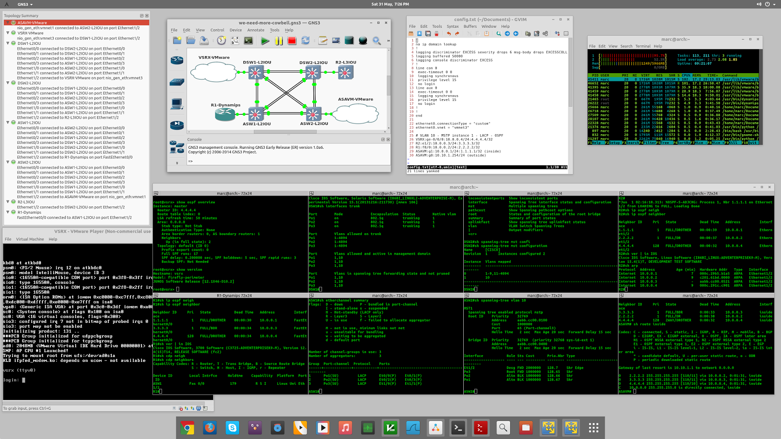

The new GNS3 has an improved switching support allowing network professionals to create complete simulations.

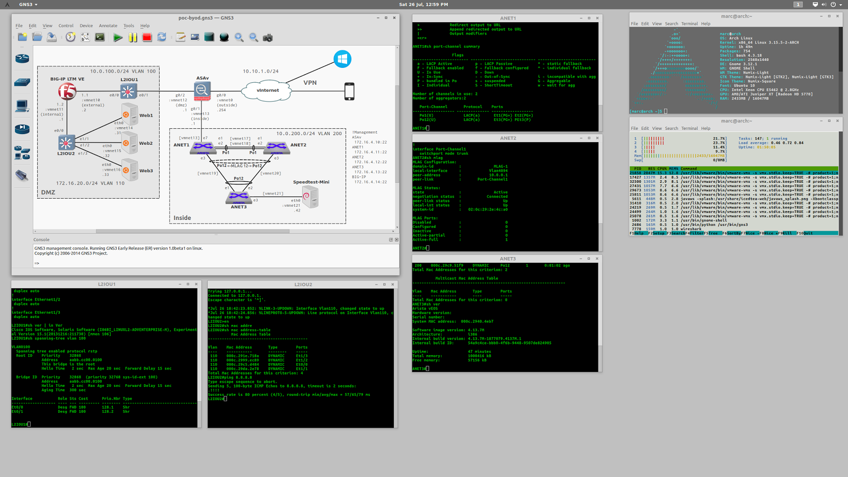

GNS3 is extremely extensible, allowing you to add external appliances and other tools not available from within the software. There is no limit of what network topologies can be created.

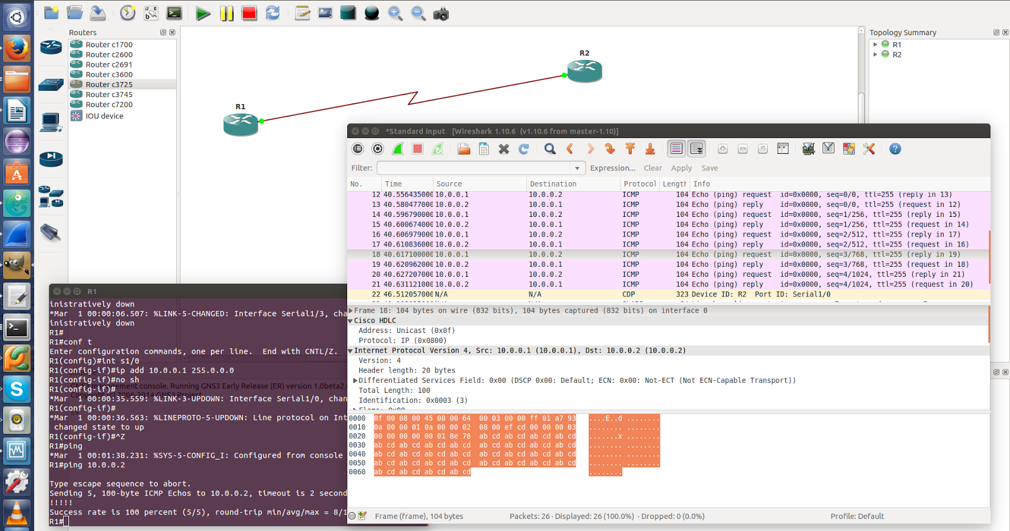

GNS3 allows network professionals to easily capture traffic and therefore understand network protocols and what is really happening under the hood. This is also a great feature to troubleshoot networks.

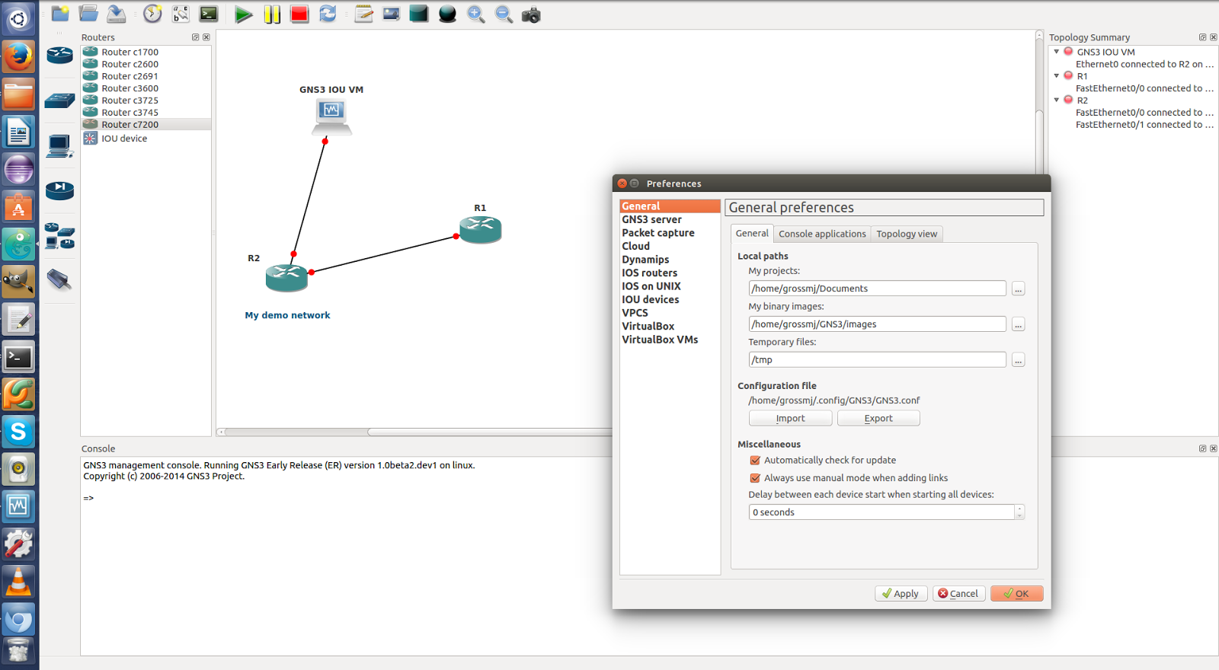
GNS3 is an easy to use and complete network simulation software. Creating great network topologies has never been so simple!

