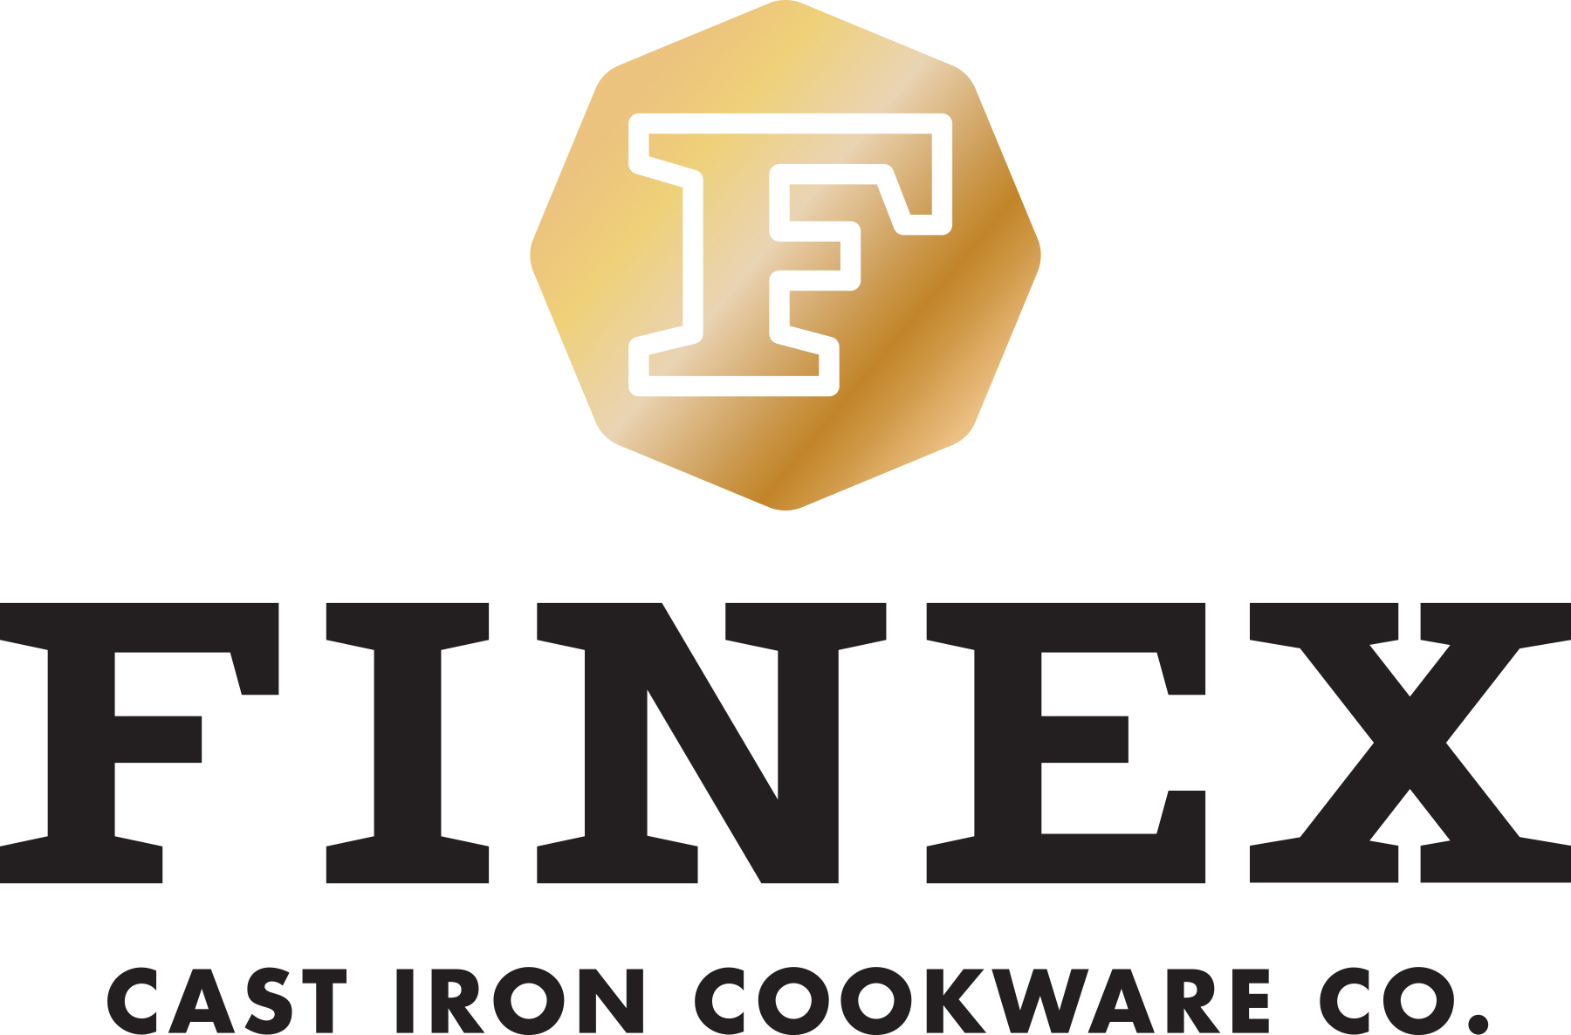
NEWS RELEASE
For immediate release

Crowdsourcing Funding @ 384% -- American Made FINEX® Cast Iron Heats Up Premium Cookware Market
FINEX (www.FINEXUSA.com) is close to completing a very successful Kickstarter campaign for their premium 8-inch Cast Iron Skillet. FINEX has already achieved a remarkable 384% of their funding goal with over 600 backers and will continue to seek additional support on Kickstarter through September 8th.
Portland, Oregon (August 26, 2014) --- FINEX Cast Iron Cookware Co. (www.FINEXUSA.com) is close to completing a very successful Kickstarter campaign of their second product, an 8-inch version of their iconic heirloom quality skillet. The strong acceptance of its design and features has attracted nearly $100,000 from supporters in less than 30 days on Kickstarter. FINEX has already achieved a remarkable 384% of their funding goal with over 600 backers and will continue to seek additional support on Kickstarter through September 8th.

This American designed and manufactured 8-inch Cast Iron Skillet is another long overdue redesign of a beloved classic featuring:

- Iconic Octagonal “Multi-Pour” Design
- Ergonomic “Speed Cool” Spring Handle
- Polished Easy Release Cooking Surface
- Pre-Seasoned with Organic Flaxseed Oil
- Fully designed and manufactured in the USA

“Cast iron cookware is the original nonstick cookware. It’s what our grandparents ate breakfast from when they were little kids. It gets better with time and actually outlasts the kitchens that it’s used in,” muses Mike Whitehead, FINEX founder, in their recently released video. “Crowdsourcing is truly supporting the quality redesign of a beloved classic like a cast iron skillet, in much the same way early American pioneers who cooked with those same skillets gathered together to raise communities. It just feels right.”

FINEX’s 8-inch Cast Iron Skillet retains cast iron’s time-honored cooking superiority and durability without the toxicity concerns that come with much of modern cookware. The 8-inch is a perfect everyday skillet.

FINEX is continuing to raise launch funds through their Kickstarter campaign through September 8, 2014 offering backers special pre-release pricing of $95 during the campaign for an estimated delivery of November 2014. After fulfilling Kickstarter, the 8-inch skillet will retail for an estimated $125 through select channels.

# # #
Founded in 2012, FINEX® Cast Iron Cookware Company is a small team of Portland-based perfectionists dedicated to making heirloom quality cast iron cookware in America for the first time in over half a century.

For more information, visit http://www.FINEXUSA.com; or e-mail cookwithus@FINEXUSA(dot)com.

High-resolution images are available at http://www.FINEXUSA.com/press-resources/.

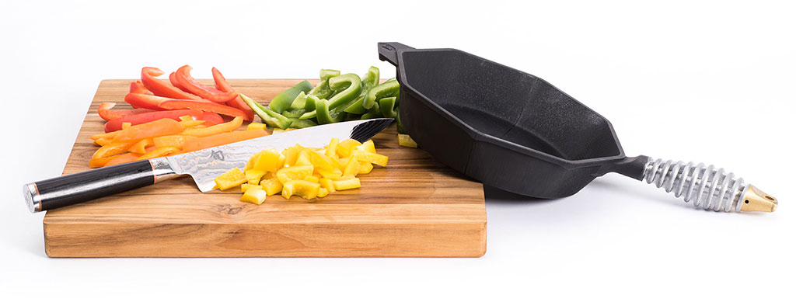 FINEX 8" Cast Iron Skillet [3D Model]

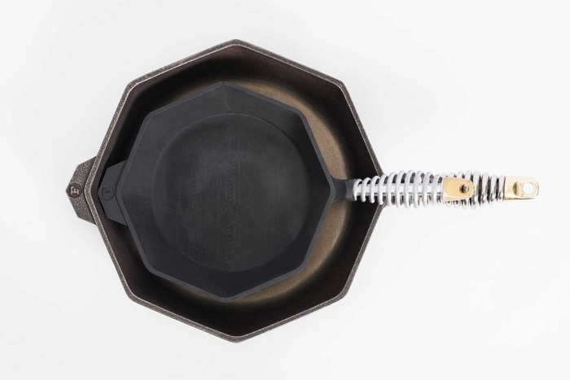
FINEX 8" Cast Iron Skillet [3D Model] with FINEX 12” Cast Iron Skillet

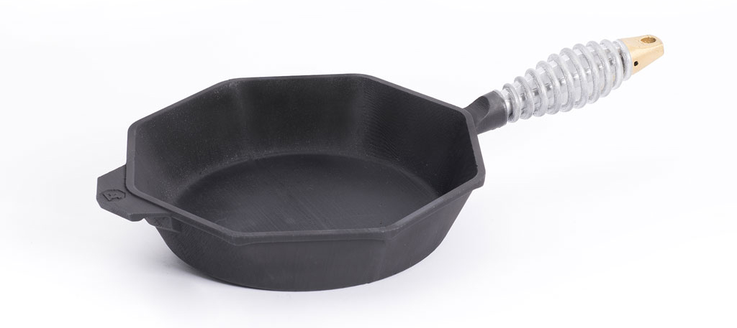
FINEX 8" Cast Iron Skillet [3D Model]
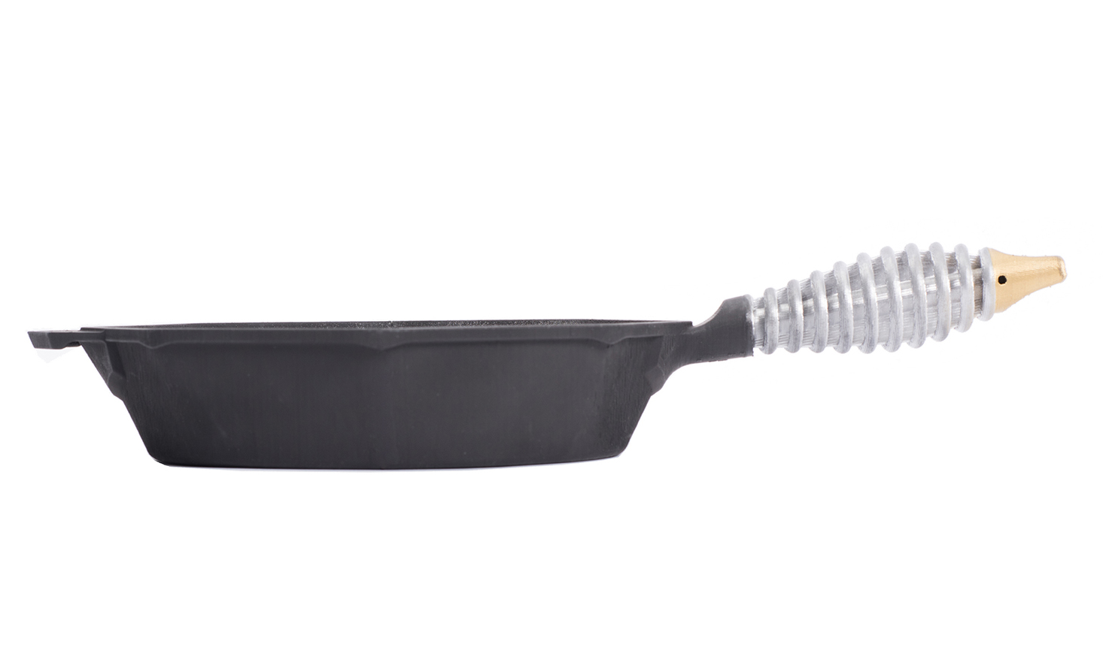
FINEX 8" Cast Iron Skillet [3D Model]

