  - Immigration Law Firm Serving Clients Nationwide Since 1995

Family Immigration Employment Immigration Investor Immigration Deportation Defense

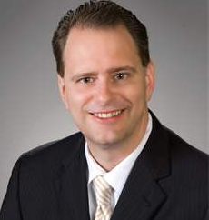

RICHARD HERMAN

Richard Herman is a nationally-known advocate for immigrant rights and founder of the Herman Legal Group, an immigration and general practice law firm founded in 1995, now serving clients in Ohio and Michigan. Along with attorneys Charmaine Rozario Vania Stefanova and Of-Counsel Frank Krajenke, Richard and his team speak over 12 languages. We are experienced in all aspects of immigration law, including family immigration, employment immigration, investor immigration and deportation defense.

Richard has been named to Best Lawyers in America 2015, the oldest and most respected peer-review publication in the legal profession. Partnered with U.S. News & World Report, the Best Lawyer lists are published The Washington Post, The Wall Street Journal, The New York Times, The Chicago Tribune and publications around the world.
For 10 years in a row, Richard has been acknowledged as a “Super Lawyer” and “Leading Lawyer” by various business publications.

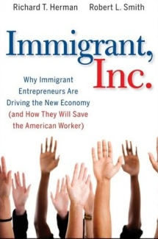

Richard is the co-author of the internationally-acclaimed book, Immigrant, Inc. ---Why Immigrant Entrepreneurs Are Driving the New Economy (John Wiley & Sons, 2009), a powerful interweaving of success stories and research which will forever change the way you look at immigrants ---- and America

Richard’s poignant commentary has been sought out by many national media outlets, including New York Times, USA Today, BusinessWeek, Forbes, FOX News (The O’Reilly Factor), National Public Radio, Inc., National Lawyers Weekly, PC World, Computerworld, CIO, TechCrunch, Washington Times, San Francisco Chronicle and InformationWeek.

Richard is “AV-Rated,” the highest rating by Martindale-Hubbell’s peer review conducted by lawyers and judges. Richard is admitted to the Ohio Bar; the U.S. Federal District Court, N. District of Ohio; and the U.S. 6th Circuit Federal Court of Appeals. Richard is a graduate of Case Western Reserve University School of Law, and is a former trustee of the Cuyahoga County Bar Association and Legal Aid Society of Cleveland..

Richard received the “Client’s Choice Award” and top rating of “10” by the law website AVVO.

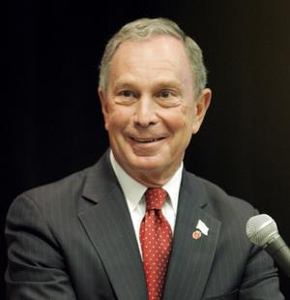
Richard has spoken around the country on behalf of former New York City Mayor Michael Bloomberg’s initiative, Partnership for a New American Economy, a national coalition of over 400 CEOs and mayors who make the case that smart immigration makes America stronger. A fierce advocate for his clients and for immigration law reform, Richard is a nationally-renowned commentator on immigration and global diversity.

Richard is the co-founder of TiE-Ohio, the Columbus-based chapter of The Immigrant Entrepreneurs Association based in Silicon Valley and sits on its board

Richard is a co-founder of Global Detroit, an effort to revitalize Southeast Michigan’s economy by pursuing strategies that strengthen Detroit’s connections to the world, and that make the region more attractive and welcoming to immigrants, internationals, and foreign trade and investment.

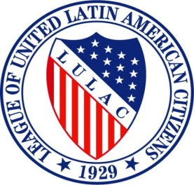
Richard is the Civil Rights Director of LULAC Ohio, a chapter of The League of United Latin America Citizens, the largest and oldest Hispanic organization in the U.S.

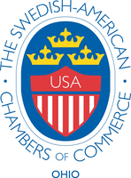
Richard has recently served on the board of The Swedish Chamber of Commerce of Ohio. Headquartered in Cleveland, the Ohio Chapter of SACC-USA serves the Ohio region., which includes Western Pennsylvania, Eastern Indiana, Western New York and West Virginia.

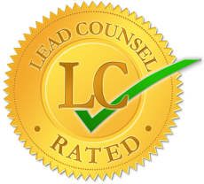

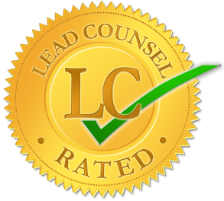
Richard received the Lead Counsel Rating in by the Lead Counsel Review Board.

On a personal note, Richard is a Cleveland native and former resident of Moscow, Russia. He is married to Dr. Kimberly Chen, a physician born in Taiwan. They are raising their children, Nathan (12) and Isabella (10), to be citizens of the world.

