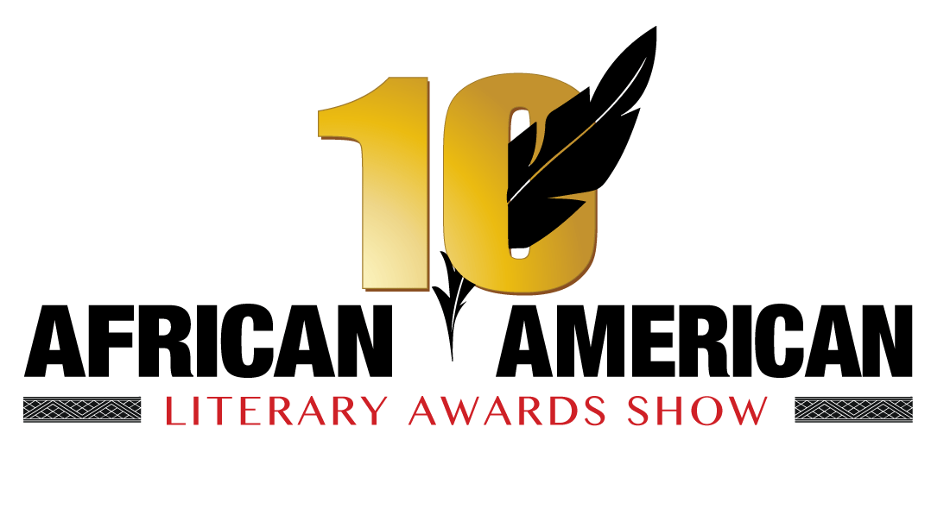

CONTACT: Valerie Wilson, Valinc PR FOR IMMEDIATE RELEASE
917-405-5917, Valerie@ValincPR.com

THE 10TH ANNUAL AFRICAN AMERICAN LITERARY AWARDS SHOW
TO TAKE PLACE SUNDAY, OCTOBER 26TH IN HARLEM

AWARDS HOSTED BY TV PERSONALITY& AWARD-WINNING PRODUCER PATRICK L. RILEY

HONOREES INCLUDE MAYA ANGELOU AND JAMES EARL HARDY

Harlem, New York – October 13, 2014 – The 10th Annual African American Literary Awards is set to take place on Sunday, October 26, 2014 at MIST Harlem 46 W. 116th Street. The event is the first and only awards show to recognize, honor, celebrate and promote the achievements and contributions of African-American authors, writers, publishers, artists and related entertainment industries together with their fans. This year marks the Awards’ 10th Anniversary, making this legendary awards ceremony the most anticipated literary event of the year.

The awards will be hosted by TV Personality & Award-Winning Producer Patrick Riley. He will be joined by an impressive list of presenters, including: Wendy Williams, Walter Mosley, Terrie Williams, Hi Five, (singing group), Freddie Jackson, Shawn Bullard, Khalil Kain, Stanley Bennett Clay, Robert Christopher Riley, Tiffany Denee Jones, Bevy Smith and Michaela Angela Davis.

The program will include recognition of two honorees, Dr. Maya Angelou and James Earl Hardy. Also in attendance and presenting will be several offspring of great literary and entertainment giants, including Gina Belafonte (Harry Belafonte), Raoul Roach (Max Roach), Suzanne Bramford (Diahann Carroll), Trevor Baldwin (James Baldwin), Richard Pryor Jr. (Richard Pryor), Rhonda Ross (Diana Ross and Berry Gordy) and Tren'ness Woods- Black (Sylvia Woods).

The evening will begin with a Pre-Show VIP Red Carpet Cocktail reception featuring songbird Lady Leah, followed by The Awards show that will include musical guests and Harlem sensation Farrah Burns, and special tributes to our honorees James Earl Hardy and the late Dr. Maya Angelou. Part of the evening’s proceeds will benefit the Harlem Educational Activities Fund (HEAF). Tickets are available for purchase at www. http://literaryawardshow.com.

-more-

About AALAS and Founder Yvette Hayward:
Yvette Hayward is the president of Flowers & Hayward Publicity & Mgmt. a public relations company that has been a powerful resource in the literary and entertainment field for over seven (10) years. She has represented well-known authors such as, Essence best-selling authors, Lolita Files, Victoria Christopher Murray, Carol Mackey, New York Times best-selling authors, Eric Jerome Dickey & Wendy Williams.

The company’s primary mission is to bring recognition to African-American authors throughout the country. With an established client base of best-selling authors, the company is able to carry out its mission through developing client specific tailored programs such as book signings, radio, television, print and promotional tours.

The African American Literary Award show is the brainchild of Ms. Hayward. She came up with the idea in 1996 and was finally able to bring it to fruition in September 2004.

About Harlem Educational Activities Fund:
The Harlem Educational Activities Fund (HEAF) changes the lives of underserved young people beginning in middle school and continuing in college and beyond through a youth development approach that includes rigorous year-round academic enrichment, social and cultural exposure and constant individual attention. Founded in 1989 by philanthropist Daniel Rose, HEAF has long been at the forefront of providing high-quality supplemental education and creating pathways to higher learning for underserved minority New York City youth. We serve approximately 500 middle school, high school, and college students each year through our college access and success programs, providing the resources and guidance they need to get excited about learning, as well as pursue and complete a college education.

Musa Jackson Productions LLC( MJP)/Producer:
Musa Jackson, CEO of MJP is a Harlem native has been in the entertainment field for more than three decades. He has produced fashion shows for Catherine Malandrino, DVF and Betsy Johnson, written TV pilots such as “One Two Five” as well as “Pandora’s Box” a feature film for Disney’s Hollywood Pictures Division. He is one of the winners of The American Screen Gem Awards for Best Short Screenplay. MJP is a force in the Harlem community, working with non- profits like HEAF, MMPCIA and HCDC and opening and building brands like Harlem Shake, Corner Social, Barawine, Settepani, Red Rooster/Ginny’s, Cedric’s, BTL Harlem and The Apollo. For more information please visit: www.heaf.org

2014 AALAS NOMINEES:

Biography/Memoir
Misty Copeland – Life in Motion
Janet Mock – Redefining Realness
Robin Roberts – Everybody’s Got Something
Jesymn Ward – Men We Reaped

Christian
ReShonda Tate Billingsley & Victoria Christopher Murray – Fortune & Fame
E.N. Joy – More Than I Can Bear
Sharel E. Gordon – Change Me For My Season
K.T. Richey – Sunday Morning Blues

Fiction
Elissa Gabrielle – Eye Of the Beholder
Nina Foxx – Momma: Gone
William Frederick Cooper – Unbreakable
Danielle Santiago – The Conglomerate

Erotica
Elissa Gabrielle - Pillow Talk in the Heat of the Night
Cairo – Slippery When Wet
Eden Davis - Dare to Be Wild
N’Tyse – Twisted Vows of Seduction

Mystery
Cole Riley – Little White Lies
Walter Mosley - Debbie Doesn't Do It Anymore
Eric Jerome Dickey – A Wanted Woman
Pamela Samuels Young – Anyone’s Daughter

Romance
Wendy Williams – Hold Me In Contempt
Derrick Jaxn – A Cheating Man’s Heart
Beverly Jenkins – Hear Of Gold
Donna Hill - Tender Loving Passion

Street Fiction
K’WAN – The Fix
Wahida Clark – Blood, Sweat & Payback
Tasha Macklin - Baller Dreams
Ni'chelle Genovese – Baby Momma 3

Short Stories/Anthologies
Nina Foxx – A Letter For My Mother
Elissa Gabrielle, Lorraine Elzia, Ebonee Monique – Pillow Talk in the Heat of the Night
Tenille Brown – Can’t Get Enough
Brian A. Smith , Pamela Samuels Young, Monique D. Mensah & Nakia R. Laushaul - The Funeral - an Anthology

Self Help
T.D. Jakes – Instinct
Iyanla Vanzant – Forgiveness
Russell Simmons - Success Through Stillness: Meditation Made Simple
Abiola Abrams - The Sacred Bombshell Handbook of Self-Love: The 11 Secrets of Feminine Power

Children’s Author/Young Adult
Nina Foxx: Catfish
Elissa Gabrielle & Angelia Vernon Menchan - Glowing Embers in a Dying Fire
Jerry Craft, Jaylen Craft & Aren Craft - The Offenders: Saving the World, While Serving Detention!
Betty K. Bynum - I'm a Pretty Little Black Girl!

Non Fiction
Edward Lewis - The Man from Essence: Creating a Magazine for Black Women
Marion Barry & Omar Tyree - Mayor for Life: The Incredible Story of Marion Barry, Jr.
James E. Clyburn - Blessed Experiences: Genuinely Southern, Proudly Black
Pearl Cleage - Things I Should Have Told My Daughter: Lies, Lessons, & Love Affairs

Author Of the Year (Female)
Elissa Gabrielle – Eye of the Beholder
Terry McMillian – Who Asked You?
Iyanla Vanzant - Forgiveness: 21 Days to Forgive Everyone for Everything
Nina Foxx – Mama Gone

Author Of The Year Male
K’WAN – Black Lotus
Curtis Bunn – Old Man In The Club
Walter Mosley – Debbie Doesn’t Do It Anymore
JaQuavis Coleman – The White House

Break Out Author Of The Year
Nikki Woods – Easier Said Than Done
Dr. Catrina Pullum - Breaking the Chains: From Hurting to Healing
Candy Jackson – Pink & Patent Leather
Khara Campbell – Not My Will

Self-Published Author Of The Year
Tamika Newhouse – The Words I Didn’t Say
Elissa Gabrielle – Eye of the Beholder
Joyce A. Brown--What You Can Get Away With
Monica Michelle – Lucky No. 5

Independent Publisher of The Year
Delphine Publications
Peace in the Storm
Live the Dream Publishing
Black House Publishing

Publishing House Of The Year
Kensington
Kimani Press
Simon & Schuster
Grand Central Publishing

Literary Magazine
Mosaic
SORMAG (Shades of Romance)
Black Pearls
Written

Cookbook
Pat & Gina Neely - Back Home with the Neelys: Comfort Food from Our Southern Kitchen to Yours
Carla Hall - Carla's Comfort Foods: Favorite Dishes from Around the World
Bryant Terry - Afro-Vegan: Farm-Fresh African, Caribbean, and Southern Flavors Remixed
Chef Jerome Brown - Eat Like A Celebrity: Southern Cuisine with a Gourmet Twist

Magazine (Non-Literary)
Ebony
Uptown
Black Enterprise
Heart & Soul

Book Club of The Year
Go On Girl Book Club
Sistahfriend Book Club
Lovely Essence Book Club
Booktalk ladies Book Club

###

