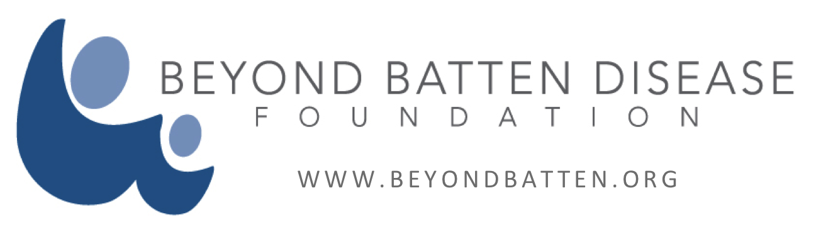

For Immediate Release

Contact: David McKeon- DMcKeon@NYSCF.org 212-365-7440 or
Angela Hale - 512-289-2995 angela@redmediagroup.com

Beyond Batten Disease Foundation and the New York Stem Cell Foundation Chosen as a National Innovator by the Milken Institute as They Partner to Find a Cure for Juvenile Batten Disease

The Battle is Personal for a Texas Father Who is Trying to Save His Own Daughter’s Life

New York City, New York – November 17, 2014 – Beyond Batten Disease Foundation (BBDF) and the New York Stem Cell Foundation (NYSCF) have been selected as a national innovator by the Milken Institute and will present their breakthrough findings about juvenile Batten disease at the 6th annual Partnering for Cures, November 16-18 in New York City. The presentation will highlight the
collaborative efforts of NYSCF, BBDF and Batten Disease Support and Research
Association.

Craig and Charlotte Benson established Beyond Batten Disease Foundation in August 2008 after their then five-year-old daughter, Christiane, was diagnosed with juvenile Batten disease. Together with hundreds of families affected by Batten disease, and many more supporters who share their hope and resolve, they are working tirelessly to create a brighter future for Christiane, and all children with Batten disease.

Watch the Benson Family story:

https://beyondbatten.org/family-stories/the-benson-family-story/

Beyond Batten Disease and the New York Stem Cell Foundation hope to ramp up funding and partnerships to develop stem cell resources to investigate and explore new treatments and ultimately find a cure for juvenile Batten disease, a fatal illness-affecting children as they convene at the FasterCures, conference. The Washington, D.C.-based center of the Milken Institute will bring together nearly 1,000 medical research leaders, investors and decision-makers to forge the collaborations needed to speed and improve outcomes-driven R&D.
NYSCF scientists have created the first iPS cells from a neurological disease and the first ever stem cell disease model from any disease. This discovery was named Time Magazine #1 breakthrough in 2008 because it was the first time anyone has made stem cells from a person with a disease and used them to produce the type of cell that degenerated in that patient. Again, in 2012 Time Magazine recognized the Beyond Batten Disease Foundation’s creation of a rate genetic disease test as a top ten medical breakthrough.

“We know the genetic mutations associated with juvenile Batten disease. This partnership will result in stem cell models of juvenile Batten, giving researchers an unprecedented look at how the disease develops, speeding research towards a cure,” said Susan L. Solomon, NYSCF Chief Executive Officer.

“Working with NYSCF to generate functional neuronal subtypes from patients and families is a stellar example of one of our key strategies in the fight against juvenile Batten disease: creating resource technology with the potential to transform juvenile Batten disease research and accelerate our timeline to a cure,” said Danielle M. Kerkovich, PhD, BBDF Principal Scientist.

Juvenile Batten disease begins in early childhood between the ages of five and ten. Initial symptoms typically begin with progressive vision loss, followed by personality changes, behavioral problems, and slowed learning. These symptoms are followed by a progressive loss of motor functions, eventually resulting in wheelchair use and premature death. Seizures and psychiatric symptoms can develop at any point in the disease.

Juvenile Batten disease is one disorder in a group of rare, fatal, inherited disorders known as Batten disease. Over 40 different errors (mutations) in the CLN3 segment of DNA (gene) have been attributed to juvenile Batten disease. The pathological hallmark of juvenile Batten is a buildup of lipopigment in the body’s tissues. It is not known why lipopigment accumulates or why brain and eventually, heart cells are selectively damaged. It is, however, clear that we need disease-specific tools that reflect human disease in order to figure this out and to build therapy.

Partnering for Cures is designed to facilitate informed investments and cultivate relationships, adapting the outcomes-oriented approach of investor conferences, and building on the networking opportunities at industry partnering meetings. In addition to innovator presentations, it also features panels that spotlight solutions to long-standing challenges in medical research.

Beyond Batten Disease Foundation is one of 30 innovators presenting their cross-sector research collaboration to potential partners and funders at the conference. Selected through a competitive proposal process, each partnership is aimed at reducing the time and cost of getting new medical solutions from discovery to patients.
###

About The New York Stem Cell Foundation
New York Stem CF researchers have achieved several major discoveries in the field, including: the first beta cell model that accurately reflects the features of a genetic form of diabetes in June 2013; the generation of functional, immune-matched bone substitutes from patients’ skin cells (featured in The Wall Street Journal in May 2013); the discovery of a clinical cure to prevent transmission of maternally inherited mitochondrial diseases in December 2012; and, the creation of the first disease model from induced pluripotent stem cells (also named the #1 Medical Breakthrough by Time magazine in 2008). More information is available at www.nyscf.org.

About Beyond Batten Disease Foundation
Beyond Batten Disease Foundation works to cure and prevent juvenile Batten disease, a rare, inherited neurological disorder that strikes young children, first causing vision loss and seizures, then cognitive and motor impairment, and ultimately death by the late teens or 20s. The foundation raises funds for research and is leading development of an easy and inexpensive, groundbreaking blood test to detect the gene mutations that cause juvenile Batten disease as well as 750-plus, other rare but serious and often fatal childhood ailments. For more information, visit www.beyondbatten.org.

About Batten Disease Support and Research Association
The Batten Disease Support and Research Association (BDSRA) is the largest nonprofit organization in North America dedicated to funding research, advancing education, providing family support services, and raising awareness of the disease and its impact. Founded in 1987, the focus of BDSRA is to help unravel the mysteries of Batten disease by bringing the worlds of science, research, and health care together toward a common goal: the discovery of treatments and cures. For more information see: www.bdsra.org.

For more information and to register for the conference, go to www.partneringforcures.org

