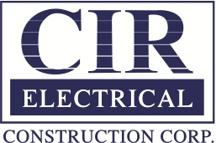
November 22, 2014
MEDIA CONTACT
Todd Salansky
ts@norrisclifton.com
716.481.0906

CIR Solar Park Produces Energy During Record “Snowvember” Snowfall
BUFFALO, NY – Jeff Pedro, Chief Financial Officer of CIR Electrical Construction Corporation, is proud to announce that the DEGERtrackers in their solar park continued to produce power during the week of record snow fall for November. In the aftermath of 60+ inches of snow, Buffalo and the surrounding suburbs attempted to clean up the mess left behind. Snow covered anything left outside during the storm, but CIR's Solar Panels remained untouched and ready to produce solar energy. Watch our Youtube video at CIR Solar Park produces energy during record "Snowvember" snowfall

DEGERtrackers use state of the art technology. The panels are protected from high winds by an anemometer, which measures wind speed, and moves the panels to a safe position. A snow sensor identifies snow buildup on the solar panels, and tilts them 90° to clear the snow. These panels yield about 45% more energy than a fixed solar system of equal size.

Despite receiving over 6 feet of snow, these solar panels continued to produce power. In fact, current monthly data shows that the system will produce 97% of the expected KiloWatt Hours for November. Continuously producing power in spite of heavy snow and generally cloudy skies.
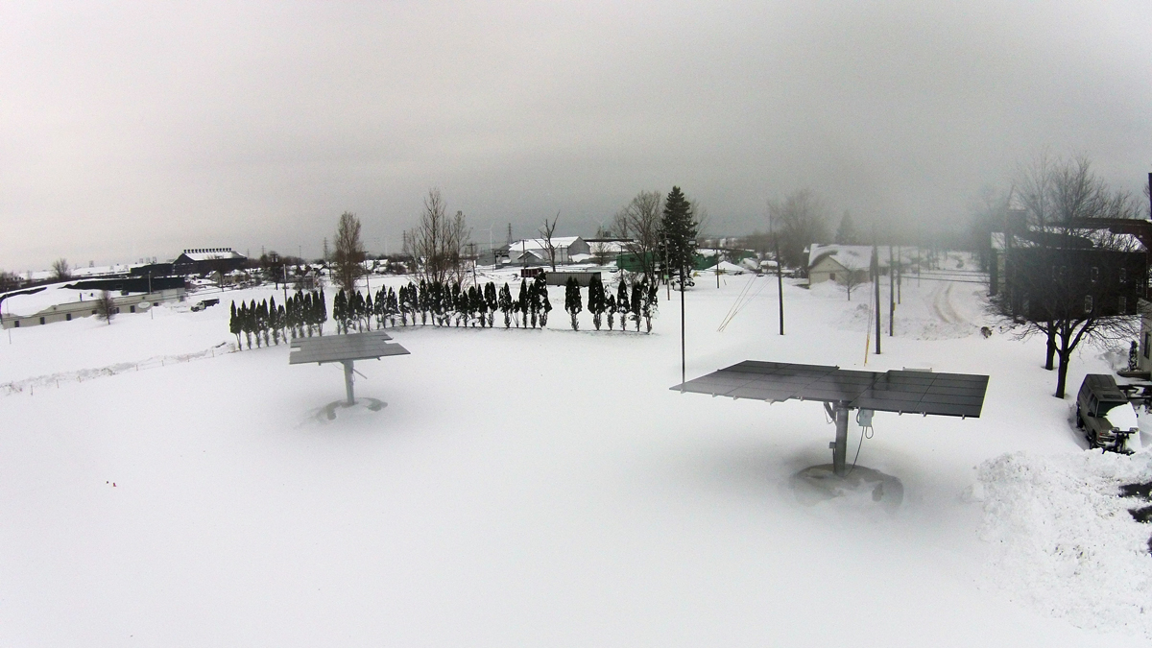
Trackers: (2) 6kW Deger 5000HD
Figure 1 Solar Park at CIR headquarters.
Panels: (48) 250W Suntech Mono-Crystalline
Microinverters: (48) Enphase M215
Elevation Range of Motion: 10-90°
Azimuth Range of Motion: 300°
Watch our Youtube video at CIR Solar Park produces energy during record "Snowvember" snowfall

About CIR Electrical Construction Corp.:
Established in 1976, CIR Electrical Construction Corporation is one of the largest electrical contractors in Western New York. Privately held, CIR is proud to have installed the first solar tracking system in Erie County and is dedicated to sustainability and energy efficient technologies that benefit both the environment and the area’s economy. CIR helps customers decrease their carbon and ecological footprints while saving on energy costs. Proudly affiliated with the National Electrical Contractors Association, CIR provides a wide range of electrical construction projects including commercial, industrial and renewable energy. For more information please visit: www.cirelectric.com
###

