Press Release Contacts:
For Immediate Release Vinitaly International
International Media Dept.
+39 045 8101447
media@vinitalytour.com
www.vinitalytour.com
Twitter: @VinitalyTour
Join Vinitaly International Network on LinkedIn

1000 wine professionals, 100 speakers, all in the name of wine2wine

Edition zero of “wine2wine” closed on the 4th of December with a positive feedback from the more than 1000 professionals present during the first event in Italy to be entirely dedicated to the business of wine: a total of 26 workshops covering a wide range of topics from marketing, law and finance to international markets and digital media offering attendees the necessary know-how to face the continuous changes of a multifaceted wine sector.

Among the many sessions dedicated to new upcoming international markets, “The New Faces of the Chinese Market”, presented by Shangri-La Hotel wine director Yang Lu, the president of Grace Vineyard, Judy Chan, Pinor Sommeliers magazine editor-in-chief Sunny Zhang and Yanni Wu ex-WINE100 Challenge, was received enthusiastically by Italian wine professionals, who were enthralled and bewildered by the recent evolution taking place under Xi Jinping’s anti-extravagance campaign.
“The Chinese wine market is no longer the ‘El Dorado’ that we saw back in 2008. To succeed in China now, you need to think long-term,” warned Yanni Wu, supporting her arguments with the latest market data.
Sunny Zhang, who could not be present in person, echoed similar thoughts in the course of a video presentation: “anti-corruption policies have on the one hand nearly crushed the luxury wine market which had been growing so fast in the past years. On the other hand, though, it is interesting to see how the sales of low to mid range wines has actually been increasing in the face of a 400% upturn of wine consumption in the Country.” Mrs Yang went on to describe some of the driving factors behind such a growth: “With new disposable income at hand, wine consumption is now being increasingly associated with a healthy and acceptable lifestyle. Chinese wine consumers are also becoming much more sophisticated in terms of wine knowledge and etiquette”.

Selling wine in China is far from challenging when compared to running a vineyard, as explained by Judy Chan, who leads one of the few top boutique vineyards in the country in Shanxi province. “Establishing a vineyard in China is strewn with all sorts of challenges and when I say ‘all sorts’, I mean it. The least of these problems” she continues, “is that you simply cannot get virus-free vines in China and we need to propagate our own.” Bureaucracy also constitutes a heavy burden: in one power point slide, Mrs Chan listed more than 30 government bodies that she regularly needs to deal with. “I have actually a whole team of staff just for our regular dealings with the government.”

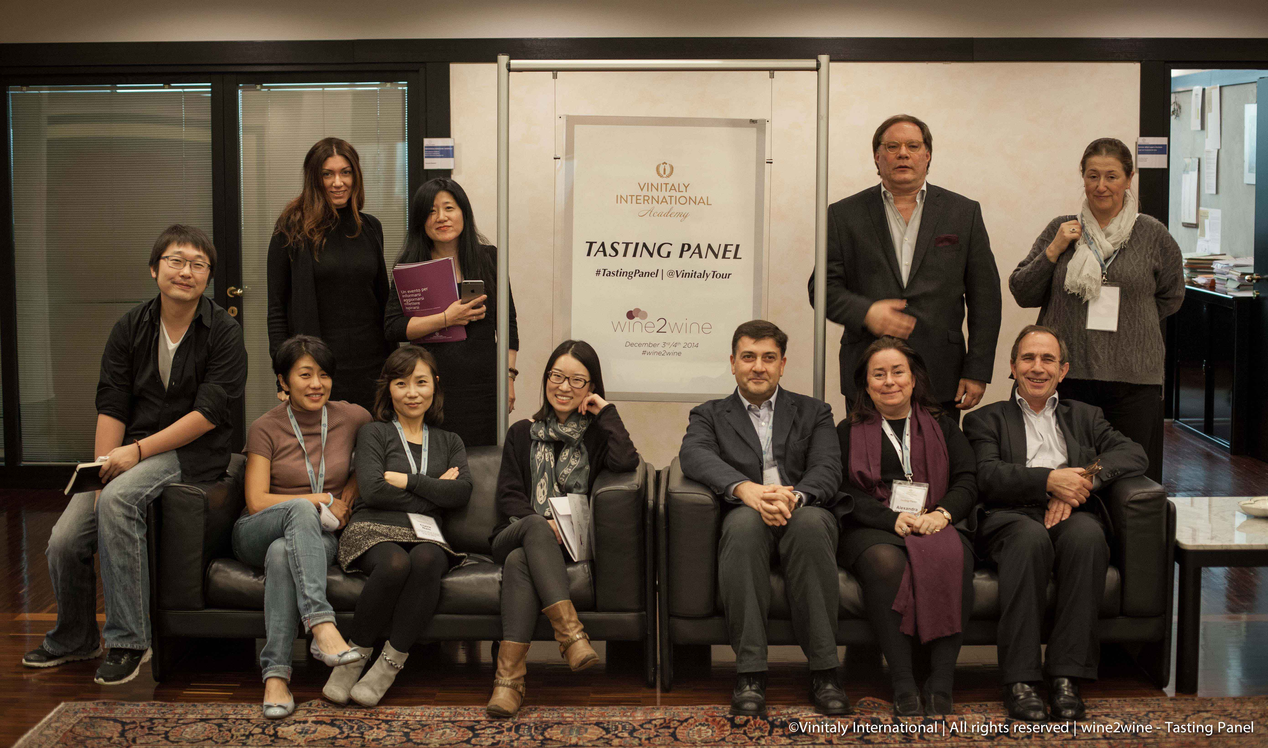

Yang Lu, Wine Director of Shangri-La group closed the session with a charming and straightforward overview of the pros and cons in the Chinese wine market today. In his presentation, “High-end On Trade Market: the Good, the Bad and the Ugly”, Mr Lu went straight to the point confessing that when it comes to listing wine in top-end on-trade, China is no different from other mature markets. “We will squeeze the price and ask for incentives. It’s normal, so be ready for this,” he cautioned, not hesitating to dole out advice. “Just to be listed in a 5-star hotel doesn’t guarantee sales at all, though it gives marketing value. Wine by glass or banquet wine sales are what you need to strive for.”
With his presentation drawing to an end, attendees started to piece together a general picture of the wine market in China, both attractive and daunting at the same time given the fact that Italian wines are still very much behind in terms of education, customer awareness and perceived value. Italian wine producers should be realistic when evaluating the potential of this market and invest in education, good importers and establish tight and respected relationships. And of course, experience the country first-hand.
The first edition of wine2wine seemed to be responsive to the Italian Wine Industry's need for additional tools to address the international markets, as explained by Stevie Kim, Managing Director of Vinitaly International: "we have actually been doing seminars dedicated to our producers during Vinitaly for many years now, but most were too busy to attend, despite the calibre of panel expertise, as all were too focused on their commercial activities. wine2wine, which recalls b2b, was positioned in December, just after the harvest and Fall promotional activities and before the Christmas holidays.
It was the "trial" edition in many ways, many things to improve, but like Yang Lu's intervention, the next few weeks will be dedicated to accessing the Good, the Bad and the Ugly of this showcase”.

About:

Veronafiere is the leading organizer of trade shows in Italy including Vinitaly (www.vinitaly.com), the largest wine event in the world. The 48th edition of Vinitaly counted some 155,000 visitors (+6%) in four days of event, of which 56.000 were international attendees representing 36% of the total. On 100.000 square meters, 4.000 exhibitors welcomed trade professionals, media and producers alike. The next instalment of the fair will take place on 22 – 25 March 2015. The premier event to Vinitaly, OperaWine (www.vinitalyinternational.com) “Finest Italian Wines: 100 Great Producers,” will unite international wine professionals on March 21st 2015 in the heart of Verona, offering them the unique opportunity to discover and taste the 100 best Italian wines, as selected by Wine Spectator. In 1998 Veronafiere also created Vinitaly International to develop a global platform for the promotion of Italian wine producers in foreign markets such as Russia, China, USA and Hong Kong.

# # #

