GlobeCore Announces the Production of its

New Oil Regeneration Machine

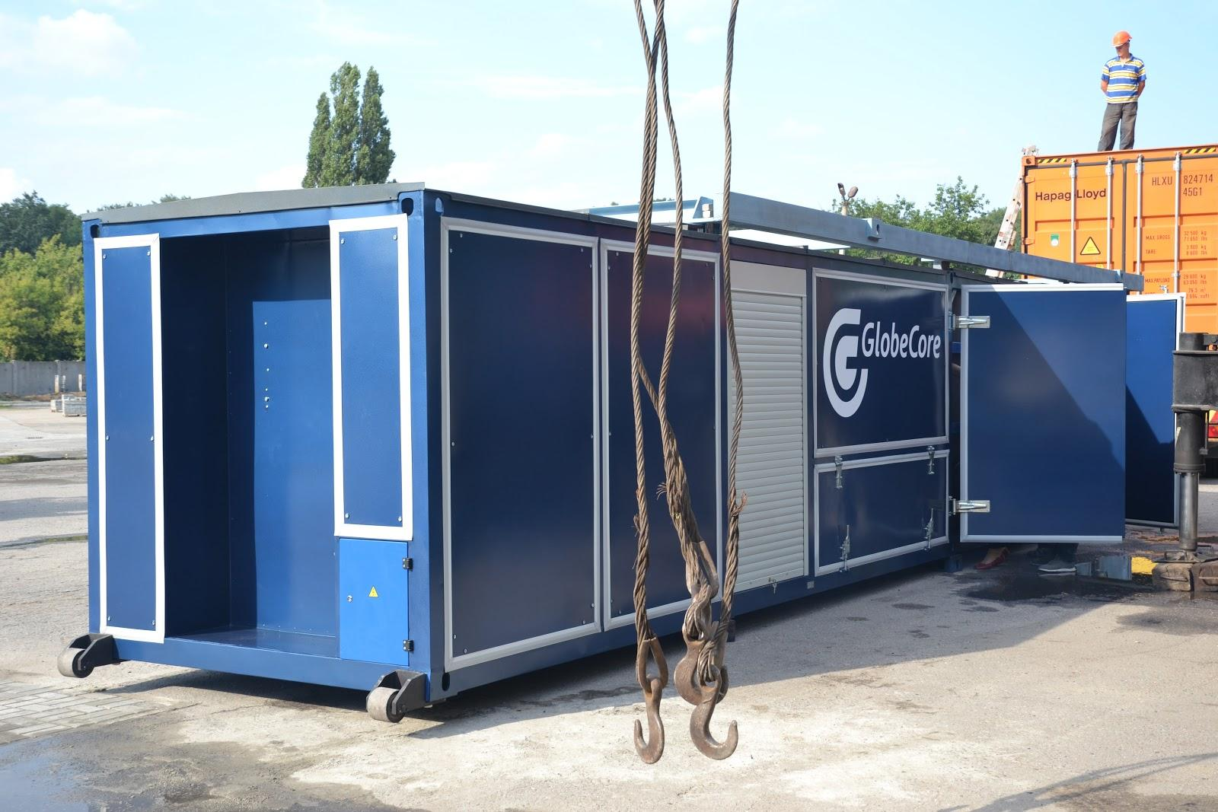
GlobeCore, a world leader in developing cost effective and environmentally sound solutions to industrial waste oil problems, is pleased to announce that it has developed and is now producing a highly efficient Oil Regeneration machine.
GlobeCore GmbH has produced oil processing equipment for many years and has now developed a machine that will eliminate the need to replace industrial oils and fluids.
GlobeCore GmbH, a German based company (head office is located in Oldenburg, Germany) with support staff located in Ukraine, South Africa and the USA, has developed a new oil filtration process that can regenerate used transformer oils and industrial oils and eliminate used oil disposal problems. www.globecore.com
Oil filtration systems are not new to the industrialized world. In fact, they have been around for more than a century. They were however, expensive and were never quite able to completely eliminate the need to dispose of used oil and oil filtering mediums. In many cases, industrial operators simply replaced used oils and fluids with new oils and fluids. Large amounts and new oils and fluids were needed and the old oils and fluids created waste oil problems for the environment.
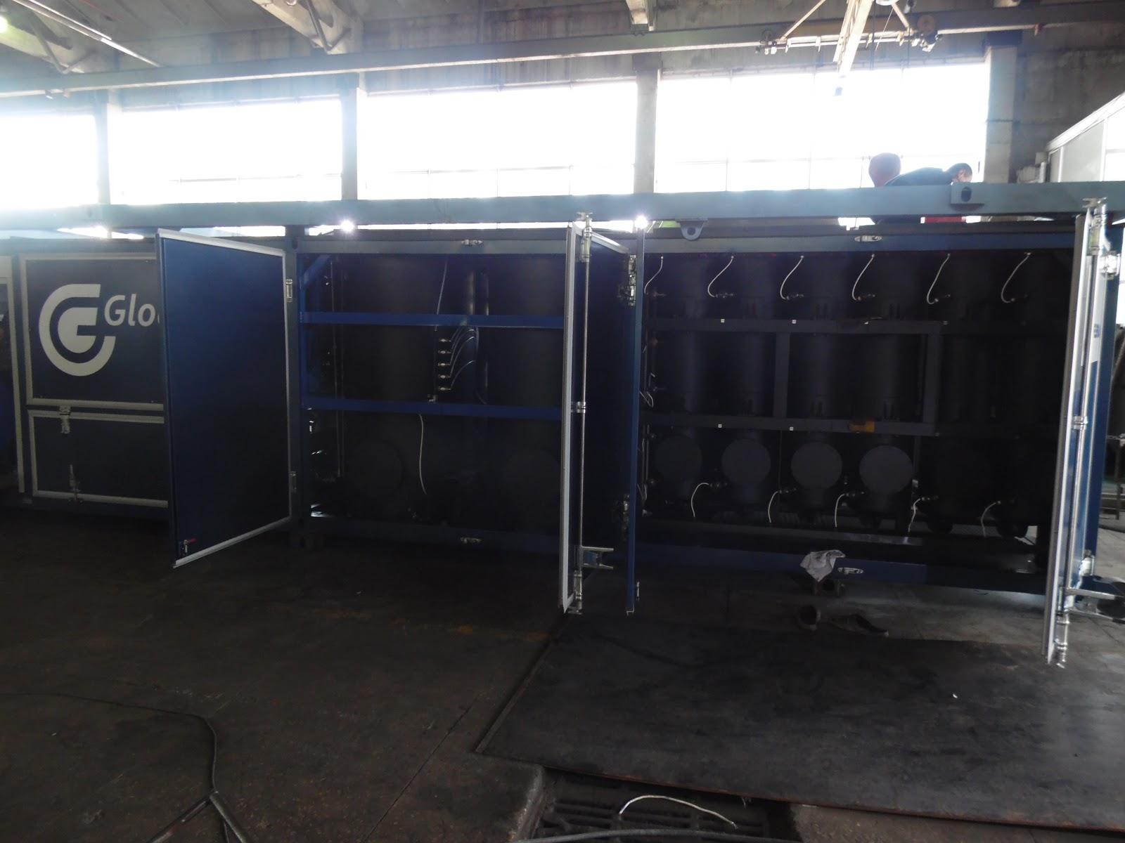
That all changed with the development of the modern oil purification and regeneration machine. Rather than replacing used oil and fluids with expensive new oil and fluids, the regeneration machine has the ability to completely restore the used oil to its new and un-used condition.
What sets this new GlobeCore machine apart from other modern oil processing equipment is the use of a Fuller’s Earth sorbent material to filter the used oil. The Fuller’s Earth is used in combination with a system that automatically reactivates and restores the sorbent materials once they have reached their maximum filtration abilities. In the past, the saturated Fuller’s Earth had to be replaced and disposed of possibly harming fresh water supplies since the sorbent materials contained oil based contaminants. It was time consuming, labor intensive, expensive, and not environmentally sound.
The Big Breakthrough: Now the Fuller’s Earth can be reactivated or cleaned and re-used hundreds of times without the need for disposal. The new process has been able to eliminate the time consuming and labor intensive process and has made oil regeneration a viable and cost effective alternative to oil and fluid replacement.
The machine only requires one operator and is fully automated with computer controls and safe guards built-in that will shut the machine down in case of any system failures.
The Oil Regeneration machine combines oil purification with oil regeneration and can completely restore dielectric insulting oils, industrial oils, and hydraulic fluids to new like condition for a fraction of the cost of replacing the used oil. (See the related story of Oil Regeneration here http://oilregeneration.globecore.com/difference-between-oil-purification-and-oil-regeneration.html)
The New GlobeCore Oil Regeneration machine is now available to electric transmission companies and the oil production industry worldwide.

About GlobeCore:
GlobeCore is a manufacturing company involved in the research, development and production of various oil and fluid processing systems for use in several different industries worldwide and is the developer of the Service Life Extension Program and the GlobeCore Process for servicing oil filled electric power transformers.

Contact Information:
Paul W. O’Finan, Senior Sales Manager
GlobeCore GmbH
Edewechter Landstraße 173, Oldenburg-Eversten, Deutschland, 26131
+49 44 84 20 23 591
Tel: +49 448 420 23 595
Email: pofinan@gobecore.com
Email: info@globecore.de
Email: sales@globecore.de

