A Promo Gift - Silicone Ssssspeaker by aiia - suddenly wins
the iF DESIGN AWARD 2015!

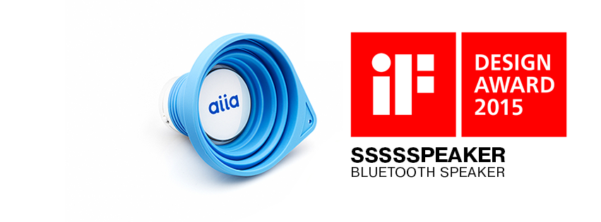

Out of 5,000 high-cost retail entries a simple yet unbelievable Ssssspeaker by aiia was admitted by high-profile international jury as a winner of the IF Design Award 2015. A promo product costing just $7.7 received this coveted seal of excellence.

For over 60 years, the iF DESIGN AWARD has been recognized the world over as a label of design excellence. The iF logo is an internationally established symbol that identifies outstanding achievements in design.

“This victory is very important for us and for promo industry as a whole”, says Andrii Klymenko, the CEO of aiia. “We have proven to the whole world that beautiful objects do not necessarily have to cost a fortune. You can visit the art gallery to get inspired or have beautiful things all around you.”

Ssssseaker (http://enjoy-aiia.com/product/ssssspeaker) is a collapsible portable speaker uniquely shaped from silicone. It provides up to 5 hours of rich 3-Watt sound and plays music in 3 various modes. Ssssspeaker was introduced to market in 2014 as one of the 12 promotional products designed by aiia.

aiia is the only company from Ukraine that has won at iF DESIGN AWARD during last 6 years. ”There are always emotions that we invest in our products”, says Oleg Volodymyrenko, the managing partner of aiia, “people are hungry for emotions and we’re here to make them feel different”.

aiia's award-winning “Ssssspeaker” will be featured in one of three subsequent special shows at iF design exhibition Hamburg.

At the same time, aiia is not going to stop and hopes to get among the winners of the Red Dot Design Award 2016.

