Dime Water Inc. Introduces the Science Kit

Dime Water Inc. has developed a Science Kit to be used in 7th grade trough K12 teaching of what reverse osmosis is, what it does and how it works.

The kit consists of a complete reverse osmosis unit that has been custom built. Students can run water through it and determine the quality of the water and observe the process. TDS meter will be provided and students may check the quality of the water going into the unit and also check the quality of the water coming out of the unit.
Each step in the process is documented and explanations about the components are provided.
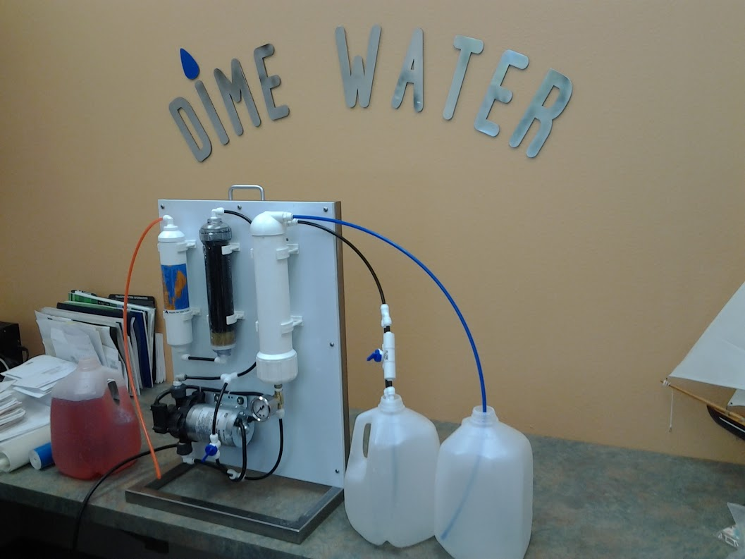
“This is a small unit that we recently built to demonstrate how a reverse osmosis unit performs. This unit is quite small; it would purify about 100 gallons of water a day and this type of unit is designed to perform on municipal waters or many well water applications. The same process with slightly different components can be used to turn seawater into good quality drinking water.”
Michael Colburn

Step by Step Process Guide

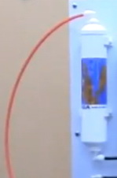
The water will be drawn through the orange tube into a particle filter that takes out any visible pieces of material that are in the water. Within this chamber is nothing more than something like a tightly woven cotton suck and this is the first filter that the water goes through. It is called a turbidity filter and its job is to take all visible impurities out of the water down to a level of 5 micron.
The water leaves here and it goes up-flow through a particular filter, we use clear ones so you can see what’s in it.

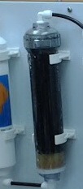
orange tube and particle filter
The first thing that the water sees is a material called KDF. KDF is a brass based material and its job is about 3 fold:
- it removes chlorine and turns it into chloride
- reduces the chloramines
- takes out many of the heavy metals (most of the bacteria will be killed by this first stage)
The water continues up through a bed, which is a very special grade of activated carbon and its job is to take out any remaining chloramines. This process is quite important especially if you are going to use this kind of process for dialysis equipment as the chloramines become quite toxic to the patient.
activated carbon bed
The water comes out of the carbon bed and goes into a pressurizing pump. It’s a diaphragm pump so it will not only pressurize water but it will suck water from the demonstration vessel that you use. The pressurized water goes to the final stage of filtration, which is the reverse osmosis membrane. The reverse osmosis membrane has some electrical charges on it such that water will go through but anything dissolved in the water and that can be calcium, table salt, sulfates and nitrates will be trapped in the rejection surface allowing a relatively clean, pure water to go through, which will come out of the blue hose.
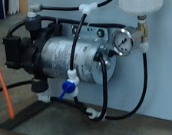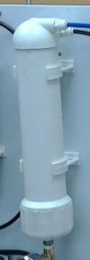
Pressurizing pump RO membrane
Incidentally the RO membrane has porosity such that the pores are so small that they will take out any of the bacteria or viruses that are in the water and will also take out cysts.

Quoting Dime Water Inc.’s Chief Engineer

“As you set the unit up, you need to do 2 things: you need to put the orange tube into a vessel of tap water or any demonstrating water that you want to use. We encourage that you put a few drops of food dye in so that you can visualize what’s going on. As you start to pump right in the center of the unit down near the bottom there is a blue valve. You adjust that valve so that the pressure gage on the inlet to the reverse osmosis membrane reads somewhere between 50psi -80psi. That is the water pressure that pushes the water through the RO membrane. Now, you are taking dissolved solids out so you got to do something with them; you can’t let them accumulate in there so you have on each unit a drain, which is the black line and you put the black line into yet another vessel and periodically like at the end of every experiment you’ll see a little blue valve on it, open that valve for a couple of minutes and then close it for the next demonstration. This will do a nice job of flushing out the junk that you have taken out of the water.”
Mike Colburn, chief engineer

FAQS

Q: What kind of water can we use?
A: Water that is relatively clean you don’t want something that is full of iron or dirt. We recommend tap water whether it comes from city or private well. Definitely not seawater.

Q: My water came out at TDS 80. Why?
A: That is a bit high, probably you contaminated it with some raw water or the jar that you had wasn’t completely rinsed out or you hadn’t adjusted the pressure and maybe you were running a little bit low on pressure.
Q: What does it take out of the water?
A: Anything that can be dissolved, you name it. All can be taken out or significantly reduced.
Q: Can bacteria be taken out?
A: Yes the membrane pores are smaller than any known bacteria, virus or cyst so the porosity of the membrane will not permit the passage of these.

Benefits of Reverse Osmosis from a Human Consumption Standpoint

- It reduces nitrates to the point where that’ll be within the federal regulatory limits. Nitrates, once they get into your body covert into nitrites and if these get into your blood they limit the amount of oxygen that the blood can absorb. Result is that especially a young child or an older person will end up with the bluing of the gums, which is an indication that they are not getting enough oxygen (blue baby syndrome).
- Another thing that will come out is sulfates . Especially in farm areas sulfates are known to be a problem because they cause a very loose bowl movement, and people associated with loose bowl movement suffer from loss of fluid, the loss of water ending up with dehydration.
- Fluoride
- Arsenic - this can cause problems with mental acuity as people age.
- Sodium - if you got high sodium in the water more often than not your physician will ask you to lower your sodium intake and that’s because excess sodium creates a osmotic pressure on your vascular system and you’ll end up with water in your ankles and feet and as a result your heart has to work harder to push it, so you end up having high blood pressure.
- Chlorine - it is taken out not by the membrane but by the transparent filter. There are all kinds of studies indicating that chlorine has a negative effect on the body apparently it turns to some forms of chloroform and again have an effect on the nervous system.

